Bridge Strike Protection Program Countess Street, Brisbane

The Queensland Government is committed to improving safety at low-level rail over road bridges and is working with Queensland Rail and local councils to prevent bridge strikes.

The Countess Street rail bridge in Brisbane is part of the state-wide Bridge Strike Protection Program that involves installing protection beams to prevent over-height vehicles striking existing rail bridges.
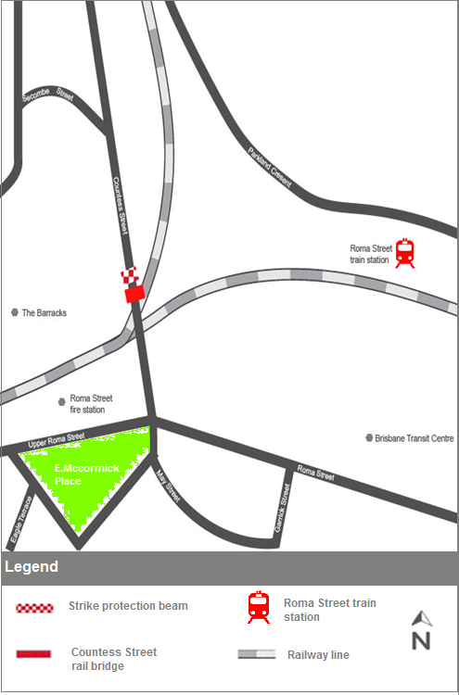
Construction Impacts

Construction work is scheduled to occur from late August until mid-October, weather and construction conditions permitting.

Regular working hours will be between 8pm and 5am Sunday to Thursday.

For times we know work will be louder than normal, we will send out additional notices in advance and will work hard to limit disruption where possible.

Please be assured that every effort is made to minimise any unnecessary noise, and we have reminded all staff and contractors to be considerate of the environment they are working in.

Road Closures

Some partial road closures of Countess Street will be required while works are undertaken, with traffic management in place to direct road users.

A full road closure at night will be required to lift the protection beam into place. Advance notification and detour signage will also be provided.

Changed road conditions

Once the protection beams are installed, the maximum clearance height for vehicles will remain at 4.4 metres.

It is essential that motorists are aware of the height of their vehicles and follow the warning signs.

Advance warning signs will be installed by Brisbane City Council as part of this project.

What is involved?

The protection beam will be mounted on a ‘stand-alone’ A-frame structure, on the footpath on each side of Countess Street.

Why is this important?

Bridge strikes pose a major risk to Queensland Rail infrastructure and can result in severe consequences for passenger safety. They can also cause traffic and train delays.

The Countess Street rail bridge is already fitted with protection measures, including height clearance and advance warning signage yet bridge strikes continue to occur at this location.

The effectiveness of protection beams has already been demonstrated at various locations including Dutton Park (Annerley Road), Indooroopilly (Allwood Street), Nambour (Price Street), Woombye (Back Woombye Road) and Moorooka (Muriel Ave).

Contact Queensland Rail

We encourage you to contact us with your phone or email details so we can ensure you are notified of any works that need to take place outside of normal construction hours, or involve changed traffic arrangements.

If you have any questions about Queensland Rail’s works on Countess Street, Brisbane, please call 13 16 17 (7.15am to 5pm Monday to Friday) or email communityengagement@qr.com.au

