Alderley station accessibility upgrade

Project update –

August 2016
Main construction works have commenced at Alderley station. This accessibility upgrade is part of Queensland Rail’s $212 million upgrade program and is expected to be completed by late 2017, weather and construction conditions permitting.

Project progress
The following construction activities were recently completed:
- site established on the Queensland Rail land adjacent to platform 2
- construction of the temporary facilities and station entrance points on either side of the station commenced.

Upcoming work
In the coming weeks, customers and the community can expect to see the following construction activities:
- completion of the temporary footbridge stairs
- completion of temporary station entrance points and relocation of ticketing equipment
- excavation of new lift and footbridge foundations adjacent to both platforms
- relocation of platform shelters
- platform surface works, excavation and service installations.
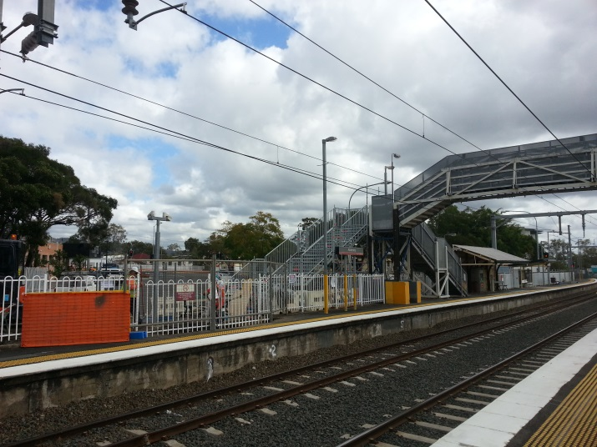

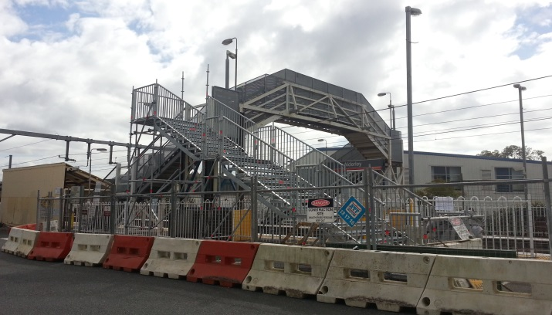

Construction impacts
Customers, residents and businesses adjacent to Alderley station may experience the following:
- noise associated with heavy machinery
- use of reversing beepers
- changed traffic and parking conditions
- mobile lighting towers for night works
- increased vehicle movements near works
- temporary changes to access paths throughout the station precinct.
Pedestrians are advised to follow all directional signage during this time.
Residents and other stakeholders will be given advance notification of construction activities likely to cause impacts, including after-hours work (nights and Sundays, as required).

Keeping you informed
For more information on this project, please contact the Stakeholder Engagement team on 1800 722 203 (free call), email stationsupgrade@qr.com.au or visit www.queenslandrail.com.au

