Alderley station accessibility upgrade

Project update –

October 2016
The Alderley station accessibility upgrade is part of Queensland Rail’s $212 million upgrade program and is expected to be completed by late 2017, weather and construction conditions permitting.

Project progress
Main construction works have commenced at Alderley station.
The following activities were recently completed:
- commissioning of temporary stairs
- removal of heritage shelter on platform 2 for refurbishment
- installation of new pedestrian footbridge supports and decks.
Pictured below and at right is the new pedestrian footbridge, which was installed during the scheduled track closure of the Ferny Grove line in early October.

Upcoming work
In the coming weeks, customers and the community can expect to see the following construction activities:
- commencement of platform raising at the core zones
- platform surface works, excavation and service installations
- excavation of lift shafts.
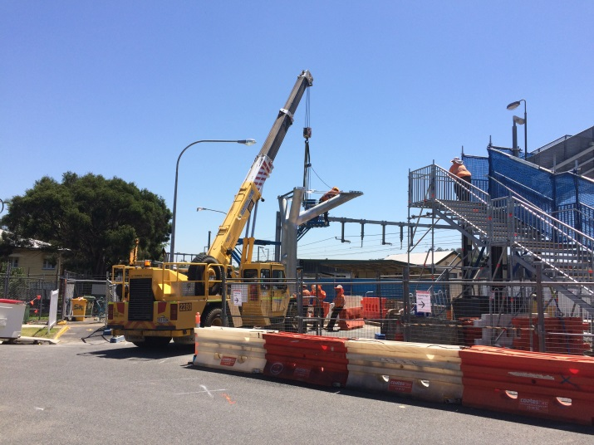

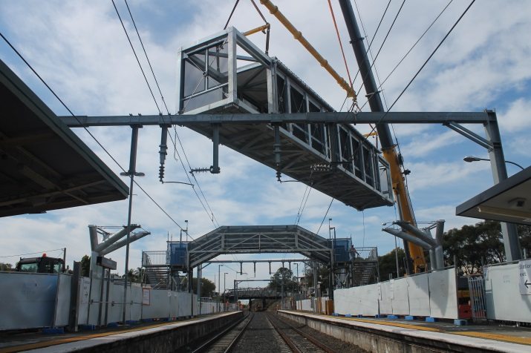

Construction impacts
Customers, residents and businesses adjacent to Alderley station may experience the following:
- noise associated with heavy machinery
- use of reversing beepers
- changed traffic and parking conditions
- mobile lighting towers for night works
- increased vehicle movements near works
- temporary changes to access paths throughout the station precinct.
Pedestrians are advised to follow all directional signage during this time.
Residents and other stakeholders will be given advance notification of construction activities likely to cause impacts, including after-hours work (nights and Sundays, as required).

Keeping you informed
For more information on this project, please contact the Stakeholder Engagement team on 1800 722 203 (free call), email stationsupgrade@qr.com.au or visit www.queenslandrail.com.au

