Dinmore station accessibility upgrade

Project update –

October 2016
The Dinmore station accessibility upgrade is part of Queensland Rail’s $212 million station upgrade program and is expected to be completed by mid-2017, weather and construction conditions permitting.

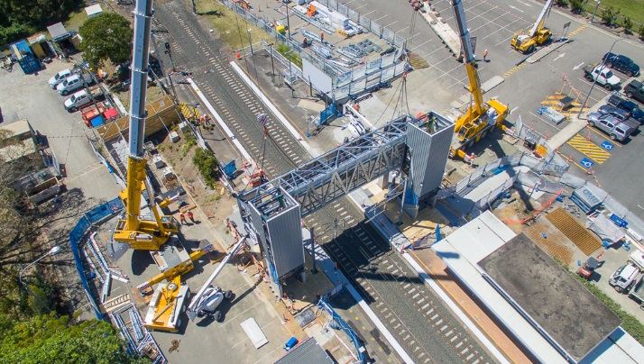

Project progress
The following construction activities were recently completed:
- installation of the new footbridge and stair structures
- cladding and glazing of new lift shafts
- platform raising works at the Brisbane-end of the station
- installation of light poles.

Upcoming work
In the coming weeks, customers and the community can expect to see the following activities:
- lift installations
- ongoing platform raising works
- construction of new platform entrances
- completion of pedestrian footbridge and stairs.
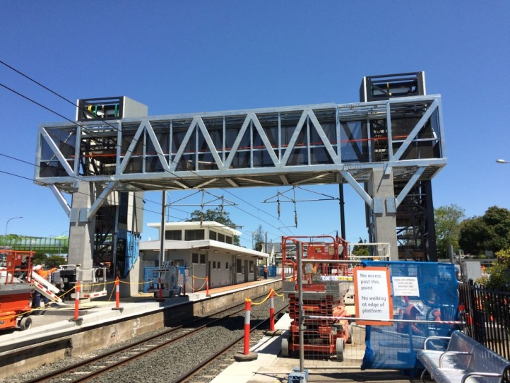

.

Image courtesy of BMD Constructions.

Construction impacts
Customers and residents adjacent to Dinmore station may experience:
- noise associated with heavy machinery
- use of reversing beepers
- mobile lighting towers for night works
- changed traffic and parking conditions
- increased vehicle movements around the work zone.
Pedestrians are asked to follow all directional signage during this time.
Residents and other stakeholders will be given advance notification of construction activities likely to cause impacts, including after-hours work (nights and Sundays, if required).

Keeping you informed
For more information on this project, please contact the Stakeholder Engagement team on 1800 722 203 (free call), email stationsupgrade@qr.com.au or visit www.queenslandrail.com.au

