Dinmore station accessibility upgrade

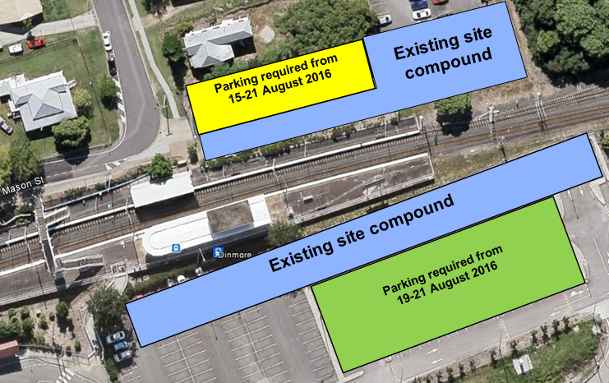
Temporary changes to parking – August 2016

Platform upgrade work has commenced at Dinmore station as part of the accessibility upgrade. To enable machinery and materials to be safely stored adjacent to the work sites, temporary changes to station parking will occur from Monday 15 August 2016:
- Mason Street carpark – parking will be unavailable in this carpark (see yellow section, above) from Monday 15 August until Sunday 21 August 2016.

- Brisbane Road carpark – a section of this carpark (see green section, above) will be unavailable from the evening of Friday 19 August until Sunday 21 August 2016.
These carparks will be made available to the public from Monday 22 August 2016. The sections of both carparks shown in blue (above) will continue to be used for site compound for the duration of works.

Keeping you informed
Queensland Rail is committed to keeping stakeholders and the community informed about this project. For more information, please contact the Stakeholder Engagement team on 1800 722 203 (free call), email stationsupgrade@qr.com.au or visit www.queenslandrail.com.au

