Graceville station accessibility upgrade

Project update –

October 2016
The Graceville station accessibility upgrade is part of Queensland Rail’s $212 million upgrade program and is expected to be completed by late 2017, weather and construction conditions permitting.

Project progress
The following construction activities were recently completed:
- lift shaft construction works
- footings for new awnings on platforms 3 and 4
- concrete pour – new stairs, platforms 3 and 4
- modification of subway walls for new stair and lift access points
- changes to traffic management controls for improved safety near the work zones.

Upcoming work
In the coming weeks, customers and the community can expect to see the following:
- resurfacing on platforms 3 and 4
- further modification of subway walls to allow for new stair and lift access points
- concrete pours for new stairs and lift shafts
- conduit installations.

After hours works
Continuous works will occur at the station from 6am Saturday 22 until 10pm Sunday 23 October and again from 10pm Friday 28 until 6am Monday 31 October.
A crane will operate from Honour Avenue to access the platforms. For safety, this work must be undertaken after hours and has been scheduled to coincide with reduced freight activity on the line.

Track closure
Over the weekend Saturday 5 to Monday 7 November, the subway and all platforms will be closed for upgrade works during a scheduled track closure.
More information will be available at the station office closer to the closure.
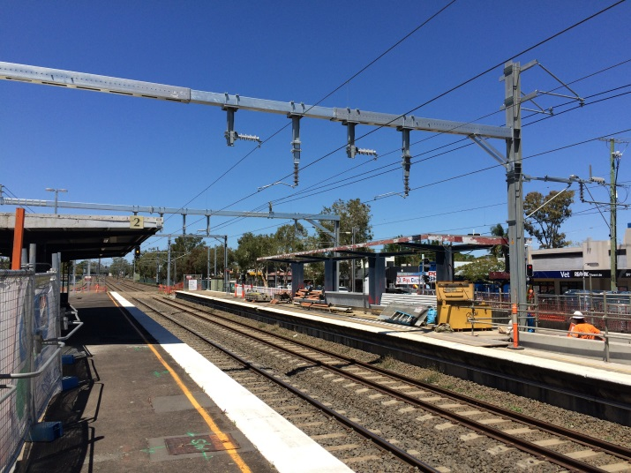

Construction impacts
Customers, residents and businesses adjacent to Graceville station may experience the following:
- noise associated with heavy machinery
- use of reversing beepers
- changed traffic and parking conditions
- mobile lighting towers for night works
- increased vehicle movements near works
- temporary changes to access paths throughout the station precinct.
Residents and other stakeholders will be given advance notification of construction activities likely to cause impacts, including after-hours work (nights and Sundays, as required).

Keeping you informed
For more information on this project, please contact the Stakeholder Engagement team on 1800 722 203 (free call), email stationsupgrade@qr.com.au or visit www.queenslandrail.com.au

