Newmarket station accessibility upgrade

Project update –

August 2016
Main construction at Newmarket station is about to begin, with works on the temporary platforms nearing completion. This accessibility upgrade is part of Queensland Rail’s $212 million upgrade program and is expected to be completed by mid-2017, weather and construction conditions permitting.

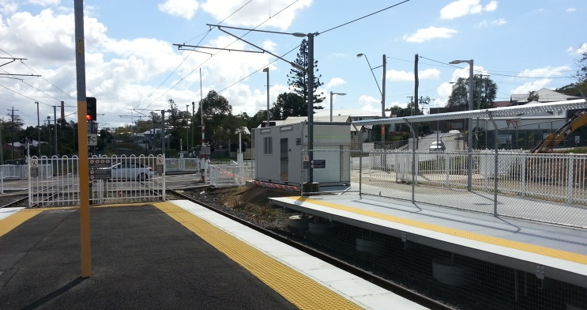

Project progress
The following construction activities were recently completed:
- site office established on the Queensland Rail land adjacent to platform 2
- services installed to temporary platforms
- temporary ticketing office and customer toilets installed near the Wilston Road level crossing, adjacent to platform 1.

Upcoming work
In the coming weeks, customers and the community will see the following activities:
- completion of the temporary platforms
- commencement of main construction works on the island platform and station building.

Temporary platforms
The temporary platforms are expected to open in early September 2016, weather and construction conditions permitting.
Once opened, passenger services will be moved to the temporary platforms enabling the accessibility upgrade of the island platform, new pedestrian footbridge and lift to progress.
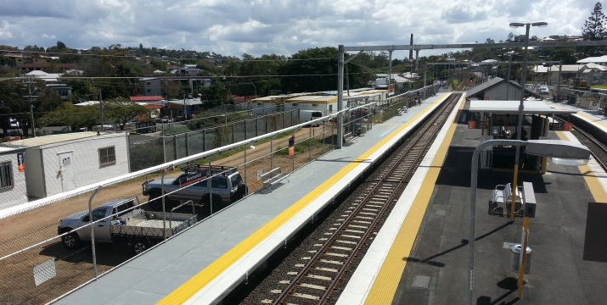
The existing footbridge and subway will then be closed to the public for the duration of works. All access to the temporary platforms will be from the Wilston Road end of the station.

Construction impacts
Customers, residents and businesses adjacent to Newmarket station may experience the following:
- noise associated with heavy machinery
- use of reversing beepers
- changed traffic and parking conditions
- mobile lighting towers for night works
- increased vehicle movements around the work zones
- temporary changes to access paths throughout the station precinct.
Pedestrians are advised to follow all directional signage during this time.
Residents and other stakeholders will be given advance notification of construction activities likely to cause impacts, including after-hours work (nights and Sundays, as required).

Keeping you informed
For more information on this project, please contact the Stakeholder Engagement team on 1800 722 203 (free call), email stationsupgrade@qr.com.au or visit www.queenslandrail.com.au

