Newmarket station accessibility upgrade

Project update –

October 2016
The Newmarket station accessibility upgrade is part of Queensland Rail’s $212 million upgrade program and is expected to be completed by mid-2017, weather and construction conditions permitting.

Project progress
Main construction at the station is underway, with the temporary platforms now in use.
The following activities were recently completed:
- completion and opening of temporary platforms in early September
- raising and moving the station building in preparation for the raising of the platforms
- removal of redundant structures and furniture from the island platform
- dismantling and removal of timber footbridge and stairs.

Upcoming work
In the coming weeks, customers and the community will see the following activities:
- installation of coping stones to the island platforms
- excavation of the lift shaft and footbridge foundations.
The subway remains closed to the public for the duration of works. All access to the temporary platforms will be from the Wilston Road level crossing end of the station.
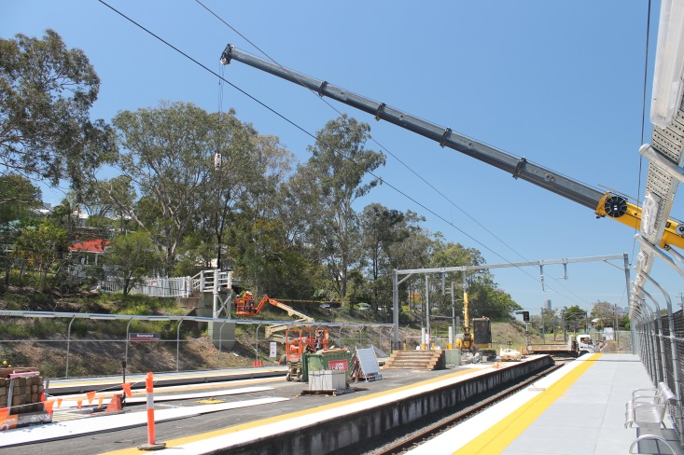

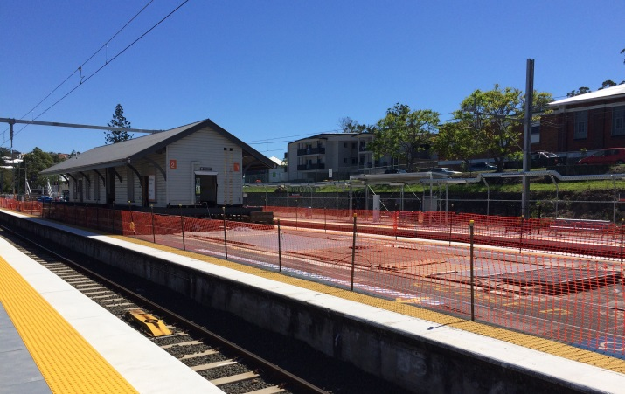

Construction impacts
Customers, residents and businesses adjacent to Newmarket station may experience the following:
- noise associated with heavy machinery
- use of reversing beepers
- changed traffic and parking conditions
- mobile lighting towers for night works
- increased vehicle movements around the work zones
- temporary changes to access paths throughout the station precinct.
Pedestrians are advised to follow all directional signage during this time.
Residents and other stakeholders will be given advance notification of construction activities likely to cause impacts, including after-hours work (nights and Sundays, as required).

Keeping you informed
For more information on this project, please contact the Stakeholder Engagement team on 1800 722 203 (free call), email stationsupgrade@qr.com.au or visit www.queenslandrail.com.au

