December 2017
Signals Upgrade Project
To improve reliability of our network, Queensland Rail is upgrading the train signals and infrastructure between Roma Street and Corinda stations.
As a valued neighbour, we are committed to keeping you informed about work Queensland Rail is undertaking in your area. This notice is a four-week look ahead outlining planned work and approximate locations for our Signals Upgrade Project.
Nearby residents and businesses may experience construction noise and traffic impacts, particularly where we require access to the rail corridor.
We apologise for any inconvenience and thank you for your understanding while we dig trenches, lay cables, move overhead electrical wires and install new signalling equipment on the line between Roma Street and Corinda.
Wishing you and your family a very Merry Christmas and a safe and Happy New Year.
Milton to Corinda day works
Day works from 6am to 6pm from Friday 1 to Friday 22 December.  - New cable and signal equipment installation between Milton and Graceville  - Testing works for new signalling equipment between Milton and Graceville. | 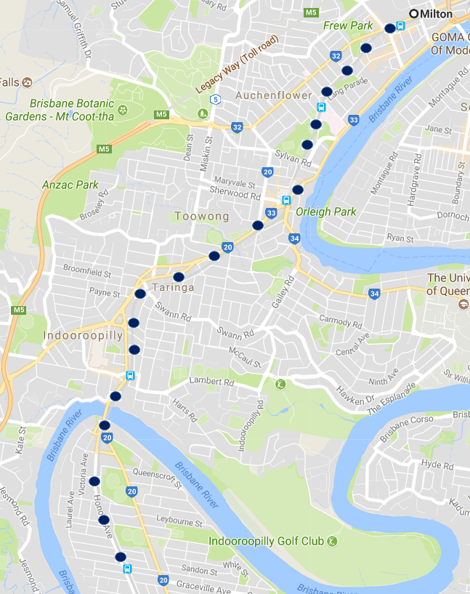
What to expect
Some noise from on-track machines and construction crews, vehicle movements and traffic control in surrounding streets.
Every effort will be made to carry out these works with minimal disruption.
Works may be subject to change due to operational and weather conditions.
Keeping you informed
To join the project mailing list so that we can notify you of upcoming works in your area, please contact us and provide your details.
For more information
Free call: 1800 959 989 | Email: communityengagement@qr.com.au
Web: queenslandrail.com.au/inthecommunity/projects

