1 August to 31 August 2017

Signals Upgrade Project

As a valued neighbour, we are committed to keeping you informed about work Queensland Rail is doing in your area. This four-week look ahead shows planned work for our Signals Upgrade Project and approximate locations.

The nature of this work is such that there will be little to see, but there will be construction noise and traffic impacts, particularly around those points where we require access to the rail corridor.

Where possible, the majority of our works will be undertaken from 6am to 6pm, Monday to Friday, to minimise disruption to local residents. However, works affecting the railway must be carried out at times that cause the least disruption to train services. Unfortunately, this means some noisy works during the night and at weekends.

Please be assured that every effort is made to minimise any unnecessary noise, and we have reminded all staff and contractors to be considerate of the environment they are working in.

Roma Street to Indooroopilly weekend works
Weekend works throughout August from 6am to 6pm:  - Installation of new power, communications and signalling cables  - Installation of signalling equipment |  | 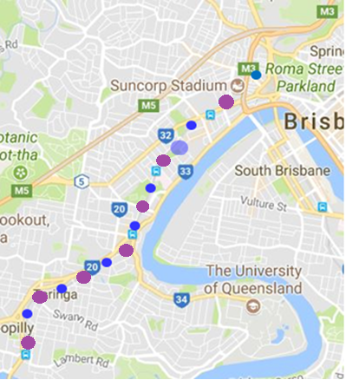
Milton to Indooroopilly day works
Day works from Tuesday 1 August to Thursday 31 August, from 6am to 6pm each day:

- Main cable route rejuvenation
- Signal upgrades
- General track work
Roma Street to Corinda weekend works
Weekend works on Saturday 5 and Sunday 6 August, from 6am to 6pm:  - Installation of signal equipment  - Installation of new cables  - Upgrade of existing equipment  - Track construction | 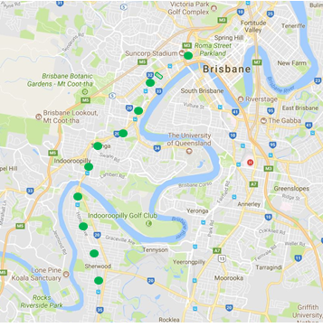
What to expect
You may experience some noise from on-track machines and construction crews, heavy vehicle movements and traffic control in surrounding streets.
Milton to Auchenflower day works

Ongoing daily signalling stage works between Milton and Auchenflower involving construction crews accessing the corridor and heavy vehicle movements.

Contact Us:

We encourage you to contact us with your phone or email details so we can ensure you are notified of any works that need to take place outside of normal construction hours, or involve changed traffic arrangements in your area.

This snapshot is broad and subject to change. If you have questions or concerns about specific dates, times or locations, please contact us.

Call: 1800 959 989
Email: communityengagement@qr.com.au

For more information about this project visit queenslandrail.com.au/inthecommunity/projects

