November 2017
Signals Upgrade Project
As a valued neighbour, we are committed to keeping you informed about work Queensland Rail is undertaking in your area. This notice is a four-week look ahead outlining planned work for our Signals Upgrade Project and approximate locations.
Due to the nature of this work, there will be little to see, but there will be construction noise and traffic impacts, particularly around those points where we require access to the rail corridor.
We apologise for any inconvenience and thank you for your understanding while we dig trenches, lay cables, move overhead electrical wires and install new signalling equipment on the line between Roma Street and Corinda.
Roma Street to Corinda weekend works
Weekend works from 6am to 6pm each day on Saturday 4 and Sunday 5 November.  - Turnout construction at Milton  - Installation of signal equipment  - Installation of new cables  - Signal equipment removal  - Upgrade of existing equipment  - Cable testing between Roma Street and Corinda  - Commissioning of new signals between Taringa and Indooroopilly.  Lane closure on Milton Road. | 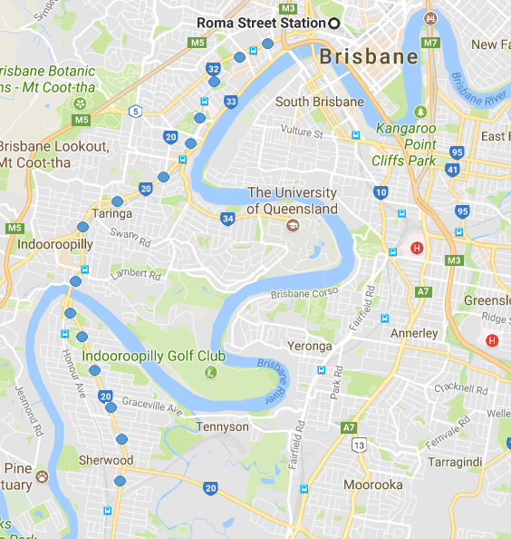
Weekend works from 6am Saturday 11 to 6pm Sunday 12 November (continuous).
- Turnout works at Milton – completion of new signalling control systems
- Installation of signal equipment
- Installation of new cables
- Signal equipment removal
- Upgrade of existing equipment
- Cable testing between Roma Street and Corinda
- Commissioning of new signals between Taringa and Indooroopilly.
See following page for road closures in Taringa during weekend works.

Taringa weekend road closures | 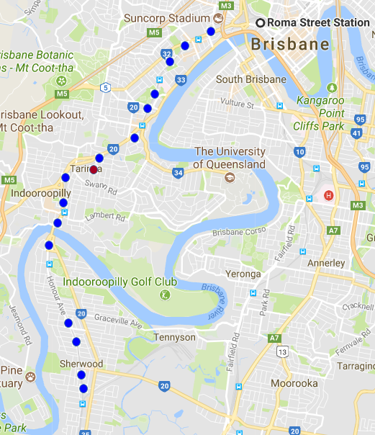
6am to 6pm each day on Saturday 11 and Sunday 12 November.
Queensland Rail will temporarily close parts of Cunningham Street and Queens Road:
- Cunningham Street (between Swann Road and Kings Road)
- Queens Road (between Cunningham Street and the rail corridor)
- Some on-street parking in Cunningham Street (near Queens Road) will be unavailable.
Milton to Corinda day works
Day works from 6am to 6pm from Wednesday 1 to Thursday 30 November.
- Cable and new signal equipment installation between Toowong and Graceville
- Testing works for new signalling equipment
- Installation of signal equipment.
- Installation of new cables
- Upgrade of existing equipment.
What to expect
Some noise from on-track machines and construction crews, vehicle movements and traffic control in surrounding streets.
Roma Street to Corinda day works
Day works from 6am to 6pm from Wednesday 1 to Thursday 30 November.
Ongoing daily signalling stage works between Roma Street and Corinda involving construction crews accessing the corridor and heavy vehicle movements.

Queensland Rail will make every effort to carry out these works with minimal disruption. We encourage you to contact us with your phone or email details so we can notify you of any works that need to take place outside of normal construction hours or involve changed traffic arrangements in your area.
This update is broad and subject to change. If you have questions or concerns about specific dates, times or locations, please contact us.
We look forward to working with you.

For more information
Call: 1800 959 989 | Email: communityengagement@qr.com.au
Web: queenslandrail.com.au/inthecommunity/projects

