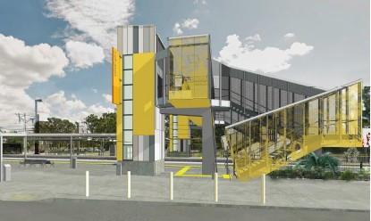Morayfield station accessibility upgrade

Night works noise notice
Tuesday 17 to Friday 20 October 2017

Queensland Rail is striving to become a modern, customer-focused rail service and is investing
significantly to upgrade a number of stations to ensure that all customers can travel safely and easily.

Early works for the Morayfield station accessibility upgrade will soon commence with the establishment of temporary platforms. To facilitate this activity, Queensland Rail plans to establish foundations for overhead equipment during scheduled night closures during October.

Overview of work

Location | Dates and hours of work | Type of work
Morayfield station | Between 8pm and 5am on:  - Tuesday 17 October  - Wednesday 18 October  - Thursday 19 October  - Friday 20 October. | Drilling and concreting foundations for  overhead equipment.  This will involve:  - concrete truck and pump  - heavy machinery including excavator and trucks with reversing beepers  - the use of small tools including hammers and drills  - portable lighting towers.

Queensland Rail appreciates your patience and apologises for the inconvenience while these works are undertaken.
Queensland Rail Limited ABN 71 132 181 090 QR2017_A4_0517

For further information regarding this work, please contact the project team on 1800 722 203 or email

stationsupgrade@qr.com.au

Queensland Rail is moving towards paperless notifications about noise, works and track closures. You’ll still see paper notices for a time, as we transition to the new system. Sign up at: queenslandrail.com.au/EmailNotification

