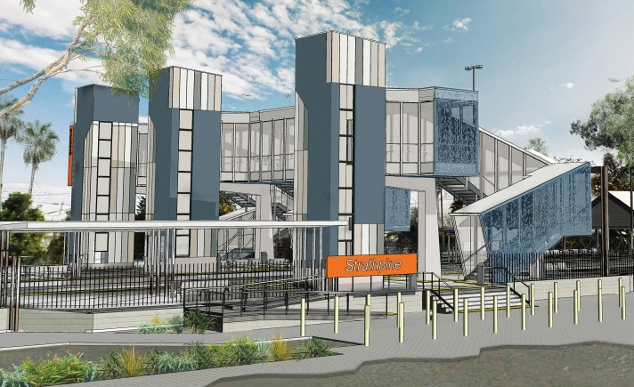Night works noise notice
Strathpine station accessibility upgrade
October 2017

Queensland Rail is striving to become a modern, customer-focused rail service and is investing
significantly to upgrade a number of stations to ensure that all customers can travel safely and easily.

Early works for the Strathpine station accessibility upgrade will soon commence with the establishment of temporary platforms. To facilitate this activity, Queensland Rail plans to undertake works on the overhead lines and tracks during scheduled night closures during October.

Overview of work

Location | Dates and hours of work | Type of work
Strathpine station | Between 8pm and 5am on:  - Sunday 15 October  - Tuesday 17 to Friday 27 October (excluding Saturday 21 October)  - Sunday 29 October | Overhead line works and installation of track crossings and barriers.  This will involve:  - cranes to lift beams into place  - heavy machinery including loaders, rollers and trucks with reversing beepers  - the use of small tools including hammers and drills  - portable lighting towers.

Queensland Rail appreciates your patience and apologises for the inconvenience while these works are undertaken.
Queensland Rail Limited ABN 71 132 181 090 QR2017_A4_0517

For further information regarding this work, please contact the project team on 1800 722 203 or email

stationsupgrade@qr.com.au

Queensland Rail is moving towards paperless notifications about noise, works and track closures. You’ll still see paper notices for a time, as we transition to the new system. Sign up at: queenslandrail.com.au/EmailNotification

