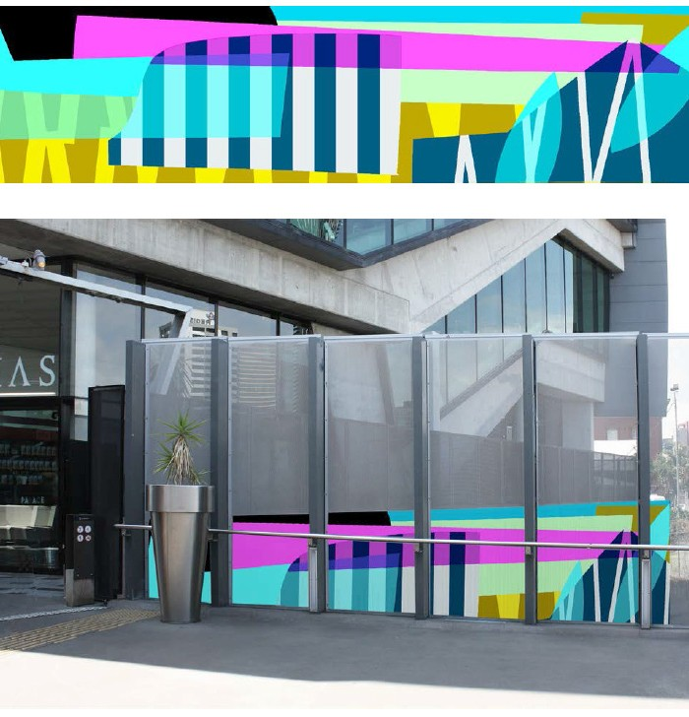Barracks about to get brighter
The wall bordering the Barracks complex is about to get a makeover, with a new Queensland Rail mural aimed at brightening up the journey for our customers and the community.
The striking 30 metre mural, by local artist Simon Degroot, has been inspired by the colours and forms of local buildings and will be installed during December.
The shapes in the mural represent historical architectural features like the complex’s pointed roofline and bell.
The colours complement the local street furniture and landscaping details within the Barracks complex.
Queensland Rail Limited ABN 71 132 181 090

For more information, call 13 16 17 (business hours), visit the Station Refresh project page at queenslandrail.com.au or email communityengagement@qr.com.au

