Gold Coast Stations Renewal
Helensvale station

August/September update
Queensland Rail is refurbishing its six Gold Coast stations ahead of the Commonwealth Games. This is part of a $10 million project which will deliver more modern, safe and comfortable facilities for our customers.

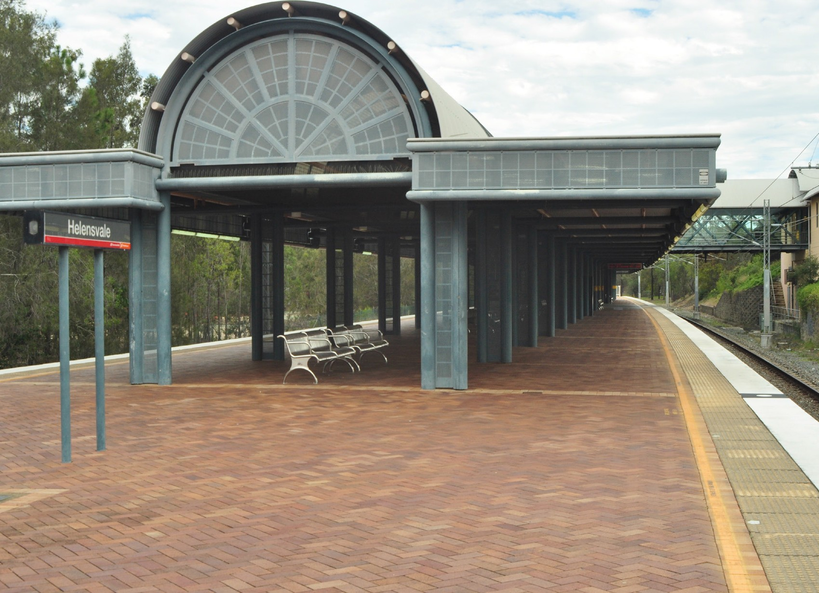Project progress
The following works at Helensvale have been completed to date:
- Platform and roof painting.

Upcoming work
In the coming weeks, customers can expect to see tiling removal being carried out throughout the concourse level to prepare for all new tiling.

Further upgrades works will commence in October 2017.

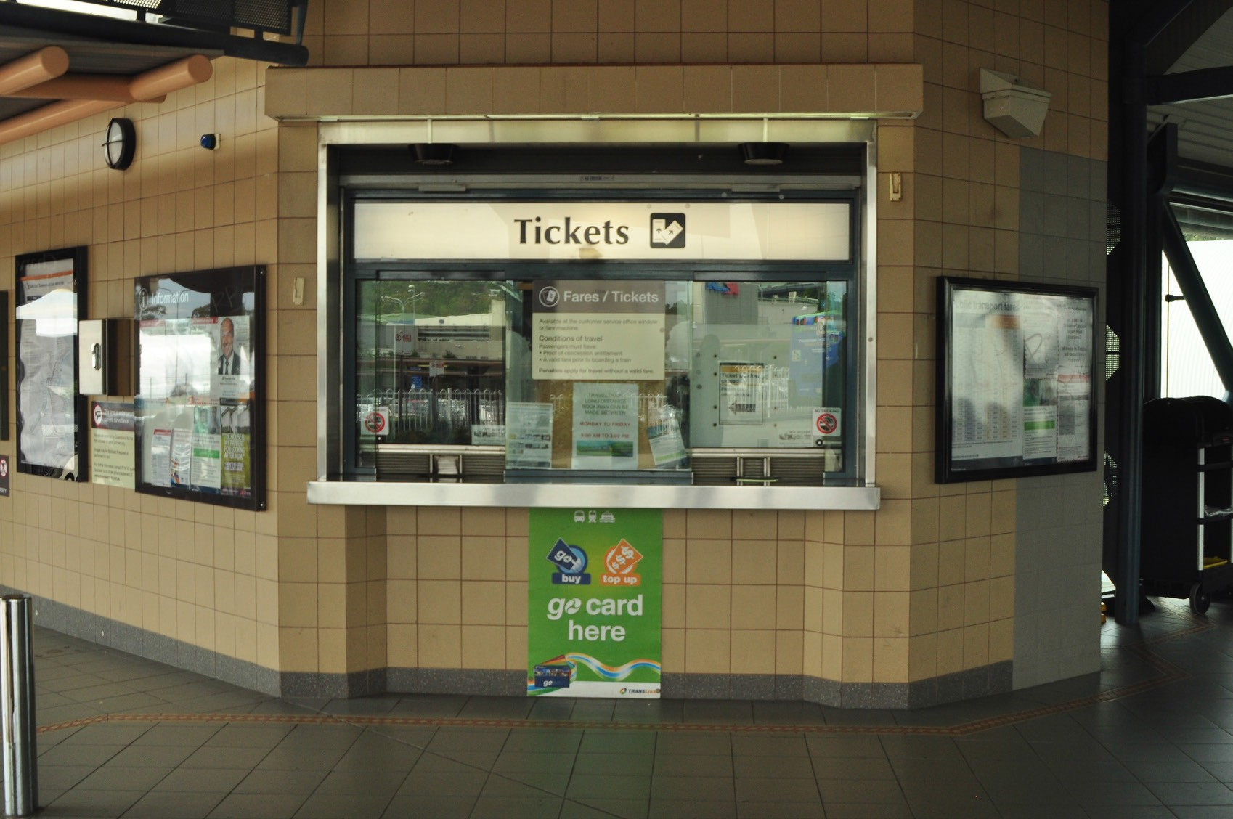Keeping you informed
For more information on this project, please contact Queensland Rail on 13 16 17 (7.15am – 5pm Monday – Friday) or email communityengagement@qr.com.au or visit www.queenslandrail.com.au.
Queensland Rail Limited ABN 71 132 181 090 QR_A3_2017

