Gold Coast Stations Renewal
Robina station

August/September update
Queensland Rail is refurbishing its six Gold Coast stations ahead of the Commonwealth Games. This is part of a $10 million project which will deliver more modern, safe and comfortable facilities for our customers.

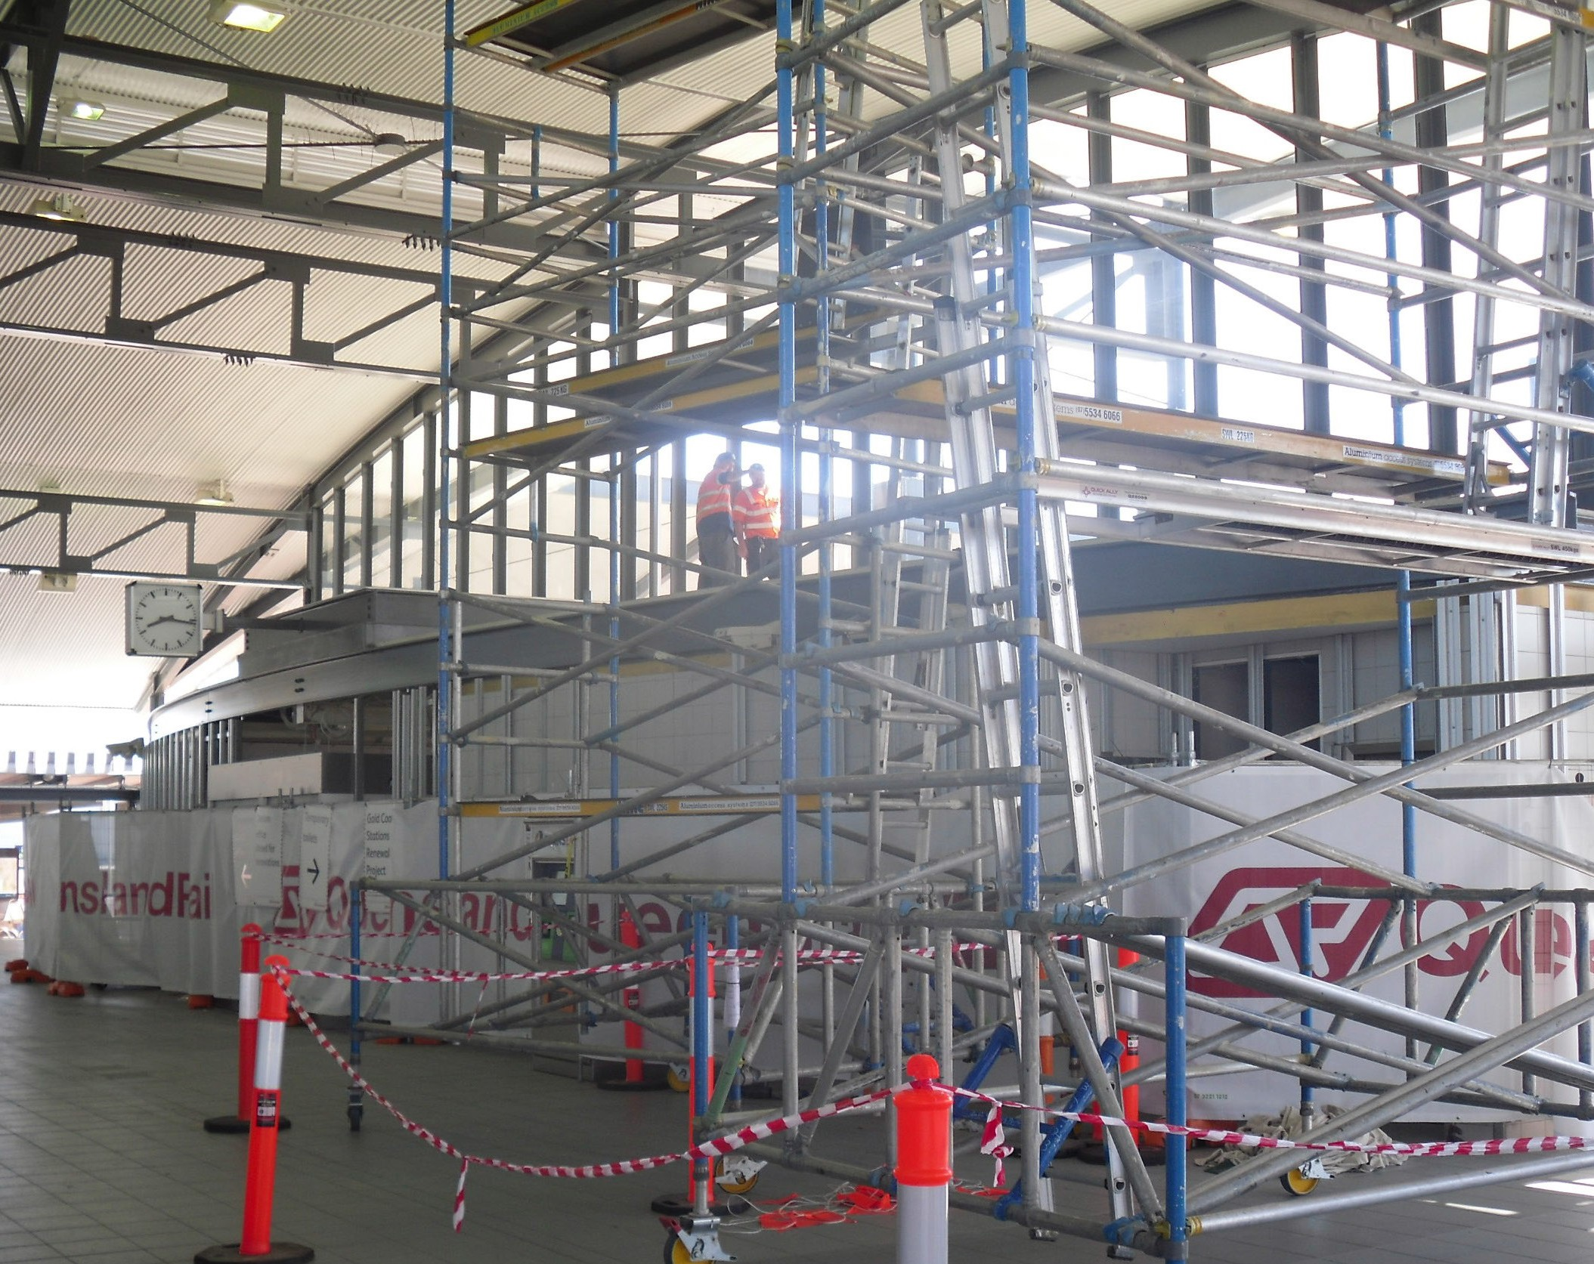Project progress
The following works have been completed:
- Fresh repaint of the platforms
- Relocation of the ticket office to outside the station entrance in preparation for upgrades to ticket office and staff facilities.

Upcoming work
In the coming weeks, customers can expect to see:
- Upgrades to public amenities
- Repaint of the entry and concourse areas
- Refurbishment of the station office.

Keeping you informed
For more information on this project, please contact Queensland Rail on 13 16 17 (7.15am – 5pm Monday – Friday) or email communityengagement@qr.com.au or visit www.queenslandrail.com.au.
Queensland Rail Limited ABN 71 132 181 090 QR_A3_2017

