Gold Coast Stations Renewal
Ormeau station

October/November update
Queensland Rail is refurbishing its six Gold Coast stations ahead of the Commonwealth Games. This is part of a $10 million project which will deliver more modern, safe and comfortable facilities for our customers.

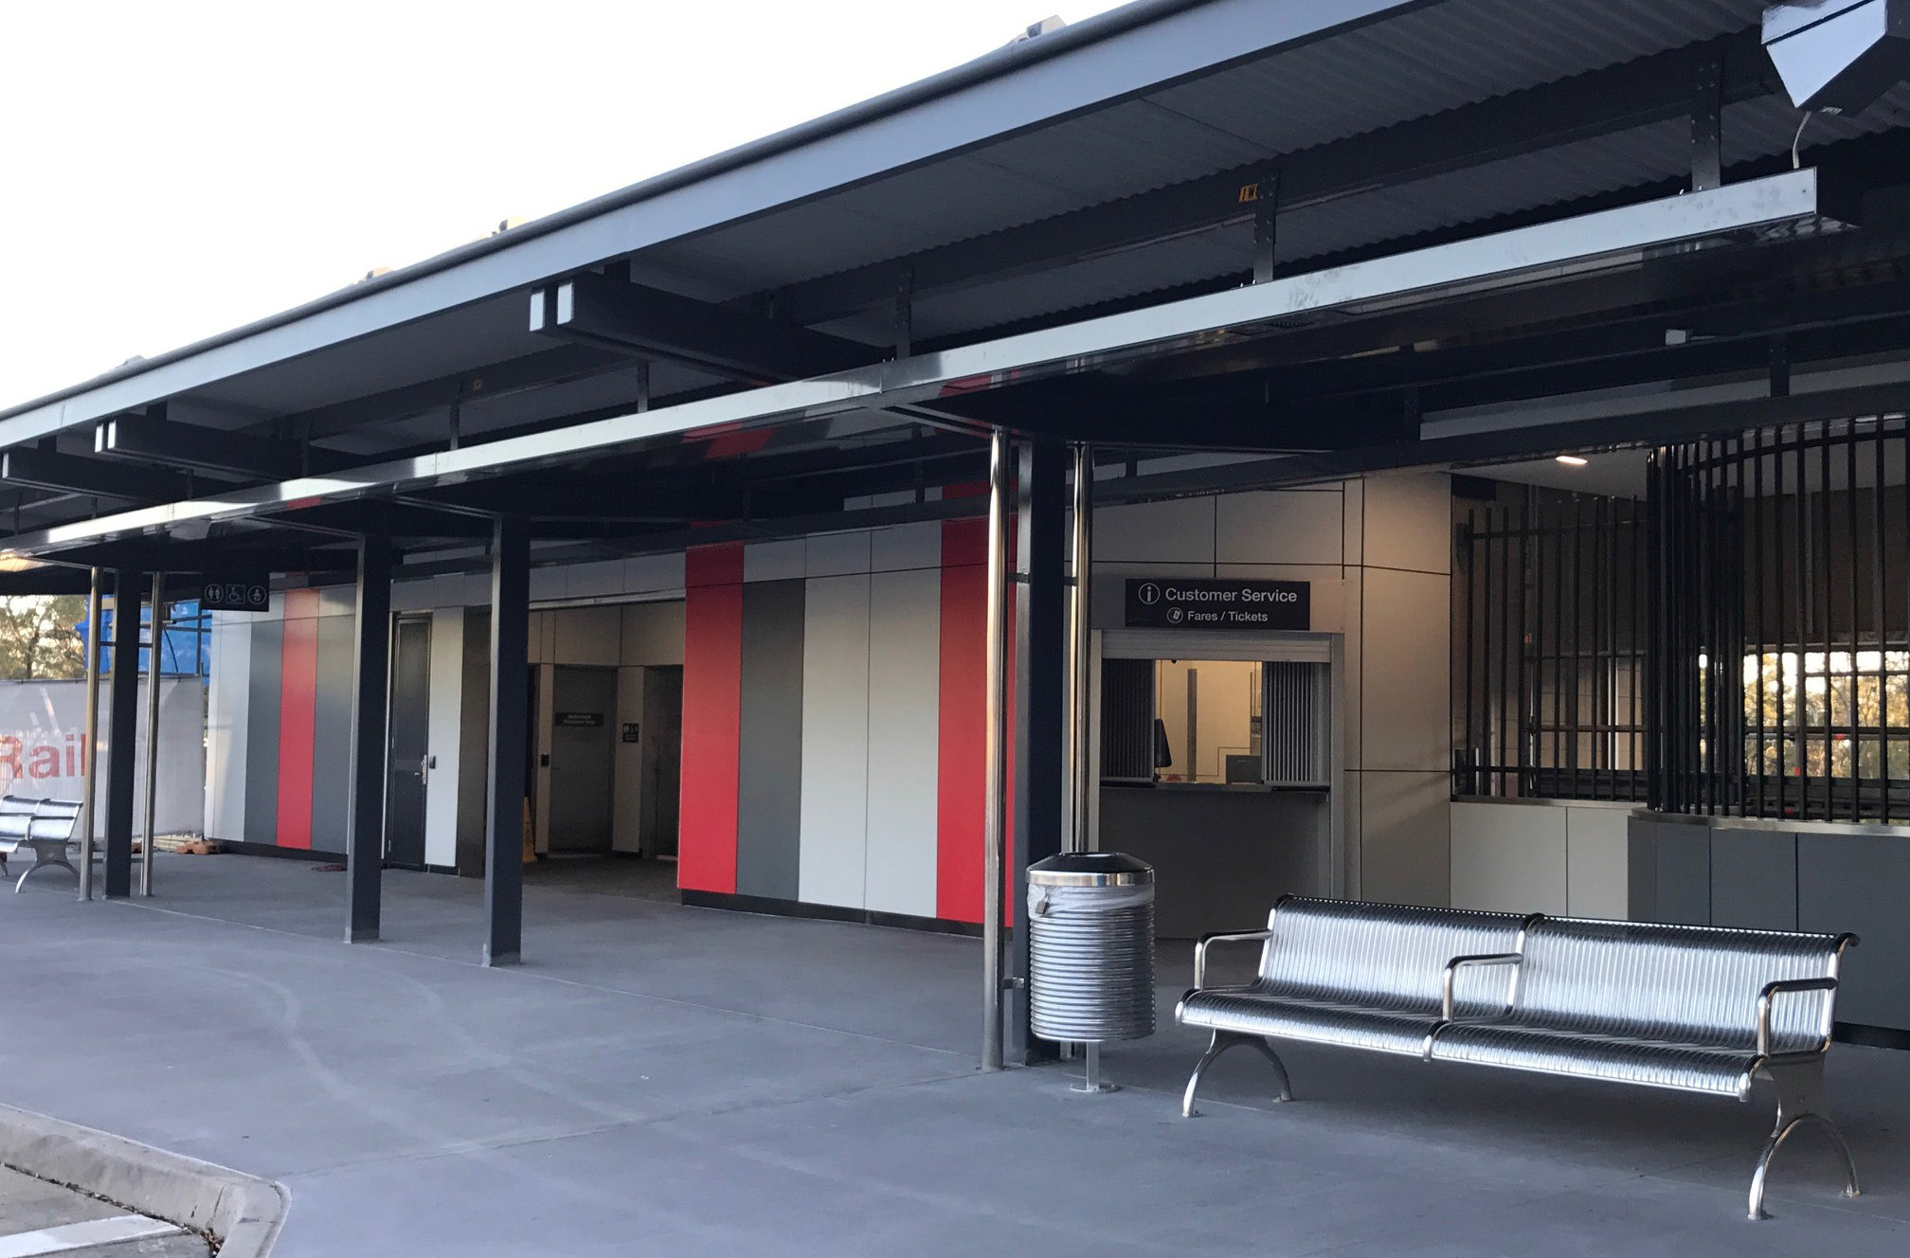Project progress
The following works at Ormeau have been completed:
- footbridge upgrade including new mesh and tiling, and removal of scaffolding around footbridge
- refurbishment and reopening of the station ticket office and public amenities
- tiling works to the stairs
- installation of new ceiling over the footbridge and foyer
- new cladding to the exterior of the station.

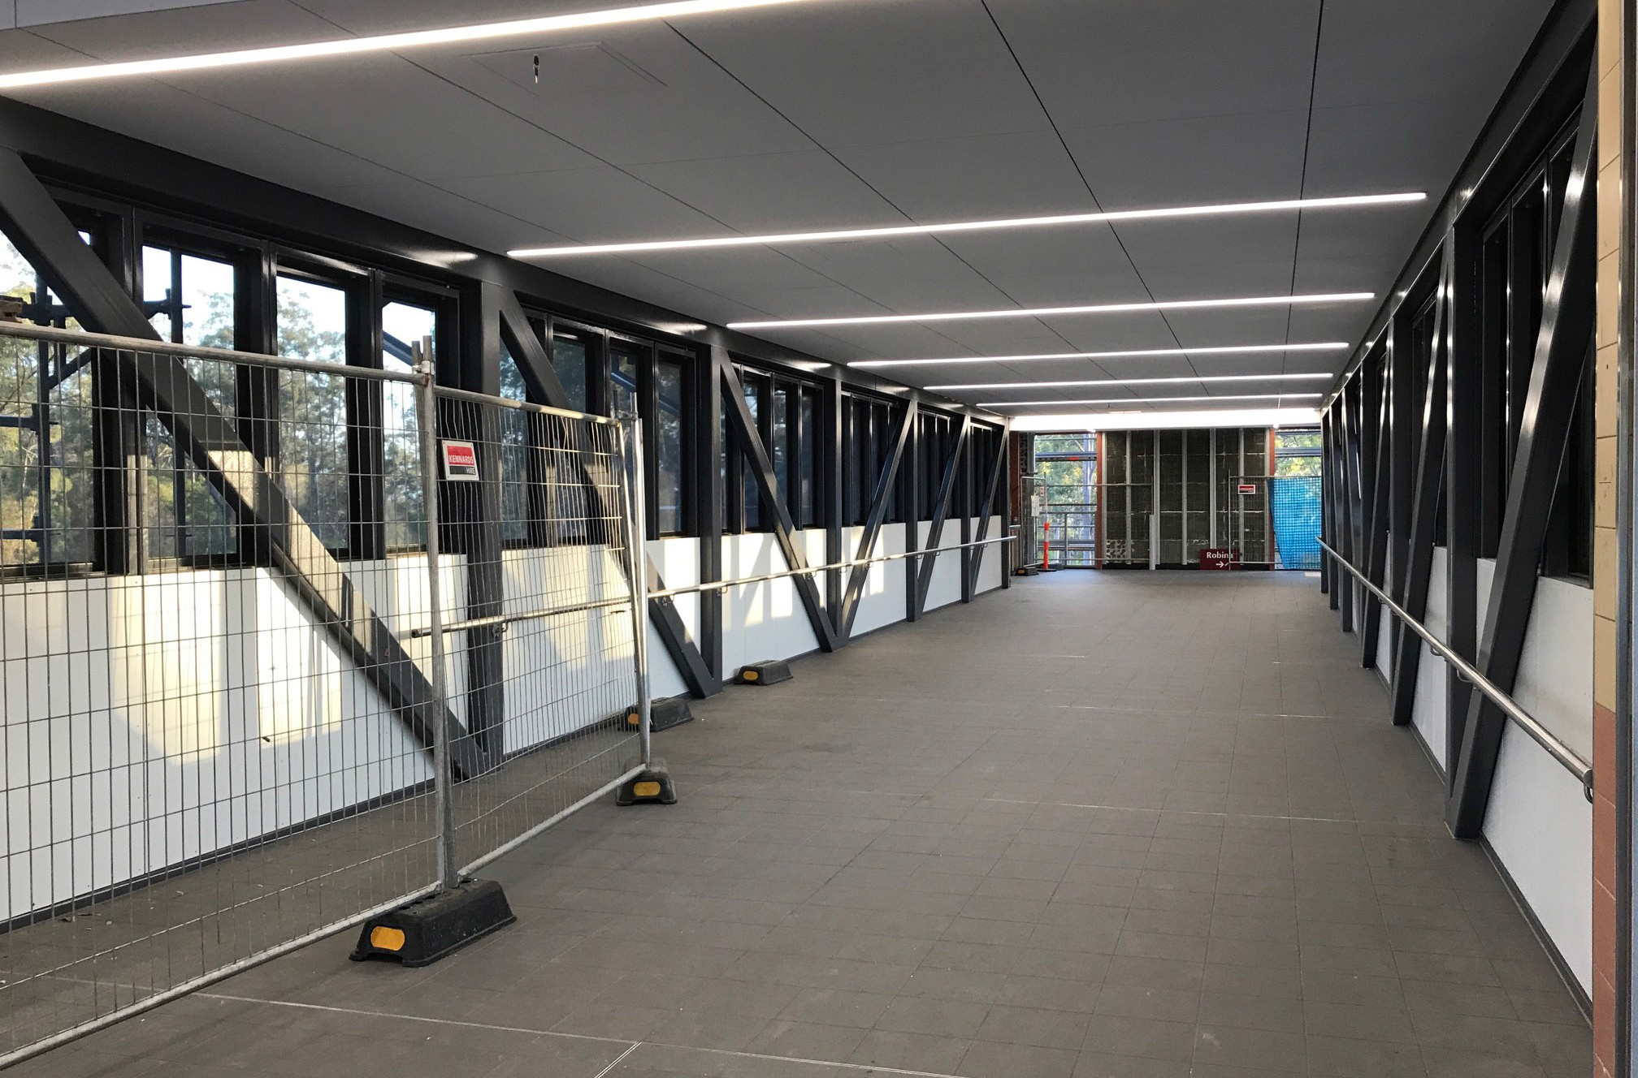Upcoming work
During October and November, customers can expect to see the following works:
- upgrades to lighting in the carpark, station buildings and platforms
- upgrades to CCTV throughout the station precinct, including carparks and entry and exit points
- completion of renewal work at Ormeau by early November.

Keeping you informed
Queensland Rail Limited ABN 71 132 181 090 QR_A3_2017
For more information on this project, please contact Queensland Rail on 13 16 17 (7.15am – 5pm Monday – Friday) or email communityengagement@qr.com.au or visit queenslandrail.com.au

