Temporary
carpark closures

Saturday 14 and Sunday 15 October
Saturday 21 and Sunday 22 October
Saturday 28 and Sunday 29 October

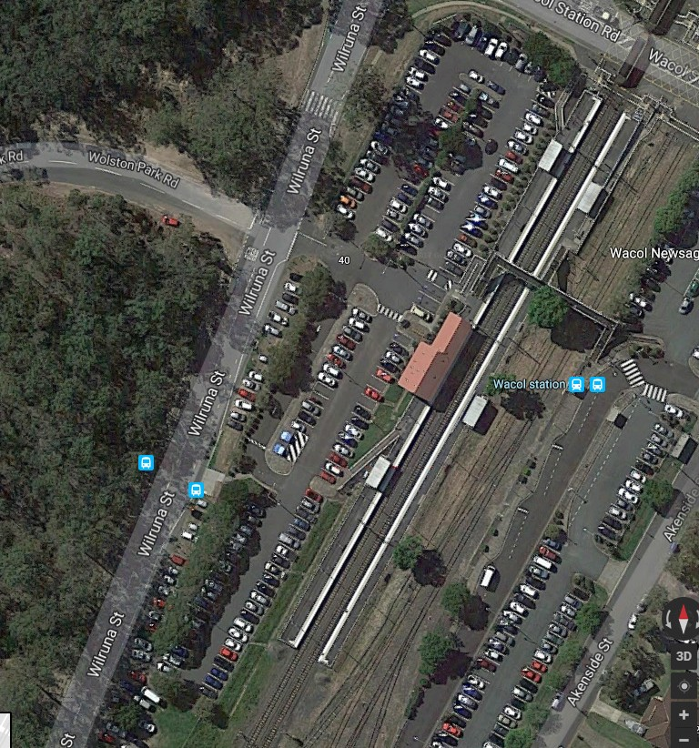The Wacol station carpark will be partially closed during weekends in October to facilitate improvement works including landscaping.
Partial closures
The weekend of Saturday 4 and Sunday 5 November may also be used to complete any outstanding work.
We apologise for any inconvenience as we work to improve your station.

Map courtesy of Google Maps
Queensland Rail Limited ABN 71 132 181 090 QR_A3_2017

If you require assistance with station access call 13 16 17 from 8am to 5pm Monday to Friday or text only 0428 774 636
Visit translink.com.au or call 13 12 30 anytime for more information, updates or assistance out of hours

