Temporary
carpark closure

Full closure – Saturday 7 and Sunday 8 October Partial closures – Saturday 14 and Sunday 15 October
– Saturday 21 and Sunday 22 October
The Wilston station carpark will be temporarily closed to facilitate improvement works including the repair of kerbing.
The carpark will be fully closed during the track closure on 7-8 October to accommodate machinery and vehicle movements. Partial closures (indicated below) will occur on the subsequent weekends.
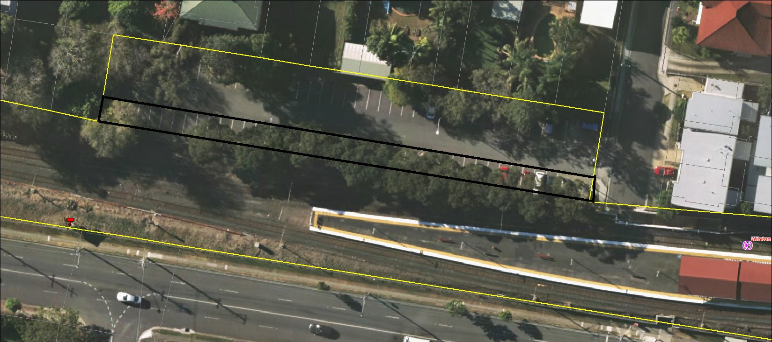We apologise for any inconvenience caused, as we work to improve your station.

If you require assistance with station access call 13 16 17 from 8am to 5pm Monday to Friday or text only 0428 774 636
Queensland Rail Limited ABN 71 132 181 090 QR_A3_2017
Visit translink.com.au or call 13 12 30 anytime for more information, updates or assistance out of hours

