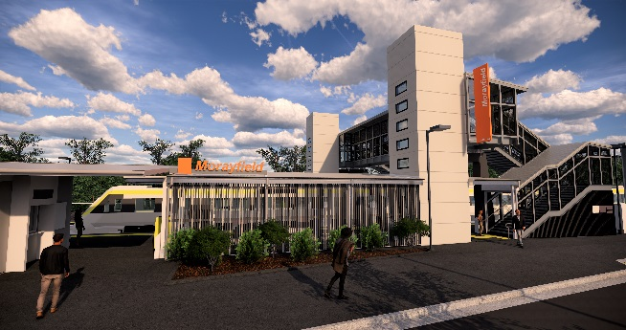
Morayfield station accessibility upgrade

PROJECT UPDATE – APRIL 2019
The Morayfield station accessibility upgrade is part of Queensland Rail’s $300 million program to upgrade stations across the South East Queensland network, making them accessible for all customers.

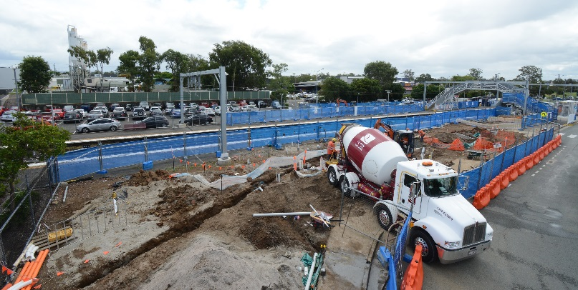

Project progress
Activities undertaken in March included:
- temporary seating and shelter – platform 1
- excavation of foundations for new footbridge and lift shafts
- installation of underground services for new station building.

Upcoming works
This month, customers and the community can expect to see the following activities:
- concrete pour – new raised platform area
- installation of formwork for footings and lift shafts – platforms 1 and 2
- construction of footings and foundations for new footbridge and lift shafts
- concrete pour – lift shaft walls, footings and station building slab
- construction of new station building outer walls
- construction of lift shaft components – offsite.

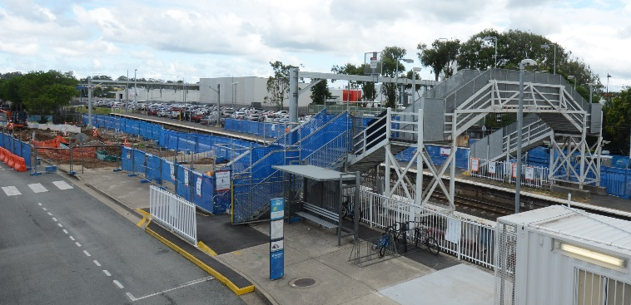
Please take care around the work zones.

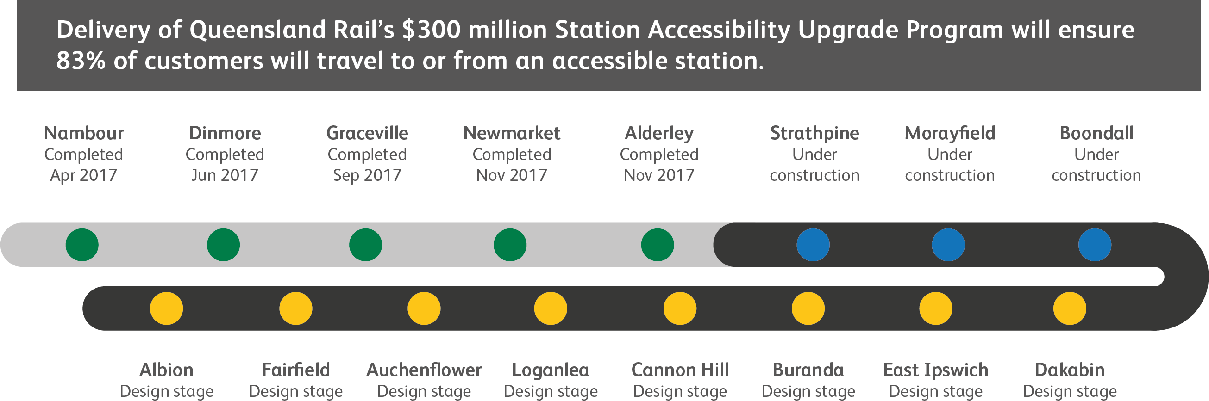

Construction impacts

Normal working hours are 6am to 5pm Monday to Saturday. Construction activities may involve:

noise associated with heavy machinery

temporary changes to station access paths

changed traffic and parking conditions

increased vehicle movements near works

mobile lighting towers for night works.

Residents and the local community will be given advance notification of construction activities likely to cause impacts, including after hours work (nights and Sundays, as required).

We thank customers and the community for your patience and cooperation as we work to improve your station.

Contact us

For more information or to provide feedback:

Phone: 1800 722 203 (free call)

Email: stationsupgrade@qr.com.au

Website: queenslandrail.com.au

