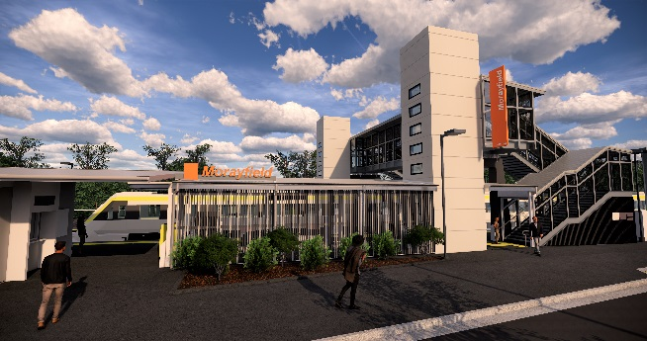
Morayfield station accessibility upgrade

PROJECT UPDATE – FEBRUARY 2019
The Morayfield station accessibility upgrade is part of Queensland Rail’s $300 million program to upgrade stations across the South East Queensland network, making them accessible for all customers.

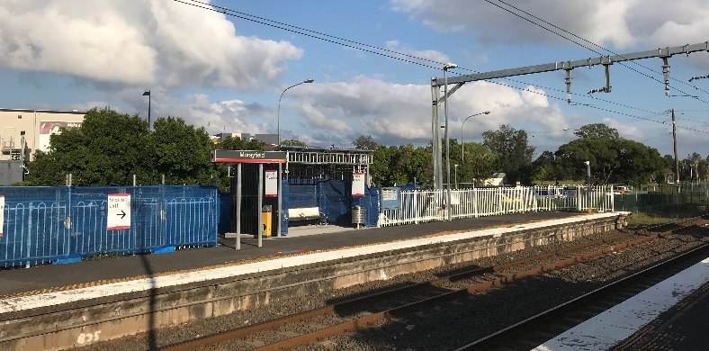

Project progress
Activities undertaken in January included:
- changes to pedestrian access – eastern carpark
- removal of station building and shelter slabs on platform 1
- removal of shelter slabs on platform 2.

Upcoming works
During February, customers and the community can expect to see the following activities:
- foundation works for raised platform sections
- excavation and construction of footings and foundations for new footbridge and lift shafts.

Please take care around the work zones.
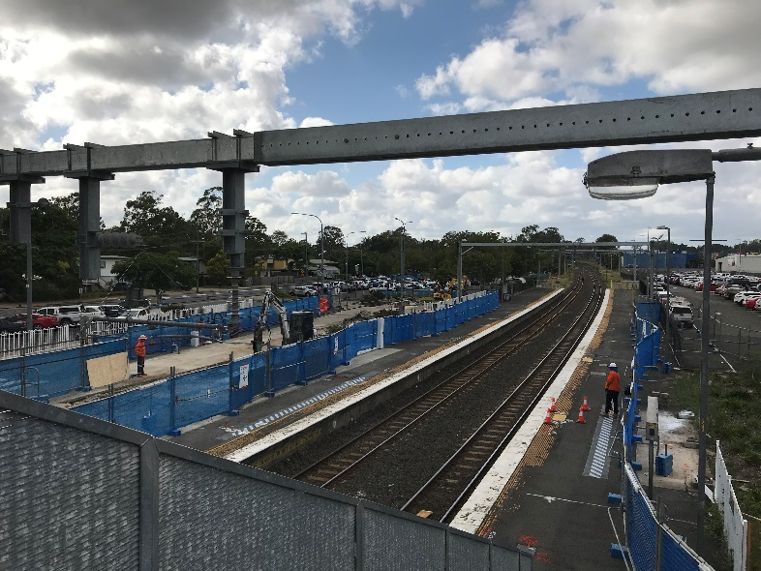

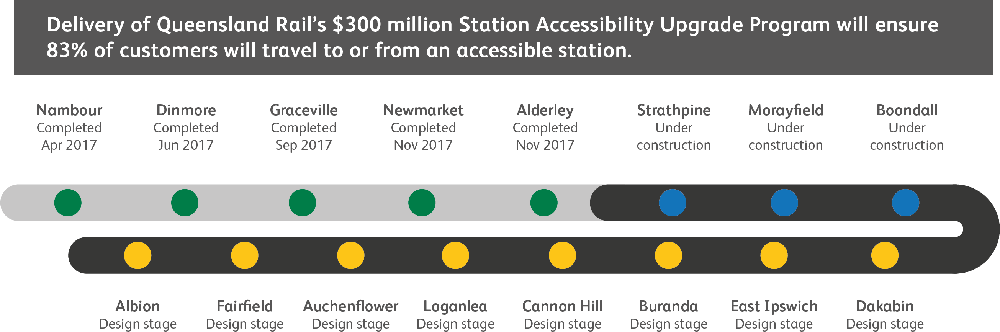

Construction impacts

Normal working hours are 6am to 5pm Monday to Saturday. Construction activities may involve:

noise associated with heavy machinery

temporary changes to station access paths

changed traffic and parking conditions

increased vehicle movements near works

mobile lighting towers for night works.

Residents and the local community will be given advance notification of construction activities likely to cause impacts, including after hours work (nights and Sundays, as required).

We thank customers and the community for your patience and cooperation as we work to improve your station.

Contact us

For more information or to provide feedback:

Phone: 1800 722 203 (free call)

Email: stationsupgrade@qr.com.au

Website: queenslandrail.com.au

