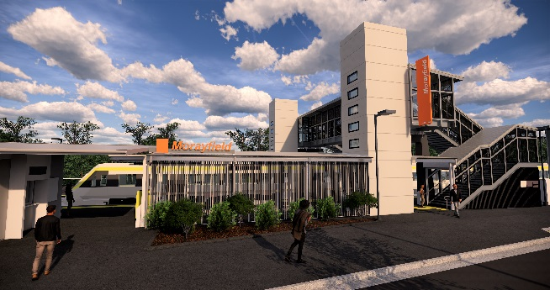

**Morayfield station accessibility upgrade**

**PROJECT UPDATE – FEBRUARY 2020**

**The Morayfield station accessibility upgrade is part of the State Government’s $357 million investment to upgrade stations across the South East Queensland network, making them accessible for all customers.**

**Project progress**

The following activities were recently undertaken at Morayfield:

* opening of the new lifts (early January)
* reopening of bus lane and bus stop shelter
* bicycle enclosure fit-out
* station identification and wayfinding signage
* station entrance, paths and landscaping works.

**Upcoming works**

In the coming weeks, customers and the community can expect to see the following activities:

* final platform surfacing works
* completion of bicycle enclosure fit-out
* bicycle racks – eastern and western sides
* installation of platform furniture
* final carpark and entrance works
* landscaping and fencing.

Please take care around the work zones.

# 

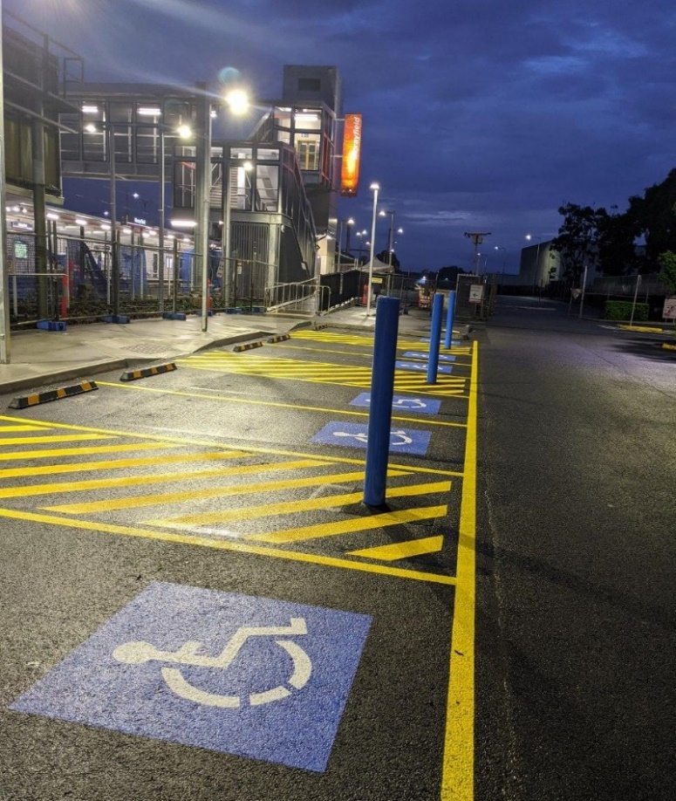

# Construction impacts

# Normal working hours are 6am to 5pm Monday to Saturday. Construction activities may involve:

# noise associated with heavy machinery

# temporary changes to station access paths

# changed traffic and parking conditions

# increased vehicle movements near works

# mobile lighting towers for night works.

# Residents and the local community will be given advance notification of construction activities likely to cause impacts, including after hours work (nights and Sundays, as required).

# We thank you for your patience and cooperation as we work to improve your station.

# Contact us

# For more information or to provide feedback:

# Phone: 1800 722 203 (free call)

# Email: stationsupgrade@qr.com.au

# Website: queenslandrail.com.au