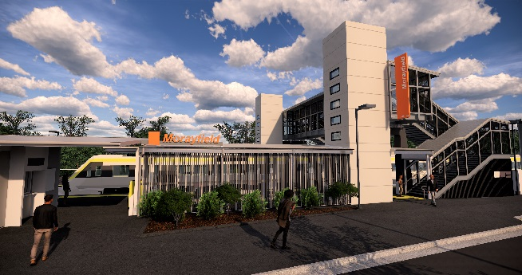

**Morayfield station accessibility upgrade**

**PROJECT UPDATE – JANUARY 2020**

**The Morayfield station accessibility upgrade is part of the State Government’s $357 million investment to upgrade stations across the South East Queensland network, making them accessible for all customers.**

**Project progress**

The following activities were recently undertaken at Morayfield:

* station entrance works – fencing and railings
* ongoing lift installation
* bicycle enclosure construction – roofing
* installation of bus shelter and associated works
* ongoing landscaping works
* opening of the new lifts (early January)
* reopening of bus lane and bus stop shelter.

**Upcoming works**

In the coming weeks, customers and the community can expect to see the following activities:

* bicycle enclosure fit-out
* station identification and wayfinding signage
* station entrance, paths and landscaping works.

Please take care around the work zones.

The station’s platforms will be closed for uninterrupted works over the weekend of Saturday 8 and Sunday 9 February. Rail services will not stop at Morayfield during this time. Regular (15-minute) free shuttle services will take customers to Caboolture to connect with all services (allow an additional 30 minutes’ travel time). Customers departing Morayfield to travel north of Caboolture should see station staff for travel assistance.

# 

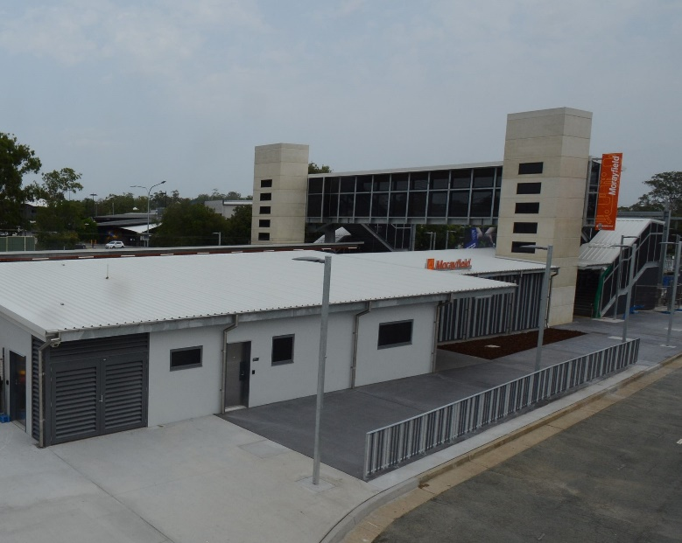

# Construction impacts

# Normal working hours are 6am to 5pm Monday to Saturday. Construction activities may involve:

# noise associated with heavy machinery

# temporary changes to station access paths

# changed traffic and parking conditions

# increased vehicle movements near works

# mobile lighting towers for night works.

# Residents and the local community will be given advance notification of construction activities likely to cause impacts, including after hours work (nights and Sundays, as required).

# We thank you for your patience and cooperation as we work to improve your station.

# Contact us

# For more information or to provide feedback:

# Phone: 1800 722 203 (free call)

# Email: stationsupgrade@qr.com.au

# Website: queenslandrail.com.au