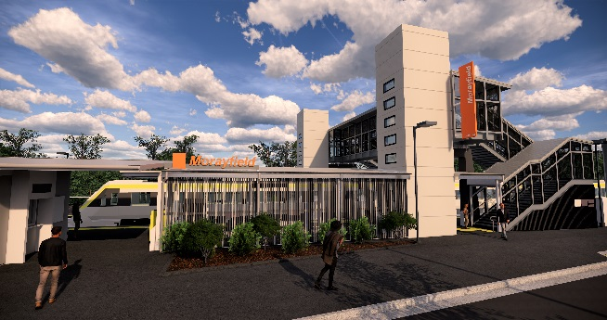
Morayfield station accessibility upgrade

PROJECT UPDATE – JULY 2019

Queensland Rail’s Morayfield station accessibility upgrade is part of the program to upgrade stations across the South East Queensland network, making them accessible for all customers.

Project progress
Activities undertaken recently at Morayfield have included:
- continued station building construction
- concreting – back of platform raising
- underground services
- installation of concrete lift shafts to ground level – platforms 1 and 2.

Upcoming works
In the coming weeks, customers and the community can expect to see the following activities:
- installation of platform roof structure and station building roofing (including night works)
- pre-cast lift shafts and footbridge stairs
- electrical works
- upgrade footpath to platform 2.

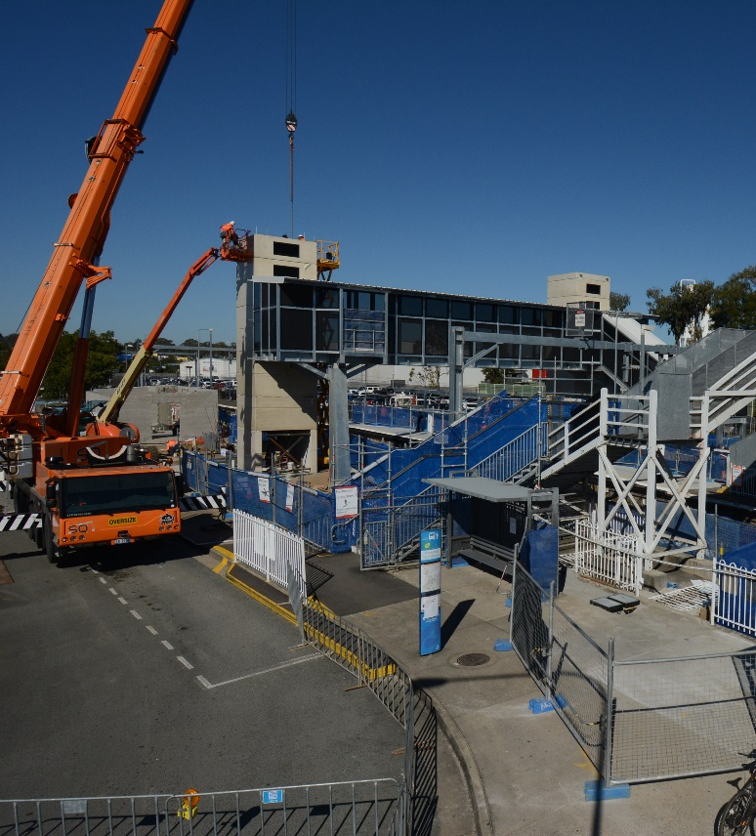
Please take care around the work zones.
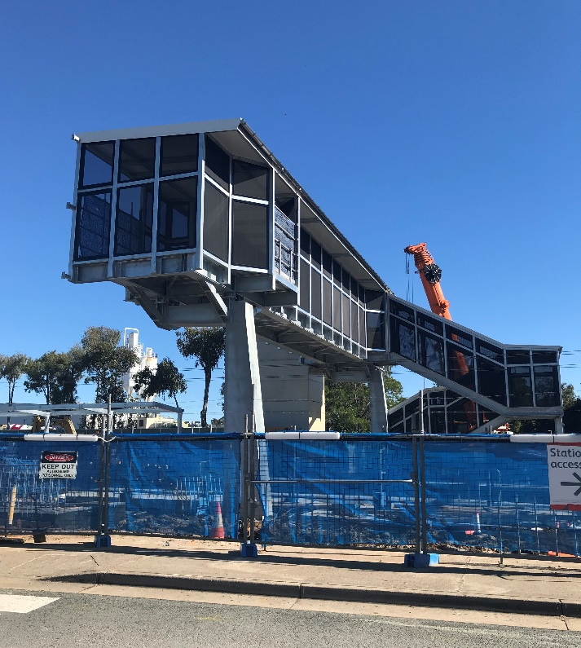

Construction impacts

Normal working hours are 6am to 5pm Monday to Saturday. Construction activities may involve:

noise associated with heavy machinery

temporary changes to station access paths

changed traffic and parking conditions

increased vehicle movements near works

mobile lighting towers for night works.

Residents and the local community will be given advance notification of construction activities likely to cause impacts, including after hours work (nights and Sundays, as required).

We thank you for your patience and cooperation as we work to improve your station.

Contact us

For more information or to provide feedback:

Phone: 1800 722 203 (free call)

Email: stationsupgrade@qr.com.au

Website: queenslandrail.com.au

