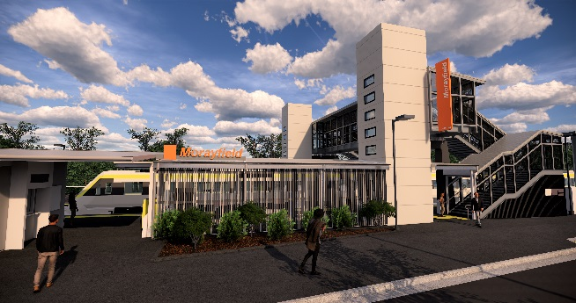
Morayfield station accessibility upgrade

PROJECT UPDATE – MAY 2019
The Morayfield station accessibility upgrade is part of Queensland Rail’s $300 million program to upgrade stations across the South East Queensland network, making them accessible for all customers.

Project progress
Activities undertaken at Morayfield in April included:
- concrete pour – new raised platform area
- installation of formwork for footings and lift shafts – platforms 1 and 2
- construction of footings and foundations for new footbridge and lift shafts
- concrete pour – lift shaft walls and footings
- construction of new station building outer walls
- construction of lift shaft segments (offsite).

Upcoming works
In the coming weeks, customers and the community can expect to see the following activities:
- work on the new footbridge footings
- construction of station building slab
- installation of underground services – platform 2
- construction of lift shaft walls
- construction of new station building outer walls
- construction of lift shaft segments and footbridge (offsite)
- installation of new footbridge (early June).

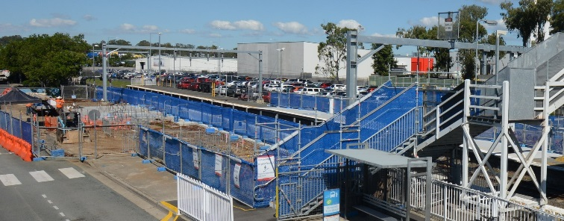
Please take care around the work zones.

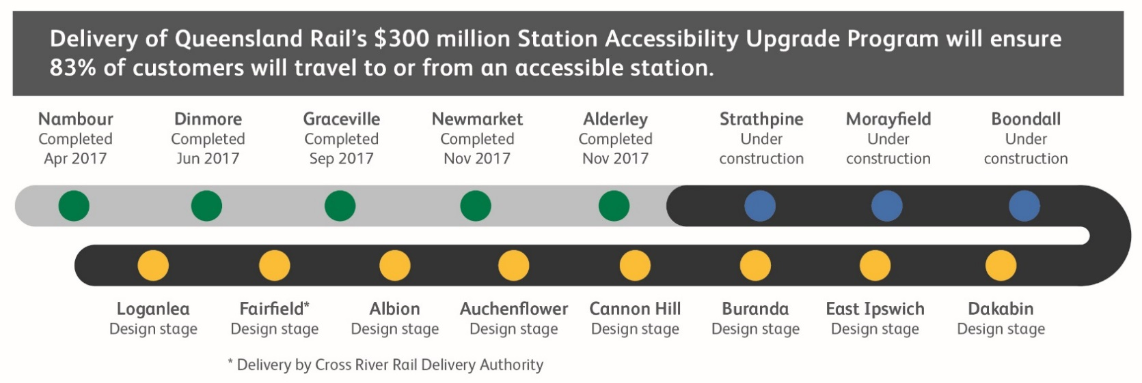

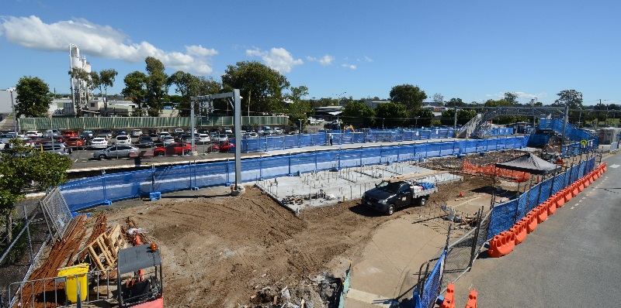

Construction impacts

Normal working hours are 6am to 5pm Monday to Saturday. Construction activities may involve:

noise associated with heavy machinery

temporary changes to station access paths

changed traffic and parking conditions

increased vehicle movements near works

mobile lighting towers for night works.

Residents and the local community will be given advance notification of construction activities likely to cause impacts, including after hours work (nights and Sundays, as required).

We thank you for your patience and cooperation as we work to improve your station.

Contact us

For more information or to provide feedback:

Phone: 1800 722 203 (free call)

Email: stationsupgrade@qr.com.au

Website: queenslandrail.com.au

