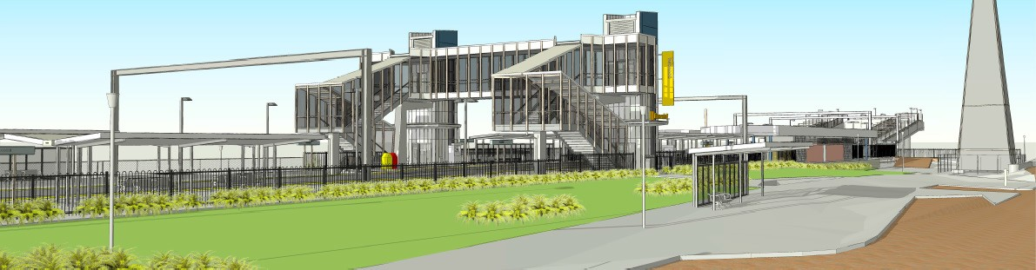Boondall station accessibility upgrade

Queensland Rail is striving to become a modern, customer-focused rail service and is significantly investing to upgrade a number of stations to ensure all customers can travel safely and easily.

As part of the Station Accessibility Upgrade Program, Queensland Rail is making improvements to Boondall station.

These improvements include:
- a new pedestrian footbridge with lift access
- raised section of platform at assisted boarding points
- new and extended platform shelters
- upgraded station entrances, accessible parking and drop-off areas
- a refurbished unisex accessible toilet
- upgraded CCTV and station lighting
- new wayfinding and platform signage.

The project is currently in the design phase and we are seeking your input. Preliminary construction works are scheduled to begin in early 2018 and major construction works from mid-2018.

Queensland Rail is interested to hear your feedback about the Boondall station accessibility upgrade. Feedback forms are available at the station or online (queenslandrail.com.au) and can be handed in to station staff or emailed to the project team.
Queensland Rail Limited ABN 71 132 181 090 QR2017_A4_0517

For more information, contact the project team on 1800 722 203 or email stationsupgrade@qr.com.au

Queensland Rail is moving towards paperless notifications about noise, works and track closures.
Sign up at: queenslandrail.com.au/EmailNotification. You will still be able to receive paper copies if you prefer.

