CENTRAL STATION PROJECT UPDATE
October 2016

CENTRAL STATION UPGRADE PROGRAM OFFICIALLY LAUNCHED

The Premier and Minister for the Arts, the Hon Annastacia Palaszczuk, with the Minister for Transport and the Commonwealth Games, the Hon Stirling Hinchliffe and Minister for Employment and Industrial Relations and Member for Brisbane Central, the Hon Grace Grace, took the opportunity to visit Central station on 5 September to announce that a three-year project to upgrade the station was underway.

While planning and design has been ongoing for some nine months, the construction contract for the first project (Back of House) was awarded
on 25 October to Brisbane firm, Badge.

Badge is working closely with Queensland Rail and pdt Architects under an Early Contractor Involvement (ECI) arrangement to ensure extremely challenging site constraints have been considered and completion target dates for specific portions of the work can be met.

The upgrade of staff facilities (Back of House) will be complete by early 2017 and work on platforms 1/2 and 3/4, including platform raising and modernisation of lifts and escalators to those platforms, must be complete prior to the Commonwealth Games in April 2018.
PROJECT INFORMATION
This station upgrade program will address critical maintenance requirements while at the same time making changes that will position the station for growth.

Opening of the new Redcliffe Peninsula line on
4 October increased the number of trains running through Central station from 4787 to 5173 per week. This number is expected to increase further with the introduction of new signaling technology that will allow trains to run closer together.

The ability to move passengers on and off trains and through the station more quickly, through platform raising, improved reliability of lifts and escalators and better wayfinding on platforms and through the station, are key design elements in this upgrade.

In the 12 months from June 2015 to June 2016, almost 19.3 million passengers boarded or alighted from trains stopping at Central station.

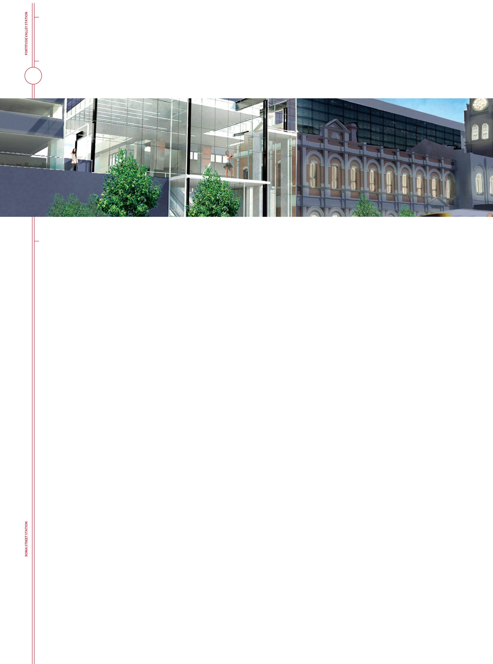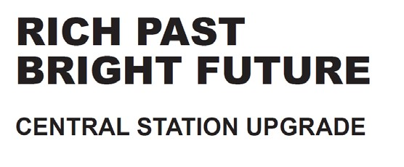
Phone:
1800 401 944

email:
centralstation@qr.com.au

web:
queenslandrail.com.au/centralupgrade

VIRTUAL REALITY TOUR
Brisbane architectural company, pdt, which has worked closely with Queensland Rail and construction company Badge, under an Early
Contractor Involvement (ECI) arrangement, have created three virtual reality renders of their early concept design for the Central station upgrade.

To inspect these visit www.queenslandrail.com.au/centralupgrade and scroll down to virtual reality tours.

A glimpse of Central station history
NEW TILES BEING ROAD TESTED
Queensland Rail staff recently spent time trying to make a real mess of the new tiles chosen for the refresh of the Central station platforms.

After that, they were required to clean them up, using the standard products routinely used to clean these station surfaces.

If you would like to see what’s planned to replace the existing floor tiles on platforms 1 to 6 , walk right up to the Roma Street end of Platform 4 and take a look. The tile finish is non slip and we can vouch for the fact that they clean up very nicely.
For those interested in this iconic station’s heritage features, Badge’s site office, to be established in the Wickham Terrace subway, will tell a story.

The images of Old Central station are from Queensland Rail’s own collection of photographs of the State heritage listed building, opened in 1901. Images of the refurbished platforms and the upper concourse’s new roof, are early concept designs.

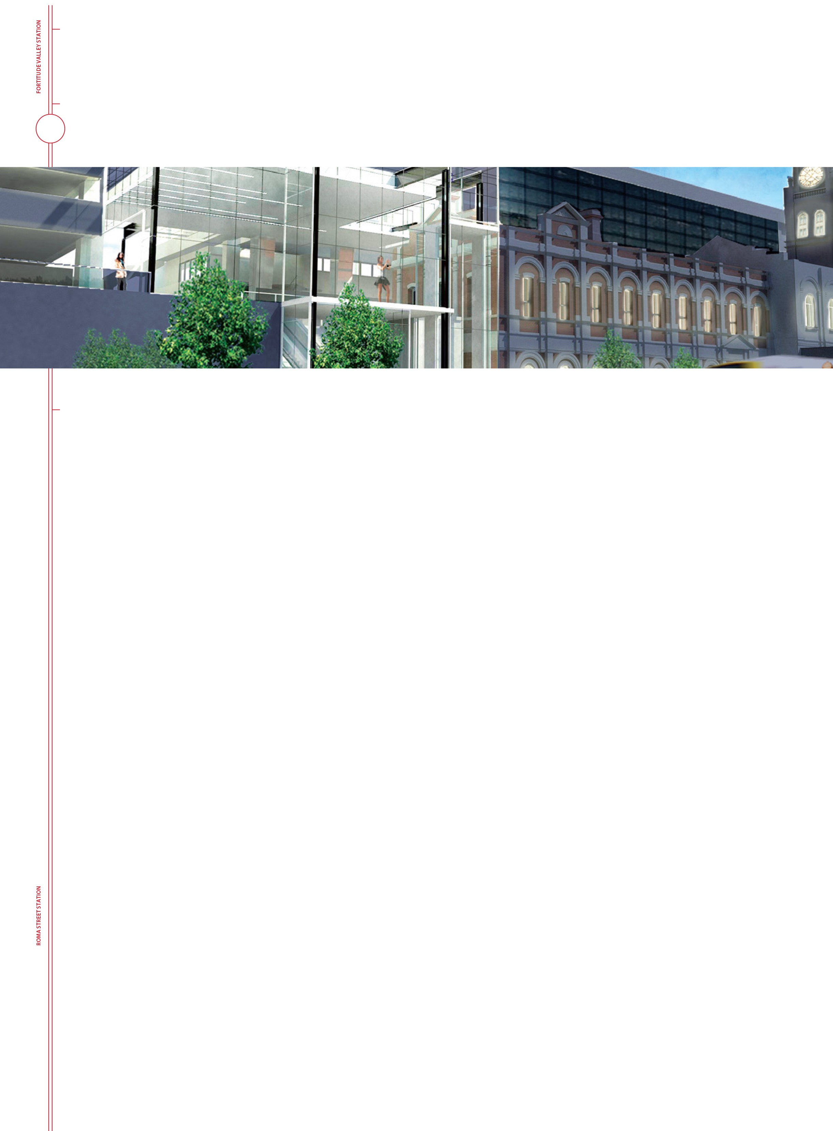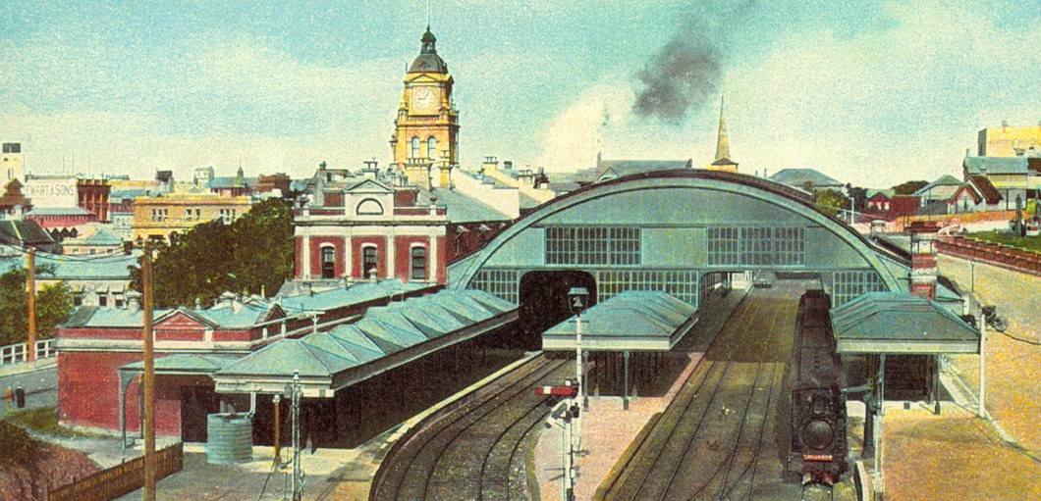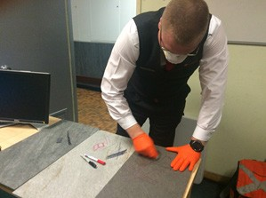These are still to be approved and are subject to change. In particular, investigations into
various aspects of the new roof and glass façade planned for the Edward/Ann Street corner of the station precinct are ongoing and will inform the detailed design phase of the project. This includes discussion with the Office of the Queensland Government Architect in the Department of Infrastructure, Local Government and Planning, the Department of Environment and Heritage Protection and other interested parties.

The proposed design will give Central station a fresh, modern and practical dimension, that also manages to showcase the heritage features of the original Central station building, and show them to best advantage.

A separate maintenance project to restore the old Central station building, beginning with the wall and parapets at the Edward Street end, will commence next year.

BINS TO BE REINTRODUCED AT CENTRAL STATION
Queensland Rail has sourced new bins that will be installed on the platforms at Central station before the end of the year.

Rubbish bins were removed from Central station before the G20 summit was held in Brisbane in November 2014.

We’ve been listening to feedback from our customers and working hard to find new bins with additional security features that meet safety standards. The new bins will enhance convenience for both customers and staff at this busy station.

