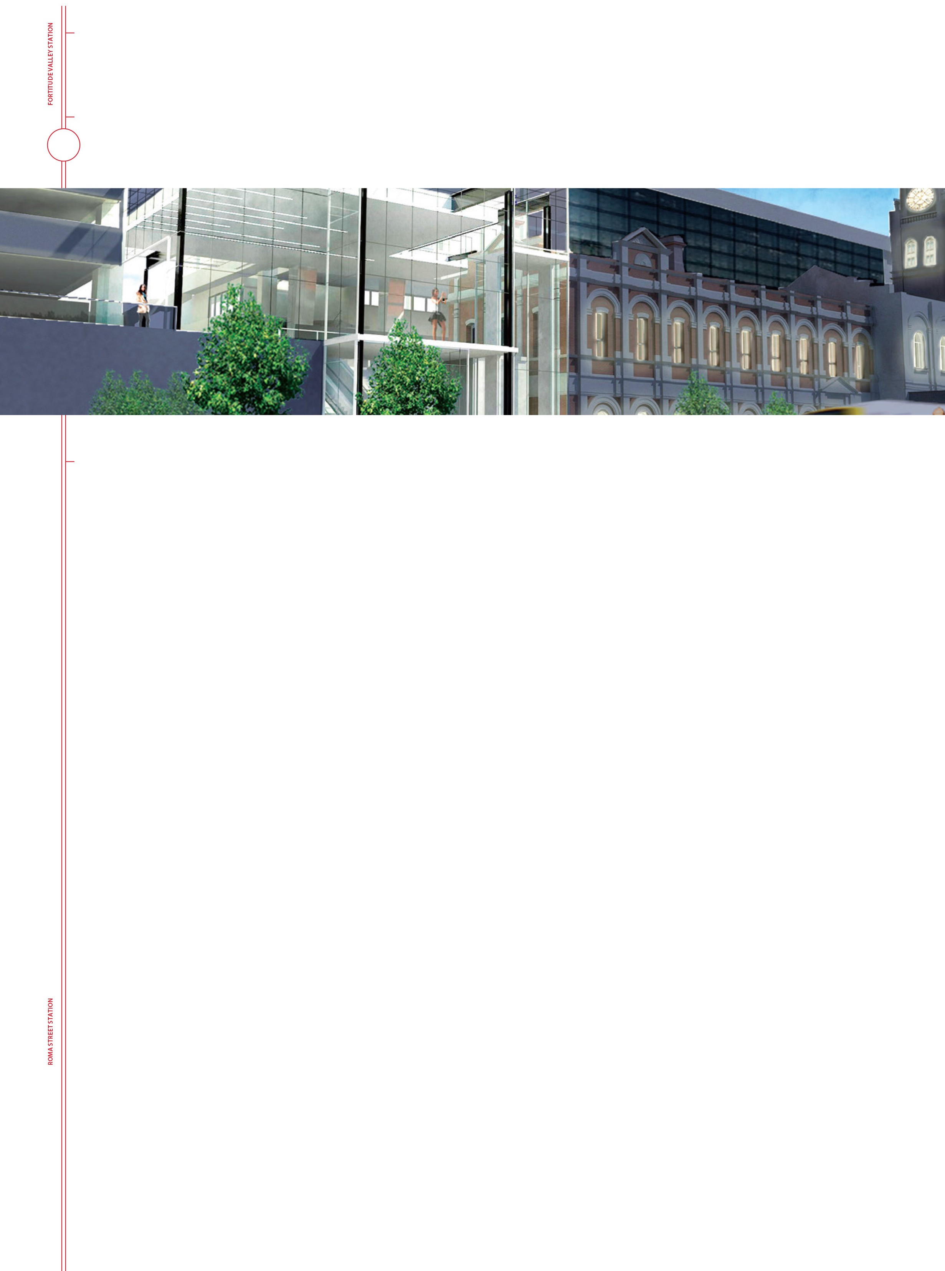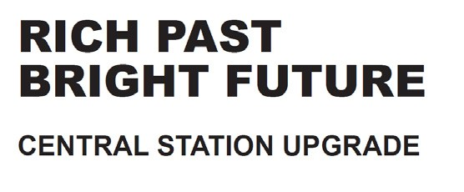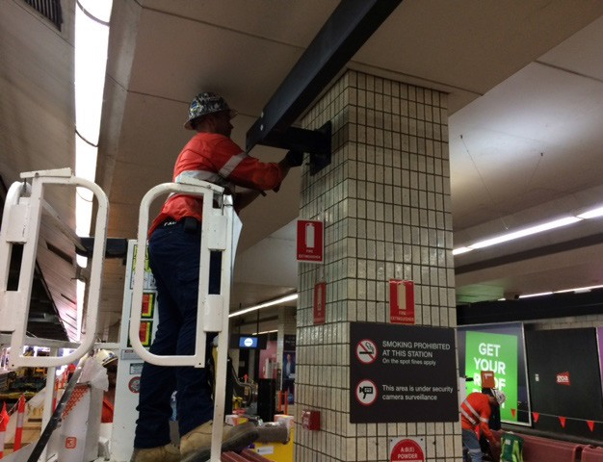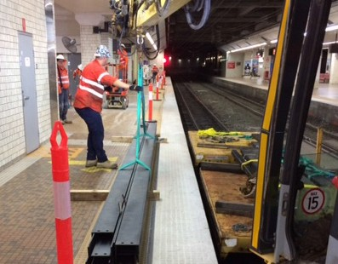
CENTRAL STATION PROJECT UPDATE
February 2017

PLATFORM RENEWAL EARLY WORKS
Early works on Platforms 1/2 to 3/4 began in January so that once the construction tender is awarded the successful tenderer can hit the ground running.
Opening the platform ceilings to identify all of the services running through them, and moving them to a temporary location while the platforms are being renovated, is a time consuming task involving numerous service providers.
The services are being relocated into cable trays suspended from temporary steel beams being fixed to the columns on Platforms 1 to 4. Other items such as timetable screens and CCTV cameras, will also be fixed to this temporary framework.
Each steel beam is up to 8m long and weighs up to 160kg. Transporting these to Central station at platform level is itself a major logistics challenge.
The steel is delivered by truck to the nearest rail corridor access point at Newstead. From there it is transferred onto a special high-rail vehicle which travels via Fortitude Valley to Central station and offloaded at below-ground platform level for installation.
Located as it is in the Brisbane CBD, bounded by Turbot, Edward, Ann and Creek Street, with six platforms located below the Sofitel and rail tunnels at either end, moving all of the materials required for this station upgrade, onto and off site, adds a significant level of complexity to this construction project.

Images show the delivery of structural steel (top) and steel beams being fixed to platform columns (bottom).

EARLY WORKS BEGIN ON PLATFORMS
The ceilings over Platforms 1/2 and 3/4 will be opened over the next few weeks so that the services running through them can be temporarily relocated. These areas have been
thoroughly investigated, and extensive planning has been done to manage dust and eliminate any hazard for customers and station staff.
One of the mitigation measures being investigated is the installation of a ceiling to floor curtain on Platform 4, which can be drawn along the length of the platform to form an exclusion zone to contain dust and noise while Platforms 5 and 6 remain operational. The curtain can be retracted on completion of each

work session to allow normal train operations on Platform 4.
Image shows a retractable construction screen being used
in an aircraft hanger. A similar curtain is being investigated for the platform works.

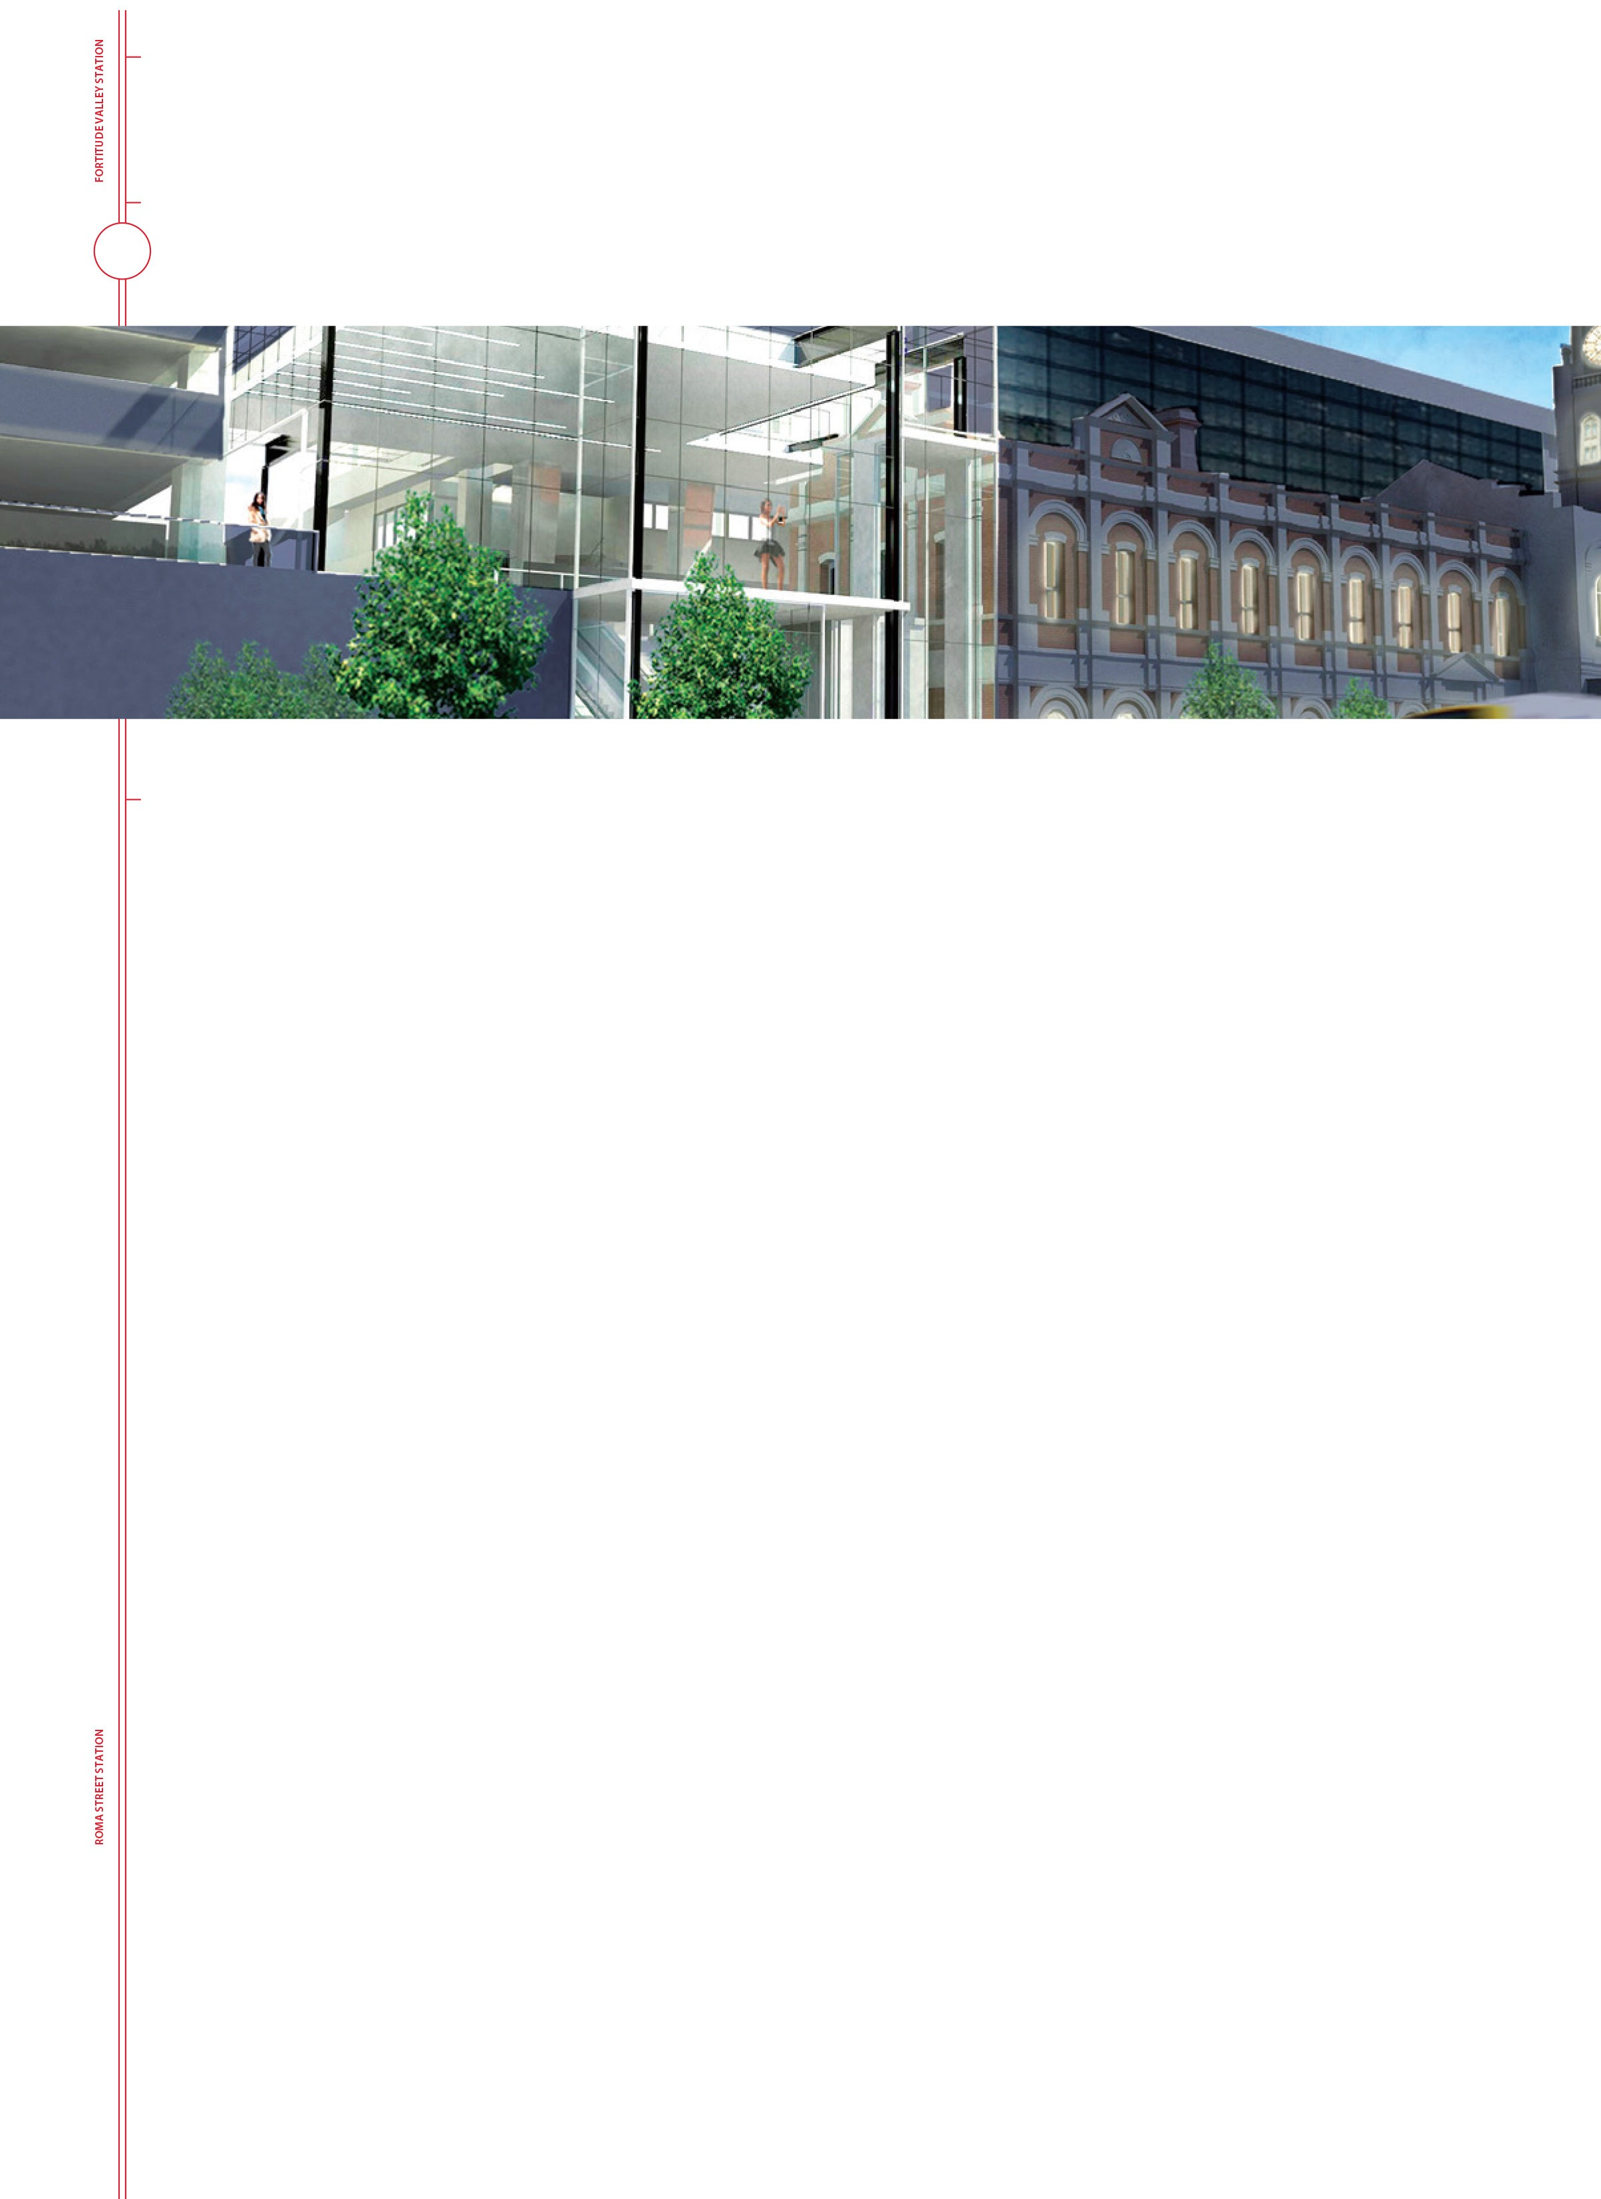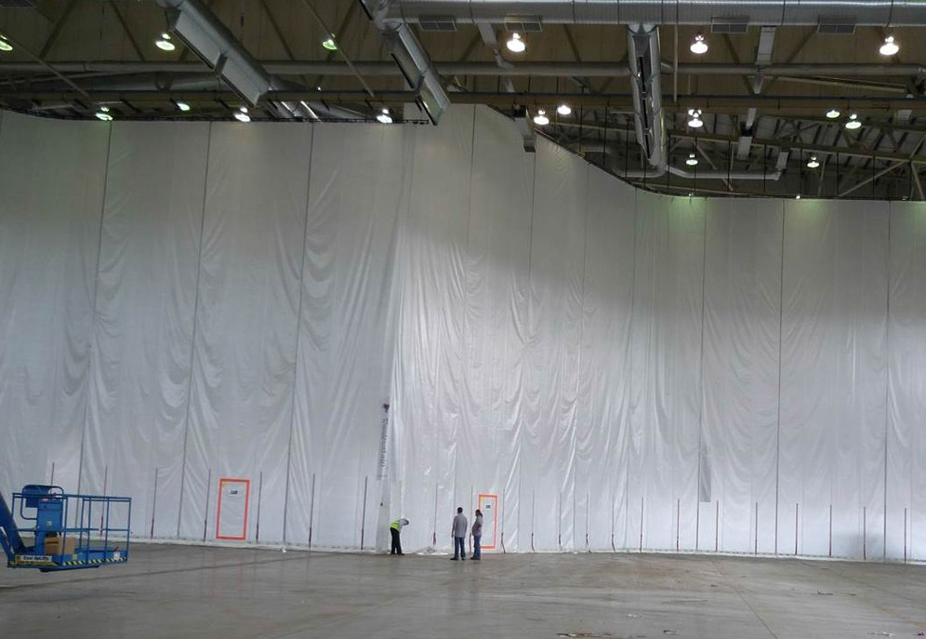BACK OF HOUSE ON SCHEDULE
centralstation@qr.com.au
queenslandrail.com.au/centralupgrade
The renovation of the Back of House area at Central station, which began in November 2016, is on track, with Stage 1 handed over in January.
Stage 1 included the reconfiguration and upgrade of facilities for more than 60 station staff who operate in three separate shifts over every 24 hour cycle, seven days a week.
Work is progressing well on Stage 2 which includes an expansion of the Operations Room, which is the control centre for all train information for Central, Roma Street and Fortitude Valley stations.
Project completion is scheduled for early April.
Not visible to the public, but an important component of the overall station upgrade is the renewal or upgrading of electrical, hydraulic and telecommunication services to improve reliability, support increased demand and decrease maintenance requirements.
A complete upgrade of electrical switchboards and wiring in the Back of House area, also involving parts of the inner concourse, is almost complete. This work, which involved
PROJECT INFORMATION
Phone:
a full electrical shutdown of the station, was undertaken in a small window, after last train and before first train next morning, so that train services were not interrupted.
email:
web:

Changes coming up on Platforms 1-4
The news kiosks on Platforms 1/ 2 and 3/4 will close permanently at the end of March.
The space currently occupied by these kiosks will be used by the contractor to assist with project delivery, and in the final design will be the location for a new platform-based staff and customer service point.
It is part of a re-design that will also see station seating and other facilities, such as Passenger Information Display Screens, vending machines, wayfinding signage and advertising relocated,
to streamline the customer experience and accommodate the increased forecast in passengers using the station.
Platforms 1/2 and 3/4 will all be raised to allow entry level boarding of trains. Platforms 5/6 are already at raised platform height.
1800 401 944

