CENTRAL STATION PROGRAM UPDATE
September 2016

BIG UPGRADE PROGRAM FOR OUR BUSIEST STATION

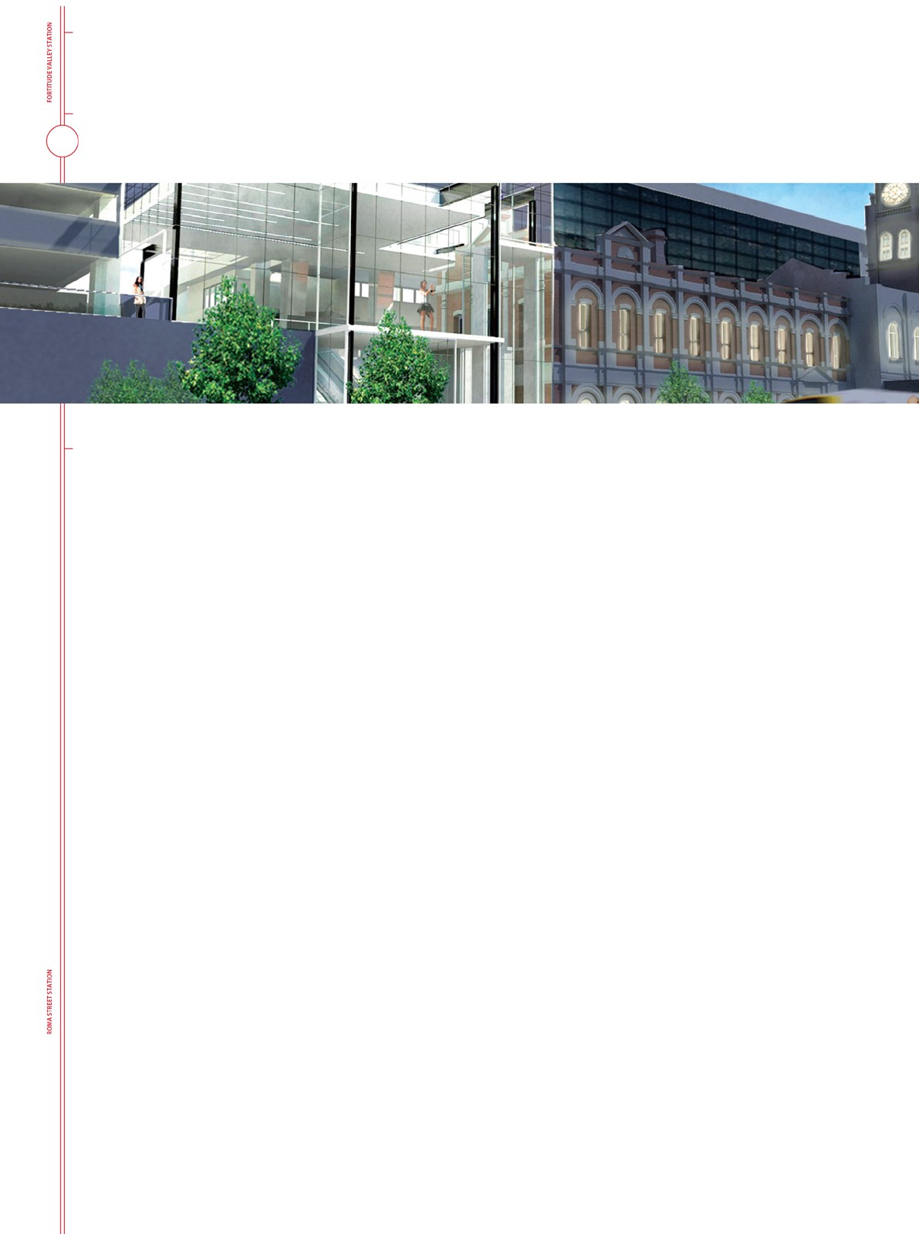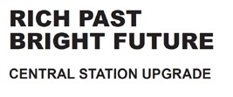The upgrade of Central station comprises a program of works involving the staged delivery of five separate projects over three years, beginning in September 2016.

Its purpose is to revitalise and modernise Brisbane’s most highly patronised station and replace or upgrade all of the services and facilities that are life expired and contribute
to an expensive and constantly growing maintenance program.

All of the platforms will be upgraded to create an efficient, uniform and modern new look expected of a premium station.

Platforms 1/2 and 3/4 will be raised to enable level entry boarding (Platforms 5/6 are already high level) and roof extensions over these platforms at the Fortitude Valley end will provide more shelter.

Platform escalators, lifts and stairs will be modernised.

A new roof over the upper concourse will create a lighter, brighter feel for this important Brisbane CBD landmark and showcase some of the heritage features of the original Central station building bounded by Edward, Ann and Creek Streets.
In addition to improved wayfinding, pedestrian flow through, the station will be enhanced by the replacement of two existing escalators and the installation of a third at the Edward Street end of the upper concourse, increasing station access via the ANZAC Square subway. The lift in this area will also be upgraded.

Platform and upper concourse works are expected to be delivered concurrently, starting with the upgrade of Platforms 1/2 and 3/4 in early 2017 with their completion planned prior to the Commonwealth Games in April 2018.

FAST FACTS
- Central station is 127 years old
- It is the busiest station on the SEQ Network

- Almost 5,000 trains per week pass through Central on two main lines and four suburban lines

- Up to 140,000 passengers get on or off at Central each weekday

- 60 staff work three shifts per day to maintain the station and provide customer service

- All public address announcements for Central, Roma Street and Fortitude Valley are made from the communications room at Central station

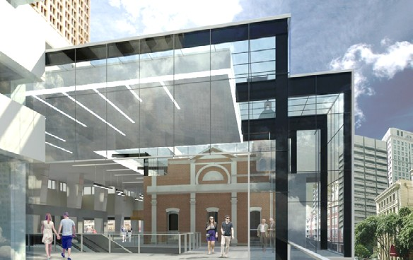
pdt Architects’ concept drawing of the new Edward Street station entrance. The addition of a third escalator and the extension of the roof over this area will assist with passenger flow in the upper concourse area.

WHERE DO WE START?
The Central Station Upgrade will begin in September with the complete renovation of the area used by the station staff for daily station operation.

This ‘back of house’ work is expected to take three months, with no impact on train services and very little activity visible to the public.
Phone:

Some early investigative works for the other projects, such as location of services in ceiling spaces in the upper concourse and platform areas, will take place before project commencement in February/March 2017.
email:
web:

SITE OFFICE
A site office will be established in the northern subway connecting with Wickham Terrace, and is expected to remain for the duration of the program. Public access to Wickham Terrace via lift and stairs will be maintained at all times.

Traders in this area will not be affected. Access to all businesses will be maintained and sight lines will be uninterrupted so that it’s clear to the public that it’s BAU on the concourse.

PROJECT DELIVERY
The ‘back of house’ renovation at the station will involve a 24/7 program of works.

Work on the platforms will largely occur during scheduled weekend closures, with some night works where these can be completed in the short window between the last and first train.

An estimated 750 people will work on this project during the three year design and construction period.

The station will remain operational throughout the upgrade and normal peak hour services will be maintained.
PROJECT INFORMATION
1800 401 944
centralstation@qr.com.au

HISTORY
queenslandrail.com.au/centralupgrade
1889 The line between Roma Street and Brisbane Central connected. Central station was a humble timber and galvanised iron structure with two passenger platforms
1899 Contract awarded to build a new ‘grand design’ station
1901 The elegant new building completed. (Now the State heritage listed Old Central building)
1930-31 Extension of subway under Ann St to Anzac Square
1963 Removal of the vaulted station roof and construction of awnings over each platform.
1968-70 Construction of office towers over platforms at Edward St end of station and development of modern pedestrian retail concourse behind the old station building.
1980s Construction of Sheraton Hotel (now Sofitel) over the centre of the station
1996 Platforms 5 and 6 opened.

