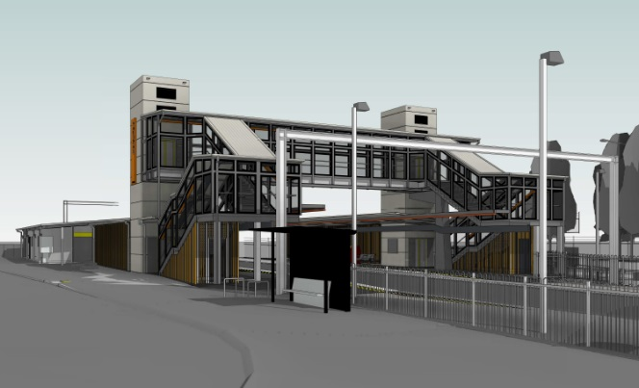
Morayfield station accessibility upgrade

PROJECT UPDATE – DECEMBER 2018
The Morayfield station accessibility upgrade is part of Queensland Rail’s $300 million program to upgrade stations across the South East Queensland network, making them accessible for all customers.

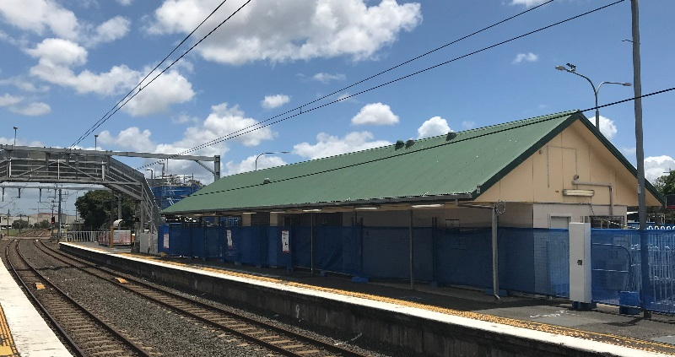
Original station building pre-demolition

Project progress
Activities recently undertaken at Morayfield include:
- changed station access and pedestrian pathways
- modifications to original footbridge stairs to enable construction on platform 1
- disconnection of services (eg. power, water) in preparation for station building demolition.

Upcoming works
In December, customers and the community can expect to see the following activities:
- demolition of station building
- changes to pedestrian access, eastern carpark.

Please take care around the work zones.
Construction of the driveway link between the station carpark and Caboolture Sports Club (pictured below) is complete, with overflow parking arrangements now in operation.
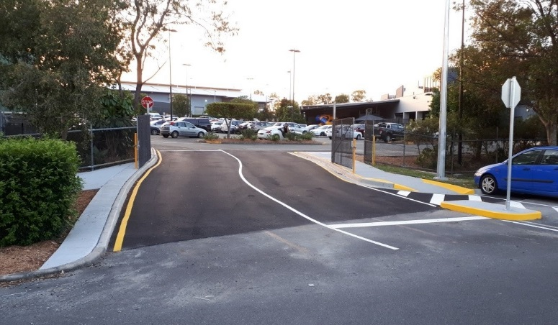

New driveway linking carparks

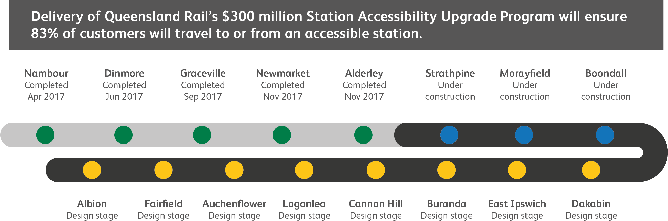

Construction impacts

Normal working hours are 6am to 5pm Monday to Saturday. Construction activities may involve:

noise associated with heavy machinery

temporary changes to station access paths

changed traffic and parking conditions

increased vehicle movements near works

mobile lighting towers for night works.

Residents and the local community will be given advance notification of construction activities likely to cause impacts, including after hours work (nights and Sundays, as required).

We thank customers and the community for your patience and cooperation as we work to improve your station.

Contact us

For more information or to provide feedback:

Phone: 1800 722 203 (free call)

Email: stationsupgrade@qr.com.au

Website: queenslandrail.com.au

