1 June to 30 June 2017
Signals Upgrade Project
As a valued neighbour, we are committed to keeping you informed about work Queensland Rail is doing in your area. This notice is a four-week look ahead outlining planned work for our Signals Upgrade Project and approximate locations, so you are fully informed.
The nature of this work is such that there will be little to see, but there will be construction noise and traffic impacts, particularly around those points where we require access to the rail corridor.
We apologise for any inconvenience and thank you for your understanding while we dig trenches, lay cables, move overhead electrical wires and install new signalling equipment on the line between Roma Street and Corinda.
Milton to Graceville day works
From 6am to 6pm each day, Monday to Saturday.  - Installation of new power, communications and signalling cables  - Installation of signalling equipment foundations and associated excavations. | 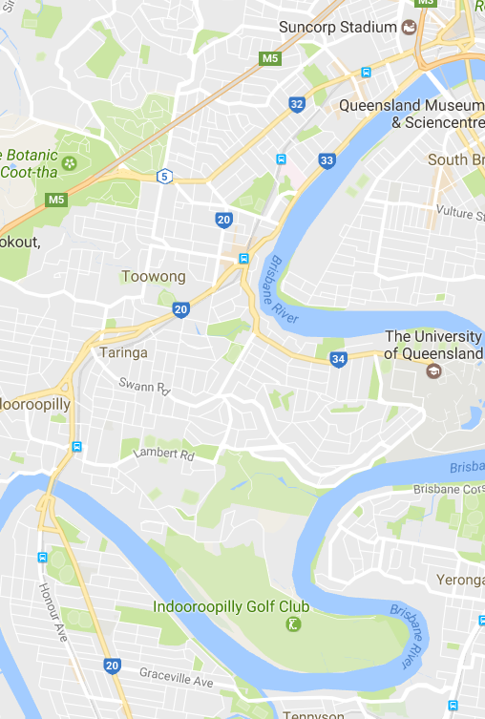
What to expect
Some noise from on-track machines and construction crews, vehicle movements and traffic control in surrounding streets.

Indooroopilly to Auchenflower day works
From 6am to 6pm each day, Monday to Saturday.

- Installation of new track equipment.

What to expect
Some noise from on-track machines and construction crews, heavy vehicle movements and traffic control in surrounding streets.
May 2017 – Progress update
During May, significant infrastructure works were completed for the project, including:
- Installation of 90 new signals on portals between Roma Street and Corinda.
- Completion of new overhead wiring for the new track works at Milton and installation of new transformers at Auchenflower.
- Installation of 20 linear kilometres of new cables.
- Installation of 10 new signalling equipment footings between Graceville and Auchenflower.
Queensland Rail will make every effort to carry out its works with minimal disruption. We encourage you to contact us with your phone or email details so we can ensure you are notified of any works that need to take place outside of normal construction hours, or involve changed traffic arrangements in your area.
This snapshot is broad and subject to change. If you have questions or concerns about specific dates, times or locations, please contact us. We look forward to working with you.

Contact:
Call: 1800 959 989
Email: communityengagement@qr.com.au
For more information about this project visit queenslandrail.com.au/inthecommunity/projects

