Pomona station platform upgrade
Queensland Rail is upgrading and modernising the platform at Pomona station to improve facilities for customers. This is part of a $4 million project to upgrade platforms at three Sunshine Coast line stations, replacing them with more durable platforms.
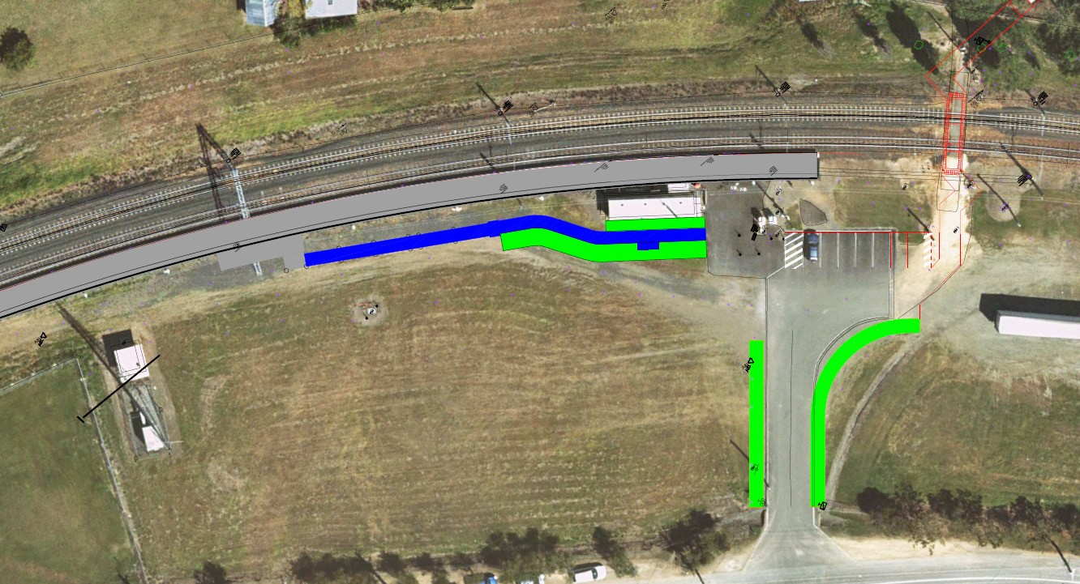
GYMPIE
Bicycle rack
Landscaping
Upgraded carpark with
disability parking bay
Access ramp
Landscaping
Landscaping
Landscaping
and footpath
TransLink
signage
New platform shelter
Heritage seat and plaque
Welcome to station signage
BRISBANE
The upgrade to Pomona station will include a number of additional features such as soft landscaping, a heritage seat and plaque, new entry signage and a disability parking bay. Works will commence in late 2018 and will be completed in the first half of 2019.
For further information or to provide feedback, call 13 16 17 or email communityengagement@qr.com.au
Queensland Rail Limited ABN 71 132 181 090

