Roma Street to Corinda Station Signals Upgrade Project

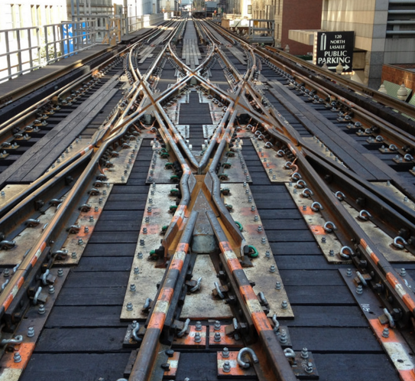
To help future proof Queensland Rail’s network, train signals between Roma Street and Corinda stations will be upgraded and new track crossovers will be installed near Milton station.

Why is the project needed?

The current signals infrastructure on this stretch of the Ipswich line is more than 50 years old, making it difficult and expensive to maintain and integrate with new, sophisticated signalling and train control systems which Queensland Rail is progressively rolling out across its network.
A crossover between two tracks

To support on-time running now and into the future, these works will also involve the installation of two new track crossovers near Milton station. This will allow trains to turn back and be stored (‘stacked’) following the morning peak time, eliminating congestion and potential for delays.
What does that mean?
Crossovers: a point in the track where a train can change from one track to another. These can be electric, air powered or manual and are sometimes called points or switches.
Gantries: the bridge-like structures built over the tracks from which signals are hung. Gantries can be climbed for maintenance and often have in-built ladders.
Portals: similar to gantries but smaller and constructed of metal framing, portals are built over the tracks and house signals. Portals cannot be climbed for maintenance.
SCAS: Queensland Rail schedules a number of Scheduled Corridor Access System (SCAS) closures each year when an entire line or section of line is shut down. During these periods the high voltage electrical systems are switched off and trains do not run, permitting necessary maintenance work to be carried out safely and with minimum inconvenience to rail users.
What is involved?

The project involves the replacement of 16 signalling gantries with signal portals, signal huts and equipment, and trackside cabling and equipment.

The construction of the new track crossovers provides a turn back facility and will allow 16 trains to be stored in the corridor between Milton and Sherwood, and then routed into Mayne Yard after the morning peak time. Installation of the new turn back will require four new turnouts, three Over Head Line Electrification (OHLE) portals and track alignment modifications around Milton station.

The new infrastructure will be built in parallel to the existing system and then switched over. Then, the old infrastructure will be removed.

Work will be staged using normal Scheduled Corridor Access System (SCAS) closures that are usually 48 hours or more of continuous works over a weekend. Some works will occur outside these periods and will have a minimal impact on normal train operations, however, may create some construction noise and traffic.

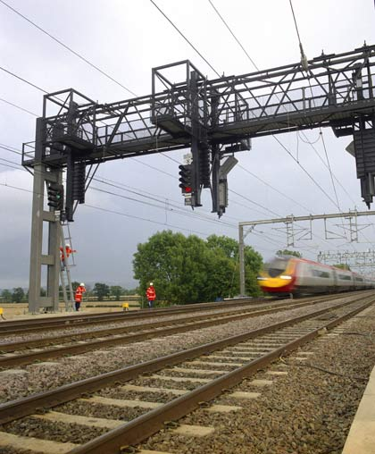
Safety is our priority

Safety is the number one priority for Queensland Rail.

To provide a safe work environment for workers and the community, public access to the construction site will be restricted during the works.

Queensland Rail will be liaising with adjacent residents and property owners to clearly communicate potential construction impacts and ensure safety is maintained at all times.

Construction impacts

While most of the work will be undertaken in the rail corridor, Queensland Rail will require corridor access at critical points along the 12.5 km stretch between Roma Street and Corinda, through which to move machinery and equipment.
A signal gantry

The use of some heavy machinery, such as cranes and excavators, will be required for the installation of signal portals, huts and cabling and the decommissioning of gantries.

Every effort will be made to identify and contact stakeholders immediately adjacent to these access points to explain specific work impacts, make arrangements and confirm agreements (if required), each time access is required.

Residents on local roads adjoining Queensland Rail access points may notice an increase in vehicle movements and Queensland Rail contractor presence in these locations.

Residents and landowners will be given advance notification of periods of heightened activity, temporary access routes, property restrictions, excessive noise or night works in accordance with Queensland Rail’s community engagement guidelines.

Keeping you informed
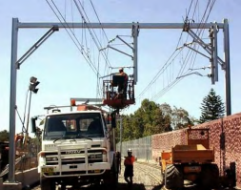
Queensland Rail will endeavour to contact all residents, business owners and special interest groups who may be impacted by this important project and invites all interested stakeholders to provide their contact details for regular project updates.

Queensland Rail will be providing regular look-ahead notices that identify locations for specific activity so that you can plan and let us know in order to minimise potential conflict.

This regular newsletter will be distributed to adjacent properties and businesses, as well as being published on the Queensland Rail website at queenslandrail.com.au/inthecommunity/projects.
A signal portal

For more information about this project, please phone 1800 399 222 (between 8am and 5pm, Monday to Friday) or email communityengagement@qr.com.au .

