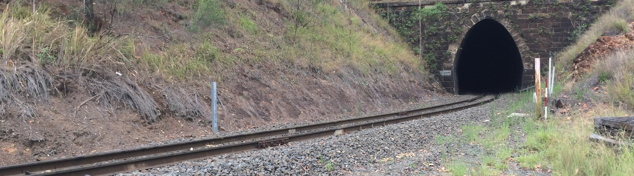Works notice
Toowoomba Range Clearance Upgrade

Queensland Rail is preparing for tunnel floor lowering works through 11 rail tunnels on the Toowoomba Range and Little Liverpool Range. This project is being undertaken to provide clearance for international standard size containers which will support the agricultural industry by enabling the transport of agricultural freight via rail from the Darling Downs and South West regions of Queensland through to the Port of Brisbane.

In addition, works will also be carried out at two sites on the Toowoomba Range to secure identified sections of slope to enable the ongoing safe operation of rail traffic in this area.

What is involved?

During scheduled track closures in January and February 2017, Queensland Rail will undertake site investigation works at all 11 tunnel locations and two slope stabilisation sites. These works will involve visual inspections and drilling activities and will be undertaken from 6am to 6pm each day between:

Saturday 14 to Sunday 15 January
- Friday 27 to Sunday 29 January
- Saturday 25 to Sunday 26 February.

Vehicles will be accessing the Toowoomba Range rail corridor via a number of locations including Murphys Creek Road (adjacent to Morleys Road), McCormack Drive and Donnellys Road.

Following these site investigation works and upon completion of the project design, it is anticipated that major construction works will commence in mid-2017.

Construction impacts
Queensland Rail Limited ABN 71 132

Residents in close proximity to the rail corridor may experience an increase in noise during planned works.

Queensland Rail apologises in advance for any temporary inconvenience generated by these works.

Works location

Nine of the 11 tunnels are located on the Toowoomba Range, indicated by blue arrows in the image below. The remaining two tunnels are located on the Little Liverpool Range adjacent to Laidley Rosewood Road in Laidley.

The two slope stabilisation sites are indicated on the map in dark orange and are located to the east of Spring Bluff station.

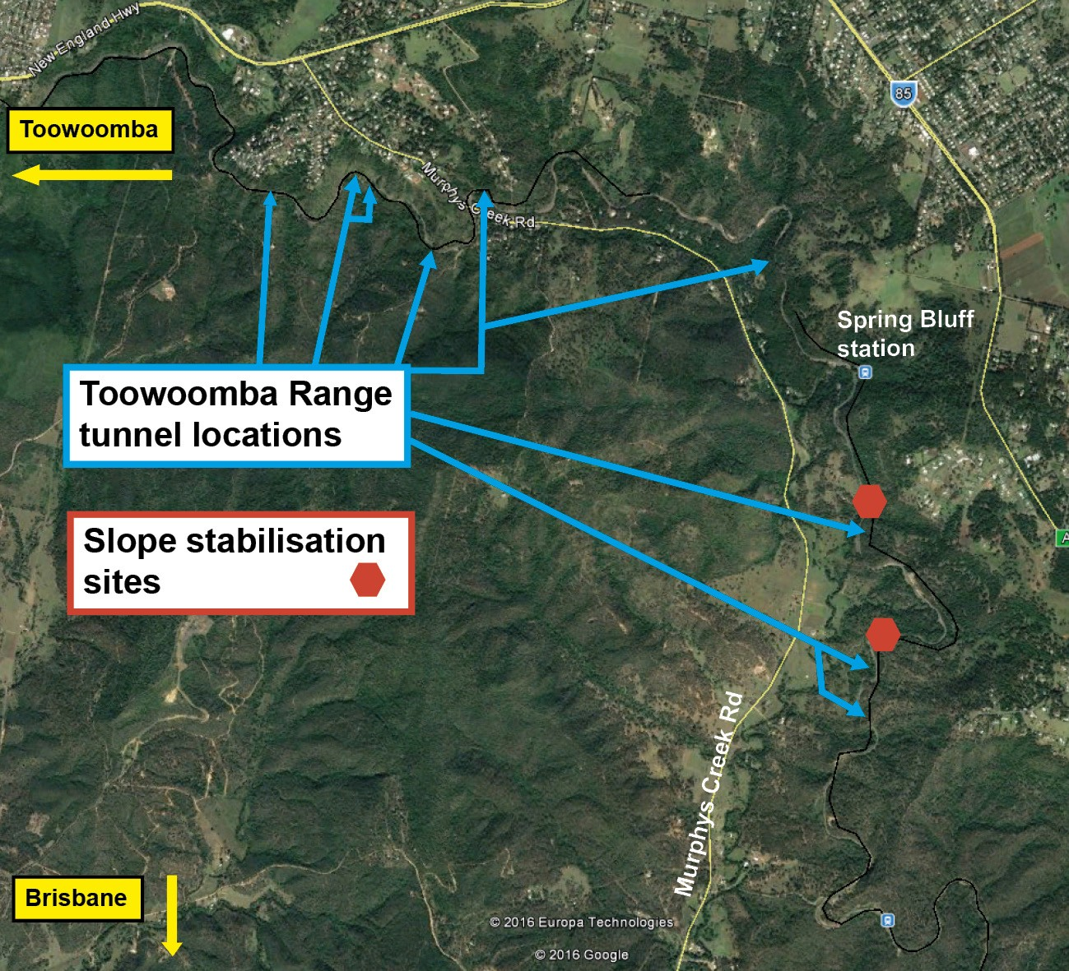

Keeping you informed

Queensland Rail is committed to keeping stakeholders and the community informed about the Toowoomba Range Clearance Upgrade and Slope Stabilisation project.

For more information, please phone 13 16 17 (between 8am and 5pm, Monday to Friday) or email communityengagement@qr.com.au.
Queensland Rail Limited ABN 71 132

