Temporary car park closure Shorncliffe station
From mid-November 2017

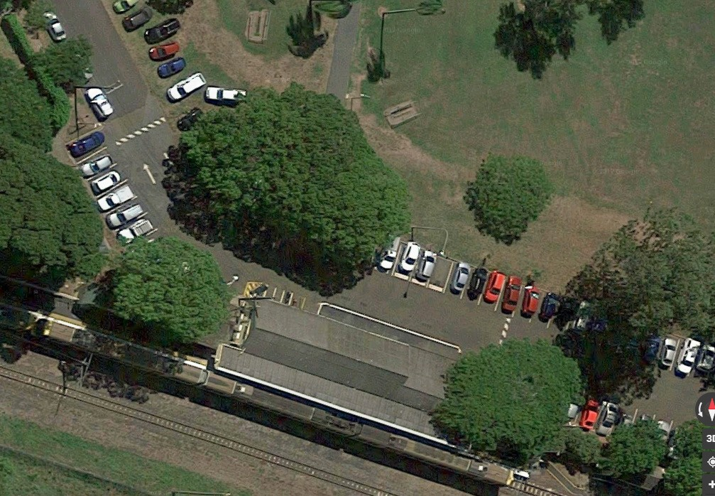Queensland Rail will be constructing temporary station facilities and access paths which requires the closure of approximately 12 car parks from mid-November, as shown in the image below. Seven of these parks are expected to be reinstated once the temporary station access is opened to customers, around mid-December 2017.
Car parks closed during
establishment of
temporary facilities
Car parks closed for
duration of project works

Image courtesy of Google Maps

Car parks highlighted in pink will remain closed until the completion of project works, in 2019.
Queensland Rail Limited ABN 71 132 181 090 QR2017_A4_0417
Queensland Rail apologises for any inconvenience.
For further information, please contact 13 16 17 (between 7.15am and 5pm Monday to Friday) or email communityengagement@qr.com.au

