North Johnstone River bridge remediation works

December 2015 to January 2016

Queensland Rail is undertaking remediation works on the North Johnstone River rail bridge on the North Coast line, approximately one kilometre south of Daradgee.
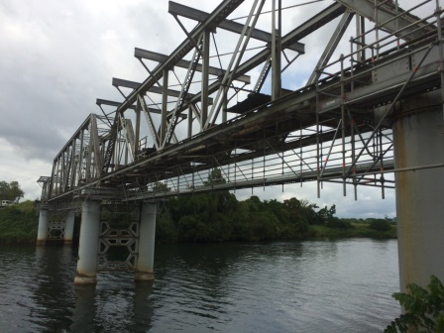
The remediation works are necessary to ensure safe, timely and adequate rail services continue to be provided to the North Coast line between Townsville and Cairns.

The full program of works will take place over a four-year period, weather and construction conditions permitting.

Upcoming activities planned for December 2015 and January 2016 are listed below.

Works may occur between 6am and 6pm Monday to Saturday.

Overview of work

Approximate date | Activity | Type of work
December 2015/ January 2016 | - Surveying  - Inspections  - Monitoring | - Surveying of bridge  - Scaffolding certification  - Site inspections  - Delivery and installation of monitoring equipment on bridge  - Vehicle movements
Ongoing | - Minor maintenance | - Vehicle movements  - Vegetation management and grass slashing

Queensland Rail is aware that works of this nature may cause temporary inconvenience to our valued neighbours. Every effort will be made to carry out these works with minimal disruption.

Residents and landowners likely to be affected will be notified in advance of works being undertaken, including works which may generate excessive noise or occur afterhours.

For more information about this project, please phone 13 16 17 (between 8am and 5pm, Monday to Friday) or email communityengagement@qr.com.au.

