SEQ timber bridge replacement
Project update – Kavanagh Road East, Thagoona

Queensland Rail’s replacement of the Kavanagh Road East rail bridge is almost complete with Principal Contractor JF Hull preparing to demobilise from site by Christmas.
The replacement rail bridge design has allowed for a doubling of the flood water capacity while still maintaining the original bridge height of 4.0 metres. The bridge height clearance and flood modelling were reviewed during the design development phase and endorsed by Ipswich City Council.
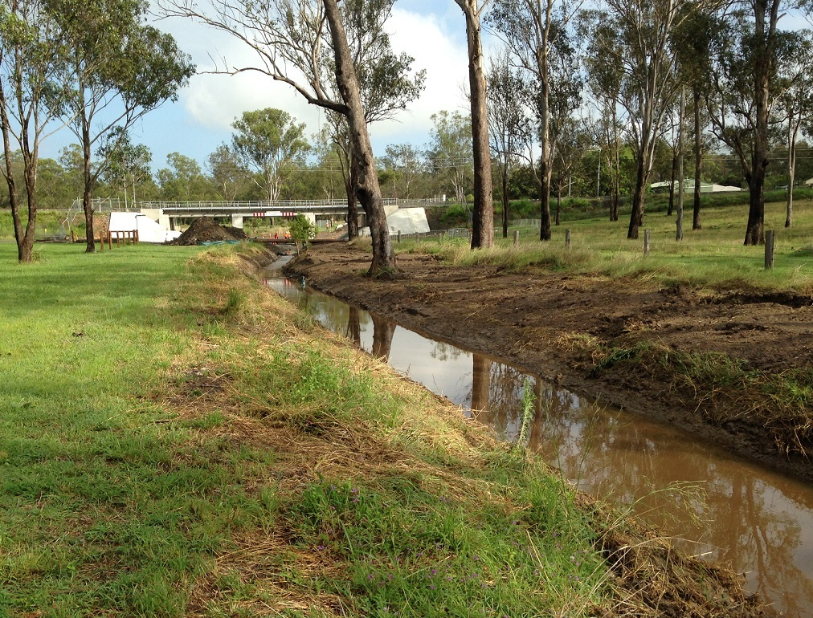
To address the potential for ponding in a rain event and until Council undertakes associated permanent downstream drainage works, Queensland Rail is undertaking temporary drainage works on site.
These short-term works have been undertaken in consultation with Council and involve a temporary low flow open drainage channel excavated to the south-east of the rail bridge, near Wanstall and Kavanagh Roads.
The drainage channel (pictured) will be approximately two metres deep by approximately five metres wide.
Queensland Rail’s bridge replacement contractor JF Hull will remain on site during December to complete these temporary drainage works.
Queensland Rail would like to thank our valued neighbours. Every effort has been made to minimise disruption and we appreciate your cooperation during these important works.

For more information, please phone the project team on freecall 1800 645 836 or email communityengagement@qr.com.au.
Contact Queensland Rail’s customer feedback team on 13 16 17 (between 8am and 5pm, Monday to Friday) or email customerfeedback@qr.com.au.
For information and updates on Queensland Rail train services visit translink.com.au or call TransLink on 13 12 30 anytime.

