Information sheet

Health assessments for Queensland Rail contractors

Who is a Queensland Rail contractor?

Contractors are workers employed by businesses contracted to perform work for, or provide services to, Queensland Rail. Contractors are not directly employed by Queensland Rail.

Why do Contractors require health assessments?

The Rail Safety National Law requires rail transport operators to have and implement a health and fitness management program, complying with the requirements prescribed under a regulation, for rail safety workers who carry out rail safety work on or in relation to the operator’s rail infrastructure or rollingstock. Such a system includes

a responsibility to monitor the health and fitness of employees and contractors who perform rail safety work. The National Standard for Health Assessment of Rail Safety Workers provides guidance for accredited rail organisations to meet these obligations.

What is the aim of Queensland Rail’s health assessment program?

Queensland Rail’s health assessment program aims to ensure that rail safety workers have the level of health required to perform their jobs safely.

What are the different types of health assessment?

There are three different types of health assessment based on whether the work undertaken is safety critical or non-safety critical as shown below:

 | Safety critical |  |  | Non-safety critical
Category 1 |  | Category 2
 |  |  |  | Category 3
High level safety |  | Safety critical worker |  | Around the track
critical worker |  | (not at a high level) |  | personnel
A risk management approach is used to determine which category of health assessment applies to various types of work.

Category 1: applies to rail safety workers who undertake safety critical work and whose ill health may result in sudden incapacity or collapse leading to a serious incident affecting public safety or the rail network.

Category 2: applies to rail safety workers who undertake safety critical work where sudden incapacity will not impact on the safety of the public or the rail network.

Category 3: applies to rail safety workers who undertake non-safety critical work and whose health and fitness does not impact directly on the rail network but who are required to protect their own safety and that of other workers.

What type of health assessment do I need? | and forward the paperwork as directed in their instructions.
This depends on the type of rail safety work you are carrying out for
 | How long will the health assessment take?
Queensland Rail. Examples are:
• Category 1: Hand signalling, RTC (Cat 3) train drivers, shunting | Please speak with the Authorised Health Professional as this depends on
• Category 2: Train guards | the category of health assessment you undertake.
• Category 3: applies to all other rail safety work performed around, | Who sees my health assessment results?
on or near the track where there is a potential interface | Your medical information is confidential and your employer is not entitled
with moving rollingstock, this includes ticketed operators
 | to receive any medical information about you. A summary of your fitness
of other on-track vehicles
 | (Certificate of Fitness) will be provided as evidence of your fitness to perform rail safety work.
If you are unsure please discuss with the Queensland Rail representative managing your contract.
Where do I go to have my health assessment?
 | The Certificate of Fitness will need to be provided to your employer either
Your health assessment must be carried out by an Authorised Health | by you or directly from the Authorised Health Professional. Your employer
 | must be able to make this available to Queensland Rail upon request.
Professional. These providers have been trained to conduct rail medicals.
A listing of Authorised Health Professionals is accessible via this site. | Who pays for the health assessment?
How do I arrange the health assessment?
 | Contractors are responsible for the cost of health assessments.
Find the nearest Authorised Health Professional to you on the list provided | Queensland Rail do not accept responsibility for any payment of
on this site. Arrange an appointment with them directly. Outline the
 | Contractor health assessments
reason for the health assessment and the Category of medical required.
 | How much will the health assessment cost me?
(If you are unsure please discuss with the Queensland Rail representative
managing your contract)
 | This depends on the Authorised Health Professional and category of
Complete the correct health assessment form, which are available on the NTC website, it also provides detailed instructions on how to complete
 | health assessment. You will need to contact your local Authorised Health
them. Once you have done this, save or print a copy for your own records | Professional for further details regarding cost.

Do I need to tell Queensland Rail that I am having a health assessment?

No. You do not need to advise Queensland Rail you are having a health assessment.

Can I fail the health assessment?

Yes. You can be deemed as Not Fit for Duty to carry out rail safety work for Queensland Rail.

What happens if I fail?

If you do not pass the requirements of a Category 1 health assessment, you will not be able to perform safeworking duties. However, there is a potential you may be fit for duty for Category 3 rail safety work. Should you be unfit for Category 3 duties, you will be unable to perform any rail safety work. The specific medical information is held between you and the Authorised Health Professional. See www.ntc.gov.au for further details.

What if I have a job modification?

If you are a contractor or subcontractor to Queensland Rail, health assessments are only accepted where you have been deemed Fit for Duty or Fit for Duty Subject to Review. Job Modifications need to be managed by you or your employer.

How long will my health assessment be valid for?

This depends on what type of health assessment you need and your age. See below table:
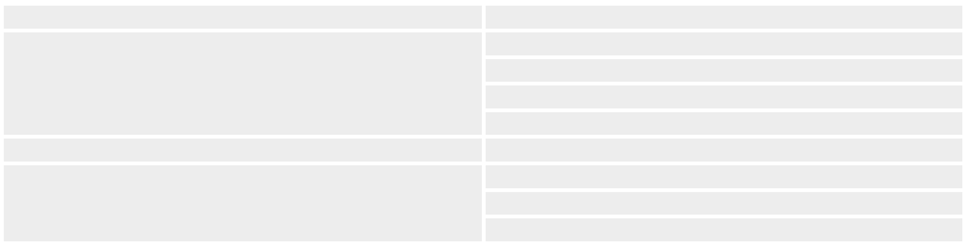
Medical Category | Validity
Category 1 | On commencement as RSW
 | 5 yearly to age 50
 | 2 yearly between age 50 to 60
 | Yearly from age 60
Category 2 | As per Category 1
Category 3 | On commencement as RSW
 | At age 40
 | 5 yearly from age 40

Please note the above timeframes are only true where an Authorised Health Professional does not determine a requirement for more frequent reviews.

How can I find out more?

If you are unsure about what level of medical you require please discuss further with the Queensland Rail representative managing your contract. For further information about the National Standards for Health Assessment of Rail Safety Workers please visit the NTC website: https://www.ntc.gov.au/rail/safety/national-standard-for-health-assessment-of-rail-safety-workers/national-standard-health-assessment-forms/

Queensland Rail medical-in-confidence. Health & Fitness Services V2.2 January 2020

