Basic Electrical Safety Requirements CIVIL-SR-003

REQUIREMENTS FOR WORK ON OR NEAR

HIGH VOLTAGE OVERHEAD LINE EQUIPMENT

AND

LOW VOLTAGE SERVICES

Revision: 7 Updated: 30/06/2016

© Queensland Rail 2016
Reproduction by any means (including electronic, mechanical, photocopying, microcopying or otherwise), except for the purposes permitted by the Copyright Act, is prohibited without prior written permission of Queensland Rail.

This publication has been created for use in the design, construction, maintenance and operation of Queensland Rail infrastructure and infrastructure owned by others that adjoins Queensland Rail's operational corridors. Every effort has been made to ensure that the information contained in this document is correct at the time of authorisation for issue. It is the responsibility of the user to ensure that the information is interpreted correctly and is up to date before it is applied. It is strongly recommended that the user consults with Queensland Rail to ensure relevancy for the specific circumstance and correct interpretation.

When the document is used in other than Queensland Rail projects, Queensland Rail gives no warranties as to the completeness; accuracy or adequacy of the publication or any parts of it and accepts no responsibility or liability upon any basis whatsoever.

Document Information
Current Revision: | 7
First Released: | 07.08.1997
Last Updated: | 30/06/2016
Review Before: | 30/06/2019
Endorsed by: | Francisco Siliezar  Discipline Head Electrical | Date: 30/06/2016
Authorised by: | Gary Smith  Discipline Head Track & Structures | Date: 30/06/2016

Document Amendment History
Revision | Date | Section(s) Amended | Summary of Amendment
Initial | 07.08.1997
A | 16.01.2001 |  | Reference made to Electrification Manual (STD/0039/SWK) QUEENSLAND RAIL costs updated
B | 04.02.2002 |  | Safety Induction Course cost updated
C | 30.06.2005 |  | Cl. 3.2.2 revised in respect of loads.  Cl. 3.2.4 revised to exclude protection by a platform. Cl. 3.2.5 revised in respect of loads.
D | 22.12.2009 |  | Complete Revision
E | 30.09.2010 |  | New disclaimer. Rebranded.
F | 30.05.2011 |  | PICOW changed to Authorised Person, definitions placed in alphabetical order, title changes from MCE to CIVIL.
7 | 30/06/2016 |  | Update of exclusion zone requirements. Terminology updated. Introduction of WET (working in the electrified territory) training. References made to Rail Safety Worker framework.  Introduction of basic rules for work near electric traction infrastructure and electrical low voltage services.

Compliance:
Significant issues with compliance with the requirements detailed in this document shall be addressed through the Rail Infrastructure Manager who will liaise with the Electrical and Track & Structures Discipline Head as necessary.

Feedback:
If you have any suggestions for improvement to any documentation, especially inaccuracies or ambiguities, please email CivilEngineeringStandards@qr.com.au with the document number in the subject heading.

TABLE OF CONTENTS

Page

1.0 INTRODUCTION 4
1.1 Definitions 4

2.0 SCOPE 4

3.0 WORK ON OR NEAR OVERHEAD TRACTION WIRING EQUIPMENT 5
  - Warning 5
  - Electric Traction High Voltage Exclusion zone 5
  - Rules for Work within the Traction Exclusion Zone 5
  - Isolation and Permit to Work 5
  - Application Procedure 5
  - Competency and Training Requirements 5

4.0 WORK ON OR NEAR LOW VOLTAGE SERVICES 6
  - Warning 6
  - Electric Low Voltage Exclusion Zone 6
  - Safety Rules for Electrical Low Voltage Work within Queensland Rail Facilities 6
  - Competency and Licencing Requirements 6

5.0 SAFE WORK METHOD STATEMENTS 7

6.0 FURTHER INFORMATION 7

1.0 INTRODUCTION
These Electrical Safety Requirements detail the conditions which must be met by an external party or contractor working on or near:
- Overhead Traction Wiring Equipment, in or about Queensland Rail property.
- Electrical low voltage services within facilities and corridors controlled by Queensland Rail.

State electrical safety law creates a framework that:
- Imposes duties on those who may affect the electrical safety of others.
- Establishes standards for industry and the public through regulations and codes of practice.
- Establishes safety management systems for electricity entities including power authorities and Queensland Rail.
- Provides a system of licensing for electrical workers and contractors.
- Provides penalties for breaches of the Electrical Safety Act 2002 (Qld).
- Provides consumer protection against electrical work not being properly performed or completed.
- Establishes a consultative structure for industry, workers and the community to participate in improving electrical safety.

Definitions:

Electric Traction Infrastructure is the railway high voltage electrical distribution network used to supply energy for rollingstock and approved designated railway applications. The system incorporates overhead line equipment, return circuits (including designated running rails), substations, switching, protection and control equipment.

Isolated means disconnected from all possible sources of energy by means that prevent unintentional energisation of the Electrical Apparatus and that are assessed as a suitable step in the process of making safe for access purposes.

Nominated Person is a competent worker who is approved and qualified to switch, test, apply local earths and issue Permits to Work (Form C).

Overhead Traction Wiring Equipment refers to overhead equipment necessary for the traction power supply for electric trains, including contact lines, ancillary conductors, isolators, and traction bonding.

Permit to Work (Form C) is a permit that is issued subsequent to isolation and earthing of relevant electrical apparatus to facilitate safe work near or on electrical apparatus including overhead line equipment.

The purpose of the form is to make known to the Recipient specifically which equipment is isolated and earthed, and upon which, or near to which, it is safe for work to be carried out.

Recipient (person in charge of electrical safety) is an authorised person who has the competence and responsibility to supervise the electrical safety aspects of the work and has been appointed to take charge of a specific worksite in electrified areas.

A Recipient can be issued with a Permit to Work (Form C) or Safety Clarification Advice (SCA) as the person responsible for the electrical safety component of the work activity, and compliance with, the requirements of a relevant Safe Work Method Statement.

The Recipient shall hold overriding safety responsibility for relevant activities within the worksite. The Recipient shall remain on site and in charge of the worksite at all times for the duration of the approved work. If the Recipient leaves the worksite the electrical safety aspects of the work for which the Form C or SCA is issued, is to stop until the Recipient returns.

Safety Clarification Advice (SCA) is written advice provided to a Recipient on how to safely carry out work that has the potential to come within the 3 metres exclusion zone of the live electric traction system.
It is site and activity specific written advice, concerning work restrictions in the vicinity of live overhead line equipment. This advice is supplied by the Traction Power Engineer or their delegated representative in response to a request from a Recipient.
Work related to a SCA shall be adequately described and controlled by a relevant Safe Work Method Statement. Note that an SCA is not a Permit to Work (Form C)

Traction Power Engineer is the competent registered professional electrical engineer responsible for the electric traction infrastructure in a defined geographic area in respect of:
    - System operation, maintenance and integrity; and
    - Electrical safety advice.
The TPE may delegate a representative to authorise works on his behalf.

2.0 SCOPE
These Safety Requirements apply to:
- Work on or near electric traction infrastructure (declared as the works of Queensland Rail as an electricity entity under Electrical Safety Legislation)
- Work on or near electrical low voltage services within facilities controlled by Queensland Rail.

WORK ON OR NEAR OVERHEAD TRACTION WIRING EQUIPMENT

  - Warning

All overhead line equipment (and associated electric traction infrastructure) must be treated as live and dangerous at all times. Overhead line equipment is energised at 25,000 volts AC.

Electric Traction High Voltage Exclusion zone

A 3 metre exclusion zone from Overhead Traction Wiring Equipment must be maintained unless suitable approved controls are in place before work commences within the electric traction exclusion zone. See Figure 1 below

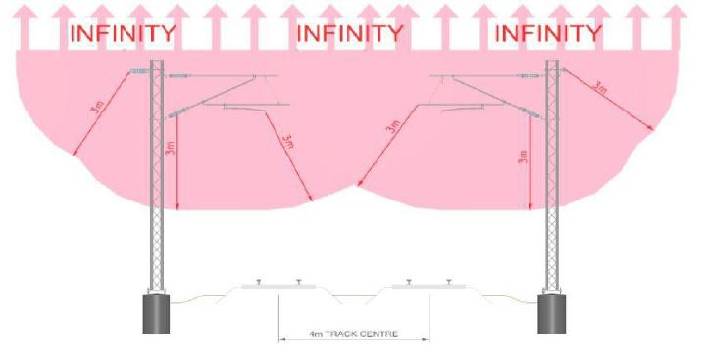

Figure 1: Overhead line equipment exclusion zone.

If, in the opinion of a Protection Officer (PO) or the Possession Protection Officer (PPO), any activity of the Contractor is considered dangerous or contravenes any of these requirements, then the PO or PPO has the authority to direct that such activity is to cease immediately.

Rules for Work within the Traction Exclusion Zone

All third parties and workers (including contractors) planning and conducting work near electric traction infrastructure must observe the requirements of MD-10-191 (Electric Traction Systems Standard - Module 2).

No work is allowed within the overhead line equipment exclusion zone (or having the potential to encroach the exclusion zone) without:

- A Permit To Work (Form C) issued by a Nominated Person, OR,
- A Safety Clarification Advice (SCA) endorsed by the traction power engineer or designated representative, OR
- A barrier endorsed by the traction power engineer or designated representative, erected with the objective to separate the worksite from exposed electrical high voltage equipment.
  - Isolation and Permit to Work: When the Traction Power Engineer (TPE) determines that work cannot be carried out safely under a Safety Clarification Advice (SCA) process,
an isolation must be sought and planned so that the work can be conducted safely. A Permit to Work (Form C) will allow suitably trained workers under the supervision of a Recipient, to work “NEAR” isolated overhead line equipment.

Application Procedure
The Contractor shall contact the Traction Power Engineer and then apply in writing for one of the above using appropriate Queensland Rail forms. The timing for the start of work by the Contractor on site is to allow for a joint Queensland Rail
/Contractor site inspection, Queensland Rail’s analysis/amendment/approval of the Contractor’s application and Queensland Rail’s planning/resourcing.

The Contractor’s application is to include but not be limited to such aspects as the provision of a Safe Work Method statement. The Safe Work Method Statement (SWMS) must contain the minimum control measures required to ensure that an unsafe electrical situation is not created at any stage of the works. The application is also to nominate the Contractor’s Recipient. This worker must have appropriate knowledge of electrical safety and working within 3 metres of the live Overhead Traction Wiring Equipment and also knowledge of working in a railway corridor which is to be obtained from appropriate Queensland Rail training courses.

Competency and Training Requirements

There will be a requirement that all third party and contractor’s staff carrying out works undergo relevant Queensland Rail safety training.

Personnel working within electrified territories shall undertake WET (Working in the Electrified Territory) induction and relevant periodic refresher training.

Workers planning and supervising work near electric traction equipment shall undertake Recipient training and relevant periodic refresher training.

Workers requiring access to high voltage substation compounds shall undertake “Safe access to HV enclosure” training.

Competency matrices for electric traction work can be found at http://www.queenslandrail.com.au/forbusiness/contr actors/railworkers
under “Electric Traction” competence matrix.

WORK ON OR NEAR LOW VOLTAGE SERVICES

  - Warning

All electrical conductors and equipment must be treated as energised (live) and adequate procedures for working on or near energised electrical equipment must be followed in accordance with:

- the Electrical Safety Code Of Practice (2013) – Managing electrical risks in the workplace, and
- AS/NZS 4836: 2011 - Safe working on or near low-voltage installations and equipment.

Electric Low Voltage Exclusion Zone

The exclusion zone below applies to the planning and execution of work on or near low voltage conductors and equipment.
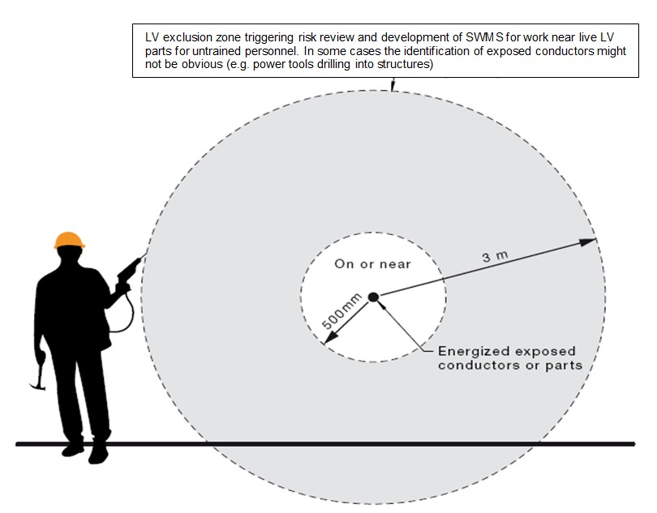

Figure 2: Low voltage equipment and cables exclusion zone.

All work must be planned and organized to minimize the risks associated with the work. An assessment shall be carried out at the work site before starting work to assess all risks that might have the potential to cause harm or damage.

If any person is required to work within 3 metres of energized exposed conductors or parts, a competent person shall identify appropriate risk treatments.

Safety Rules for Electrical Low Voltage Work within Queensland Rail Facilities

    - Work on energised electrical wiring and equipment is prohibited (exceptions from this rule are defined in section 18 of the Electrical Safety Regulation).
    - Assume electrical parts are live until proven de-energised and locked out and tagged out (LOTO).
    - Testing to prove de-energised and fault finding shall be performed in accordance with a safe work method statement suitable for the task (considering requirements for pre-start briefs, barriers, roping off, PPE, electrical safety observers, appropriately rated tools and instruments).
    - Electrical work shall be carried out by competent qualified licenced persons only.
    - All redundant cables shall be removed from the installation unless otherwise approved to remain installed in an electrically safe condition and appropriately identified.

Competency and Licencing Requirements

It is illegal to perform or supervise electrical work unless a person is the holder of a relevant and current electrical work licence.

An external business that performs electrical work on Queensland Rail assets must have a current electrical contractor’s licence.

A qualified technical person (QTP - electrical), employed by the business, is mandated for the contractor’s licence to be current. The QTP is responsible for the supervision of contracted electrical work.

Queensland Rail will review or arrange a review of electrical work as required including:
- Requesting copies of Testing and Safety certificates of compliance as soon as practicable at the end of the works (in accordance with section 26 of the Electrical Safety Regulation).
- Verification of electrical licencing.
- Spot audits of site works.

Competency matrices for electric low voltage facility work can be found at http://www.queenslandrail.com.au/forbusiness/contr actors/railworkers
under “Electric Facilities” competence matrix.

5.0 SAFE WORK METHOD STATEMENTS

If there is a safety risk associated with working near energised electrical equipment a written risk assessment needs to inform a suitable safe work method statement to identify risks and appropriate risk control measures. Electrical risks include:
- electric shock if exposed energised equipment is touched or arcs across;
- explosion, for example if a metal tool is dropped onto bus bars causing a short circuit;
- exposed high-temperature parts causing burns to bare skin;
- electrical fires induced, for example, by allowing moisture or dust to enter electrical equipment.

Work near energised live equipment must be planned and executed working through the hierarchy of controls to choose the controls that most effectively eliminate or minimise the risk of working near energised electrical equipment, so far as is reasonably practicable. This may involve a single control measure or a combination of two or more different controls.

Elimination is the most effective control measure to remove a hazard from the work site.

Under the WHS Regulation substitution, isolation and engineering controls are ranked at the same level of protection, ahead of administrative controls and then PPE.

6.0 FURTHER INFORMATION

Further electrical safety information can be obtained from:
- Queensland Rail Safety and Environment Management Systems Standard MD-10-191 “Electrical Traction Systems Standard” modules 1 and 2.
- Electrical Safety Act (2002) and Regulation (2013).
- Electrical Safety Codes of Practice including:
  - Electrical Safety Code of Practice 2010
    - Working near overhead and underground electric lines
  - Electrical Safety Code of Practice 2013
    - Managing electrical risks in the workplace
  - Electrical Safety Code of Practice 2010
    - Works
  - Electrical Safety Code of Practice 2010
    - Electrical equipment rural industry.

The Electrical Safety Act, Regulation and relevant Codes of Practice can be downloaded from: (https://www.business.qld.gov.au/business/running/ workplace-health-safety/electrical- safety/laws/codes-practice)

Reference is made to the following Queensland Rail Technical Requirements which must also be satisfied considering the scope of third party or contracted works:

CIVIL-SR-001 Design of Road Overbridges; CIVIL-SR-002 Work in or about Queensland Rail Property,
CIVIL-SR-005 Design of Buildings over or near Railways,
CIVIL-SR-006 Design of Footbridges;
CIVIL-SR-008 Protection Screens, and
CIVIL-SR-012 Collision Protection of Supporting Elements Adjacent to Railways.
CIVIL-SR-013 Advertising Signs on Queensland Rail's Property
CIVIL-SR-016 Services Under Railway Property (Non-Queensland Rail Services)
CIVIL-SR-017 Underground Services (Queensland Rail Services)
Copies of these documents may be obtained from Queensland Rail where applicable.

All reference documents including Australian Standards, Codes of Practice, Queensland Rail’s standards and Queensland Rail Technical Requirements, are to be the latest version.

