28 August to 30 September 2017
Signals Upgrade Project

As a valued neighbour, we are committed to keeping you informed about work Queensland Rail is doing in your area. This notice is a four-week look ahead outlining planned work for our Signals Upgrade Project and approximate locations, so you are fully informed.

The nature of this work is such that there will be little to see, but there will be construction noise and traffic impacts, particularly around those points where we require access to the rail corridor.

We apologise for any inconvenience and thank you for your understanding during this important project.

Roma Street to Milton night works
Monday 18 and Tuesday 19 September, from 10.45pm to 4am each day:  - Installation of new cables  - Upgrade of existing equipment |  | 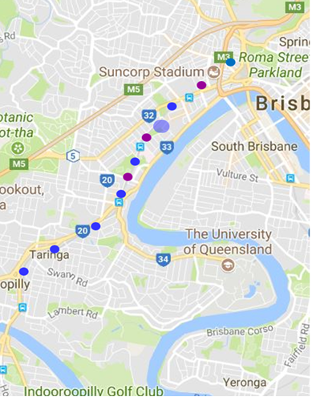
Milton to Indooroopilly day works
Monday 28 August to Friday 29 September, from 6am to 6pm each day:

- Installation of signal equipment
- Installation of new cables
- Upgrade of existing equipment

Toowong to Taringa weekend works
Saturday 2 and Sunday 3 September, from 6am to 6pm each day:  - Installation of signal equipment  - Installation of new cables  - Upgrade of existing equipment  Road closures  Saturday 2 and Sunday 3 September, from 6am to 6pm each day:  Bennett Street, Toowong  Pike Avenue, Taringa | 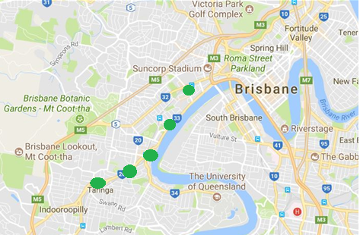
Roma Street to Corinda day works
Ongoing daily signalling works between Roma Street and Corinda involving construction crews accessing the corridor and heavy vehicle movements.

What to expect?

During these important works, you may experience some noise from on-track machines and construction crews, heavy vehicle movements and traffic control in surrounding streets.

Contact us

This snapshot is broad and subject to change. We encourage you to contact us with your phone or email details so we can ensure you are notified of any works that need to take place outside of normal construction hours, or involve changed traffic arrangements in your area.

Call: 1800 959 989
Email: communityengagement@qr.com.au
For more information about this project visit queenslandrail.com.au/inthecommunity/projects

Queensland Rail is moving towards paperless notifications about noise, works and rail line closures. You’ll still see paper notices for a time, as we transition to the new system.
Sign up at: queenslandrail.com.au/EmailNotification

