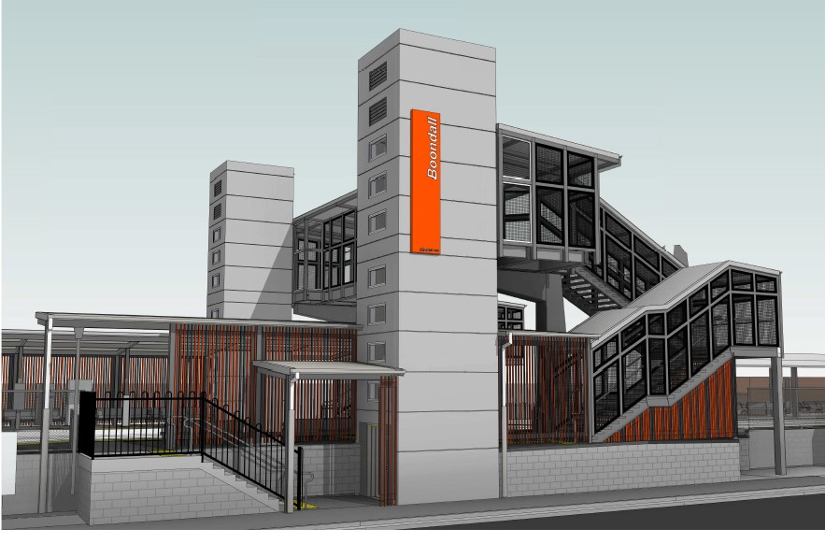Boondall station accessibility upgrade

PROJECT UPDATE – NOVEMBER 2018

The Boondall station accessibility upgrade is part of Queensland Rail’s $300 million program to upgrade stations across the network, making them accessible for all customers.

Major works are about to begin on the accessibility upgrade at Boondall station. Early works undertaken to date have included laying foundations and the relocation of overhead electrification equipment to enable the raising of the platform around the assisted boarding point (see photos below).

Upcoming works
From Monday 12 November 2018, customers and the community can expect to see the following activities:
- set up of the site compound, located between Stanworth Road and the station office
- installation of safety fencing on both sides of the platform and along the designated works area on Aberdeen Parade (this will temporarily remove approximately 12 informal parking spaces for the duration of works)
- utility works on the platform.
The loop top bike rack within the works zone on Aberdeen Parade will be temporarily relocated to the southern station entrance. There will also be no access to the Telstra payphone on Aberdeen Parade during works, however the payphone on the station platform will continue to remain accessible.

Construction impacts
Normal working hours are 6am to 5pm, Monday to Saturday. Construction activities may involve:
- noise associated with hand tools and heavy machinery
- temporary changes to access paths throughout the station precinct
- changed traffic and parking conditions on Aberdeen Parade
- increased site personnel and vehicle movements near works.
Please take care around the work zones.
Queensland Rail thanks customers and the community for their cooperation as we work to improve your station.

Contact us
For more information or to provide feedback: Phone: 1800 722 203 (free call)
Email: stationsupgrade@qr.com.au
Website: queenslandrail.com.au

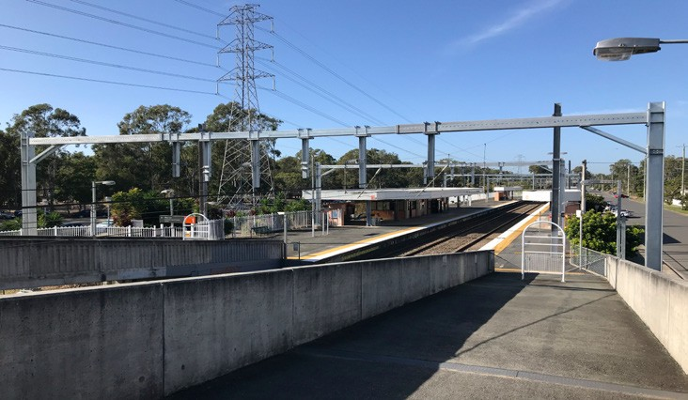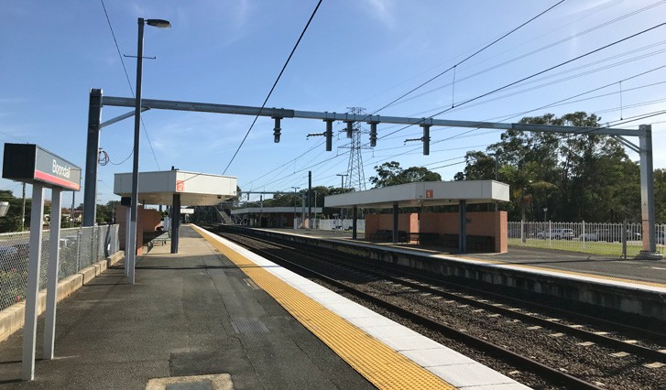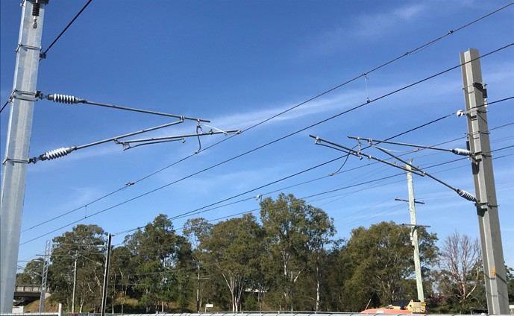
Delivery of Queensland Rail’s $300 million Station Accessibility Upgrade Program will ensure 83% of customers will travel to or from an accessible station.

Nambour | Dinmore | Graceville | Newmarket | Alderley | Strathpine | Morayfield | Boondall
Completed | Completed | Completed | Completed | Completed | Early works | Early works | Early works
Apr 2017 | Jun 2017 | Sep 2017 | Nov 2017 | Nov 2017 | commenced | commenced | commenced
 |  |  |  |  | late 2017 | late 2017 | early 2018

Albion
Design stage

Fairfield
Design stage

Auchenflower
Design stage

Loganlea
Design stage

Cannon Hill
Design stage

Buranda
Design stage

East Ipswich
Design stage

Dakabin
Design stage
Queensland Rail Limited ABN 71 132 181 090 QR2018

