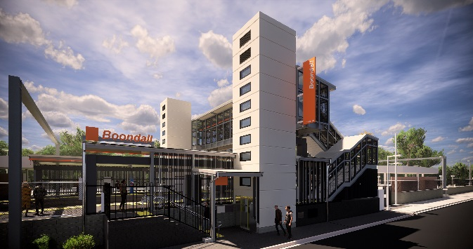
Boondall station accessibility upgrade

PROJECT UPDATE – AUGUST 2019

Queensland Rail’s Boondall station accessibility upgrade is part of the program to upgrade stations across the South East Queensland network, making them accessible for all customers.

Project progress
Activities undertaken recently at Boondall have included:
- installation of platform 2 stairs
- installation of pre-cast lift shafts (pictured at right)
- electrical power upgrade for the new facilities
- extension of raised platform 2.

Upcoming works
In the coming weeks, customers and the community can expect to see the following activities:
- extension of raised platform 1 and paving
- ongoing lift installation works
- platform shelter roofing
- installation of electrical switchboard and power connections
- station entrance, kerbing and gutters (Aberdeen Parade).

A section of platform 1 will be closed to customers from Monday 2 to Friday 6 September. Please follow all directional signage or see station staff for assistance.
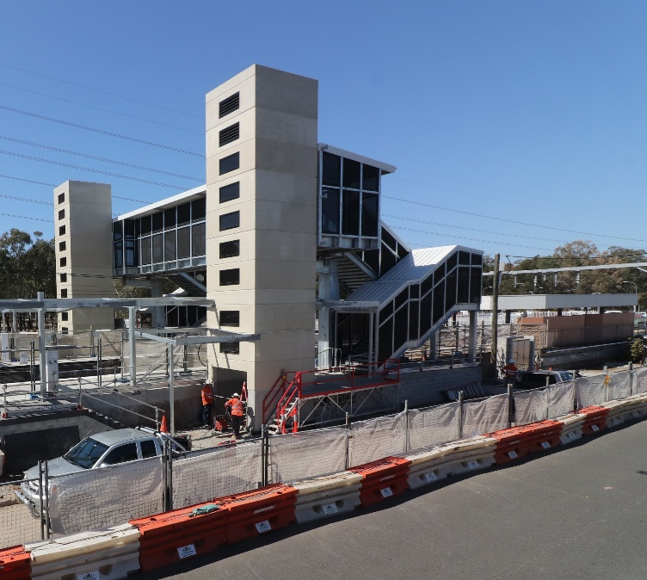
The station will be closed for uninterrupted works from 11.30pm Friday 6 until 4am Monday 9 September. Rail services will not stop at Boondall during this time. Half-hourly shuttle services will take customers to North Boondall to connect with inbound and outbound services (allow an additional 30 minutes’ travel time).
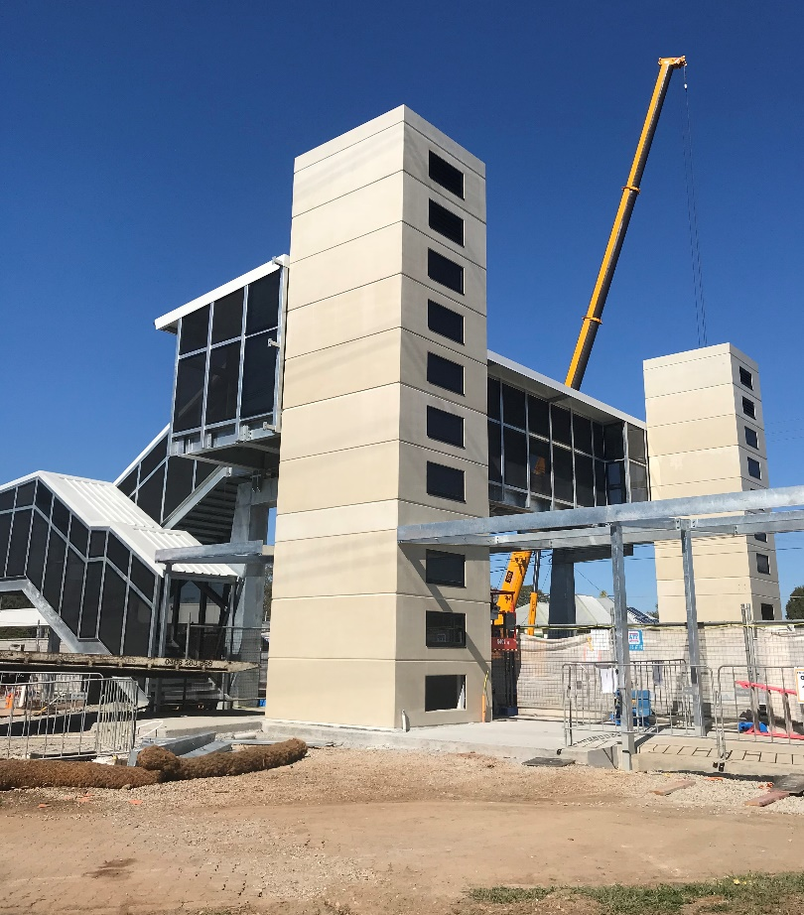

Construction impacts

Normal working hours are 6am to 5pm Monday to Saturday. Construction activities may involve:

noise associated with heavy machinery

temporary changes to station access paths

changed traffic/parking conditions (Aberdeen Parade)

increased vehicle movements near works

mobile lighting towers for night works.

Please take care around the work zones.

Local residents will be given advance notification of construction activities likely to cause impacts, including after hours work (nights and Sundays, as required).

We thank customers and the community for your patience and cooperation as we work to improve your station.

Contact us

For more information or to provide feedback:

Phone: 1800 722 203 (free call)

Email: stationsupgrade@qr.com.au

Website: queenslandrail.com.au

