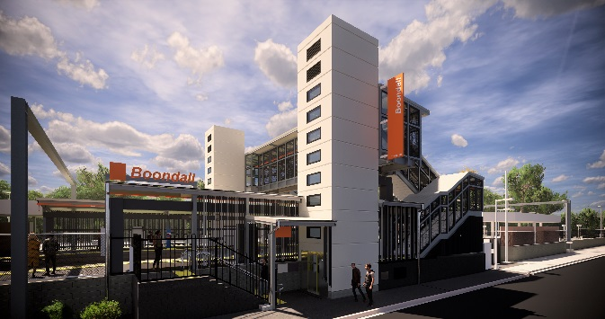
Boondall station accessibility upgrade

PROJECT UPDATE – MAY 2019
The Boondall station accessibility upgrade is part of Queensland Rail’s $300 million program to upgrade stations across the South East Queensland network, making them accessible for all customers.

Project progress
Activities undertaken at Boondall in April included:
- concrete pour – new raised platform area and lift pit – platform 1
- excavation and construction of footings and foundations for new footbridge and lift shaft – platform 2
- construction of lift shaft components – offsite.

Upcoming works
In the coming weeks, customers and the community can expect to see the following activities:
- concrete pour for footings for new footbridge and lift shaft – Aberdeen Parade
- construction of footbridge support columns
- construction of lift shaft to platform level – platforms 1 and 2
- construction of lift shaft segments (offsite)
- raised platform concrete pour – platform 2 (early June).

Please take care around the work zones.
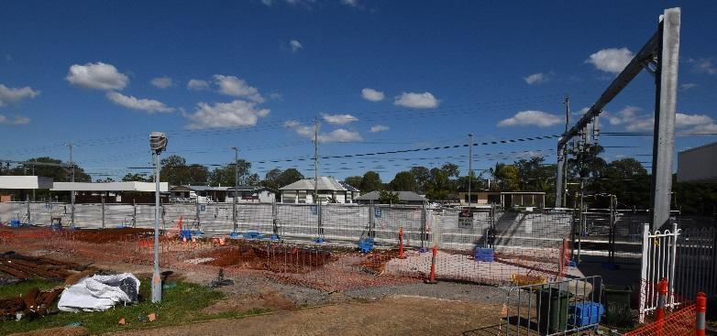

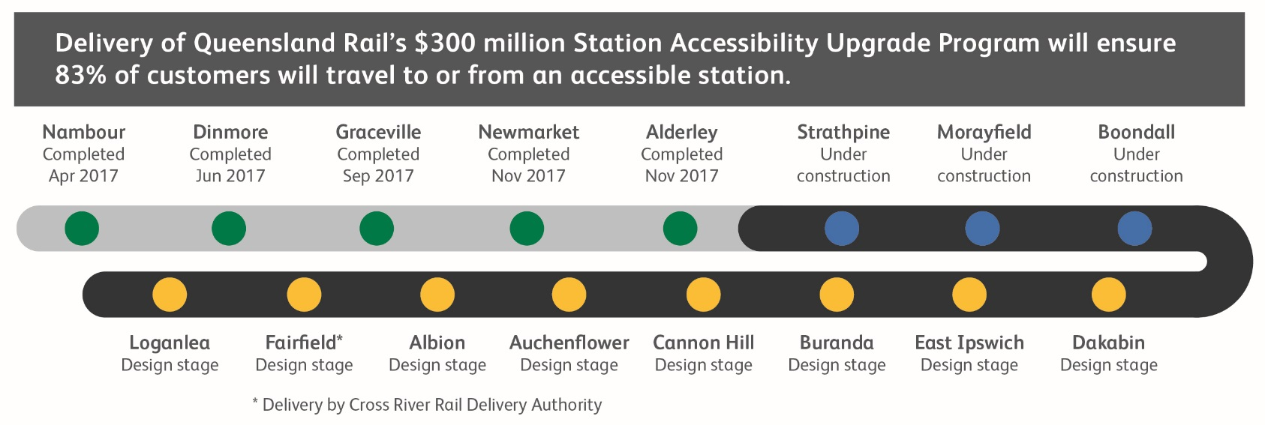

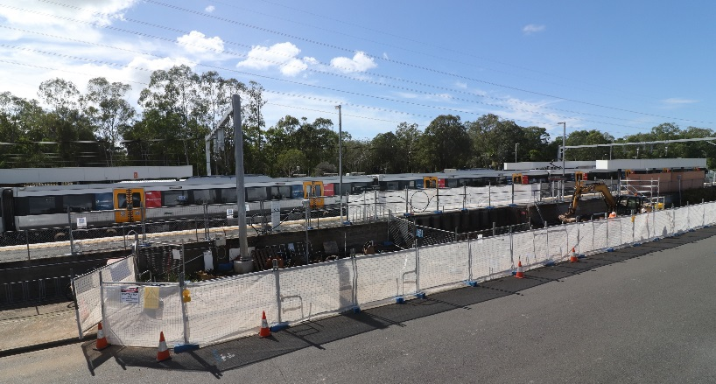

Construction impacts

Normal working hours are 6am to 5pm Monday to Saturday. Construction activities may involve:

noise associated with heavy machinery

temporary changes to station access paths

changed traffic/parking conditions (Aberdeen Parade)

increased vehicle movements near works

mobile lighting towers for night works.

Local residents will be given advance notification of construction activities likely to cause impacts, including after hours work (nights and Sundays, as required).

We thank customers and the community for your patience and cooperation as we work to improve your station.

Contact us
Queensland Rail Limited ABN 71 132 181 090 QR2018

For more information or to provide feedback:

Phone: 1800 722 203 (free call)

Email: stationsupgrade@qr.com.au

Website: queenslandrail.com.au

