Cooran station platform upgrade
Project update – September 2018
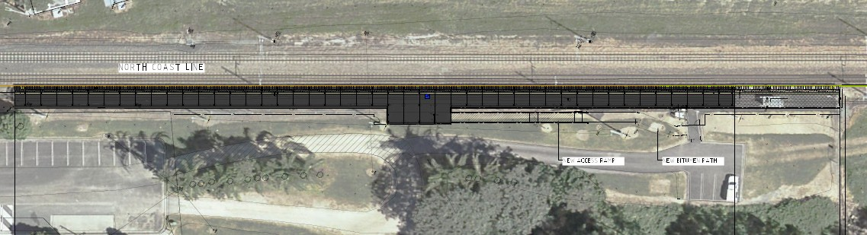Works are progressing well on Queensland Rail’s upgrade and modernisation of the platform at Cooran station to improve facilities for customers. This is part of a $4 million project to upgrade platforms at three Sunshine Coast line stations, replacing them with more durable, high level platforms. An image of the new station layout is below.
BRISBANE
New platform with painted platform markings, upgraded lighting and security cameras
GYMPIE
New waiting shelter with bin
New ramp and path to connect with new waiting area
New disability parking space
Works are being staged to ensure there are no impacts on services. The new platform will be completed in late 2018, at which time the existing section of platform will be removed.
We thank the Cooran community for its cooperation and patience as we work to improve the station. For further information, call 13 16 17 or email communityengagement@qr.com.au
Queensland Rail Limited ABN 71 132 181 090

