Northgate QPS outpost project
PROJECT UPDATE – JULY 2019
Queensland Rail has invested almost $2 million to construct a new Queensland Police Service (QPS) outpost at Northgate station, aimed at enhancing security on the inner northern lines.

Work is complete on the construction of the new QPS outpost at Northgate station and we thank all of our customers and the local community for your patience and cooperation during this time.
Project outcome
This project has delivered the following at Northgate station:
- a new QPS outpost building which will allow police to respond to crime incidents across the northern lines on the network
- a new QPS shed to house two police vehicles
- the reconfiguration of the carpark in Ridge Street to introduce
additional accessible parking spaces and accommodate the new QPS vehicle shed, while keeping the same number of spaces available to customers overall.
The new police outpost will be staffed by eight officers, who will work with officers based at Petrie station to respond to crime incidents across the northern
lines. It will reduce the risk of crime on the northern rail network through a heightened police presence.
Queensland Rail is committed to improving the safety and security of our network, and ensuring our customers feel safe on our trains and at stations.
The Northgate police outpost will be the eighth in South East Queensland, joining Robina, Roma Street, Manly, Beenleigh, Petrie, Ipswich and Redbank.

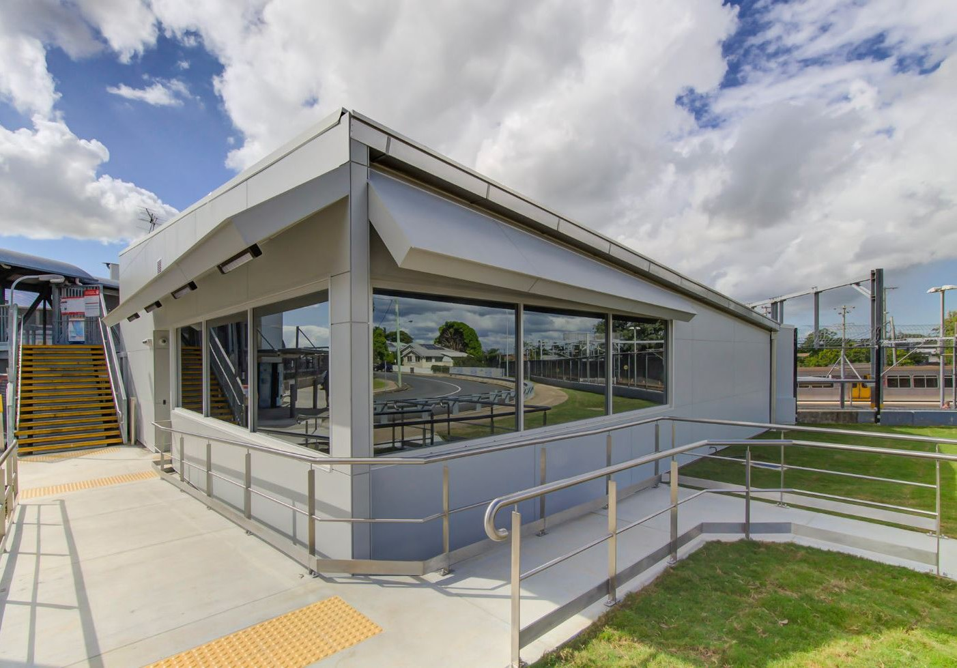

Further information

Phone: 13 16 17 (business hours) Email: customerfeedback@qr.com.au
Post: GPO Box 1429, Brisbane, QLD 4000
Website: queenslandrail.com.au

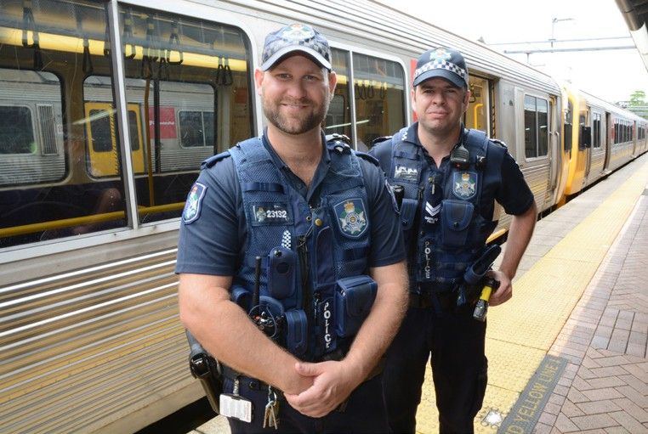
Queensland Rail Limited ABN 71 132 181 090 QR2018

