20 June to 21 July 2016
Signals Upgrade Project

This is Queensland Rail’s regular notice to keep you informed of works in your area associated with our Signals Upgrade Project. The look ahead is intended to provide an outline of planned works and their approximate location so you will know what Queensland Rail is doing and where.
This work will create some construction noise and traffic impacts, particularly around those points where we require access to the rail corridor.
We apologise for any inconvenience and thank you for your understanding while we dig trenches, lay cables, move overhead electrical wires and install new signalling equipment on the line between Roma Street and Corinda.
If you have questions or concerns about specific dates, times or locations, please contact us. We look forward to working with you.
Indooroopilly and Taringa
Works
Night works over the weekends for drilling signal portal foundations and mast installation:
From 2am Saturday 9 July to 2am Monday 11 July
From 2am Saturday 16 July to 2am Monday 18 July.
What to expect
- Heavy vehicle movements, periodic traffic control near train line access gates, some noise, construction crews in area.
- Ongoing traffic control and heavy vehicle movements on streets surrounding worksites.
- Minor traffic delays, reversing alarms, extra heavy vehicles and equipment movements and parking on street.
- Night works - bright lighting, vibration, vehicle movements and noise from construction crews and machinery.

Milton
Works | What to expect
Night works for overhead line reconfiguration between 10pm and 5am each night:  Over four nights, from Monday 20 June to Thursday 23 June  Over four nights, from Monday 11 July to Thursday 14 July  Over five nights, from Sunday 17 July to Thursday 21 July. | Some noise from on track machines and construction crews, lighting, heavy vehicle movements, traffic control in surrounding streets.
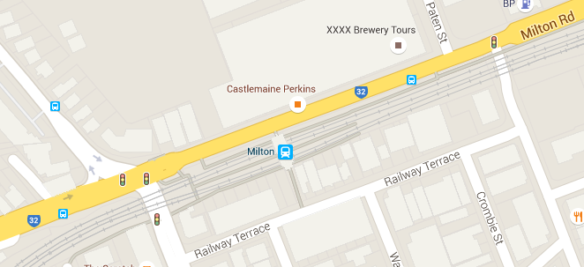

Auchenflower to Chelmer
Works | What to expect
Commencement of day works to install power equipment cabinet foundations at Auchenflower, Indooroopilly and Chelmer. | Heavy vehicle movements, some noise, construction crews in area, traffic control near train line access gates.
Trenching works near Chelmer station and Toowong station. | Noise from excavator, vacuum truck and other heavy vehicle movements, construction crews in area, ongoing traffic control in surrounding streets.
Taringa and Auchenflower drilling works
Works
Directional drilling under roads, alongside rail corridor over three weeks from Monday 20 June:
Whitmore Street, Taringa
Dixon Street, Auchenflower.
What to expect
Some noise from machines and construction crews, heavy vehicle movements, ongoing traffic control.
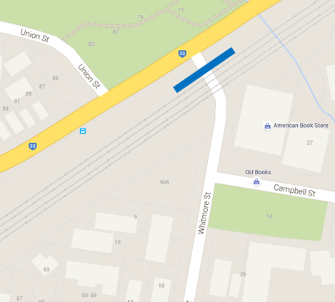
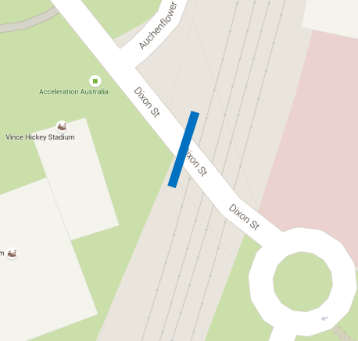

Queensland Rail will make every effort to carry out these works with minimal disruption to our neighbours. We encourage you to contact us with your phone or email details so that we can notify you of any works taking place outside of normal construction hours or other impacts in your area.
Contact:
Call: 1800 399 222 Email: communityengagement@qr.com.au
For more information about this project visit the Queensland Rail website at www.queenslandrail.com.au/inthecommunity/projects

