1 March to 31 March 2017
Signals Upgrade Project
As a valued neighbour, we are committed to keeping you informed about work Queensland Rail is doing in your area. This notice is a four-week look ahead outlining planned work for our Signals Upgrade Project and approximate locations, so you are fully informed.
The nature of this work is such that there will be little to see, but there will be construction noise and traffic impacts, particularly around those points where we require access to the rail corridor.
We apologise for any inconvenience and thank you for your understanding while we dig trenches, lay cables, move overhead electrical wires and install new signalling equipment on the line between Roma Street and Corinda.
Taringa to Indooroopilly weekend works
Day works for trough and cable route.  From 6am to 6pm each day on Saturday 4 March and Sunday 5 March. | 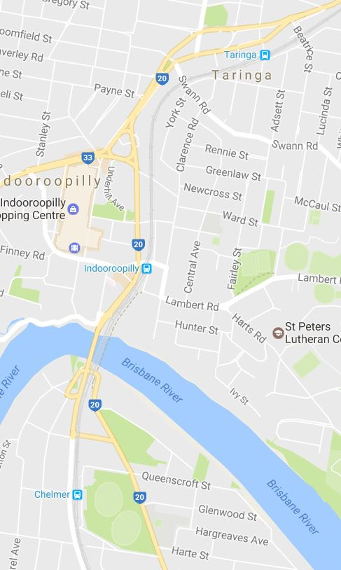
What to expect
Some noise from on-track machines and construction crews, heavy vehicle movements and traffic control in surrounding streets.

Chelmer weekend works
Day works for shotcrete refurbishment.
From 6am to 6pm each day on Saturday 4 March and Sunday 5 March.
What to expect
Some noise from on-track machines and construction crews, heavy vehicle movements and traffic control in surrounding streets.
Auchenflower - Milton overhead night works
Night works for crossover clean up:

- From 12.30am to 4.30am Tuesday 7 March
- From 12.30am to 4.30am Friday 10 March.
What to expect
Some noise from on-track machines and construction crews, heavy vehicle movements and traffic control in surrounding streets.
Milton overhead night works
Final night works for crossover installation  from 12.30am to 4.30am each night on:  - Tuesday 14 March  - Wednesday 15 March  - Thursday 16 March  - Friday 17 March. | 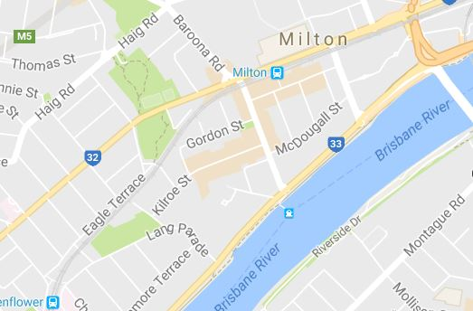  What to expect
What to expect
Some noise from on-track machines and construction crews, heavy vehicle movements and traffic control in surrounding streets.

Milton to Indooroopilly day works
Ongoing daily conduit installation between Milton and Indooroopilly involving construction crews accessing the corridor and heavy vehicle movements.
Queensland Rail will make every effort to carry out its works with minimal disruption. We encourage you to contact us with your phone or email details so we can ensure you are notified of any works that need to take place outside of normal construction hours, or involve changed traffic arrangements in your area.
This snapshot is broad and subject to change. If you have questions or concerns about specific dates, times or locations, please contact us. We look forward to working with you.
Contact:
Call: 1800 959 989
Email: communityengagement@qr.com.au
For more information about this project visit the Queensland Rail website at www.queenslandrail.com.au/inthecommunity/projects

