4 October to 31 October 2016
Signals Upgrade Project
As a valued neighbour, we are committed to keeping you informed about work Queensland Rail is doing in your area. This notice is a four-week look ahead outlining planned work for our Signals Upgrade Project and approximate locations, so you are fully informed.
The nature of this work is such that there will be little to see, but there will be construction noise and traffic impacts, particularly around those points where we require access to the rail corridor.
We apologise for any inconvenience and thank you for your understanding while we dig trenches, lay cables, move overhead electrical wires and install new signalling equipment on the line between Roma Street and Corinda.
Milton overhead works
From 10pm and 5am each night, over three nights from Tuesday 4 October to Thursday 6 October 2016.  Night works for overhead line reconfiguration near Milton station. |  | 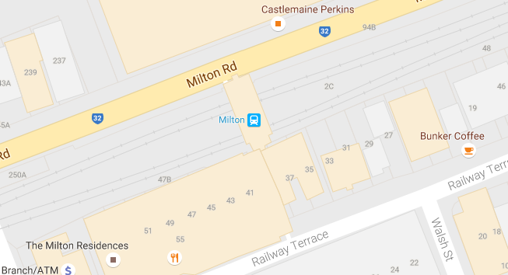
What to expect
Some noise from on track machines and construction crews, lighting, heavy vehicle movements, traffic control in surrounding streets.

Indooroopilly overhead and remedial works
From 2am Saturday 8 October to 4am Monday 10 October 2016.  Night and day works to reconfigure overhead lines and undertake remedial works, including trenching and mast installation. | 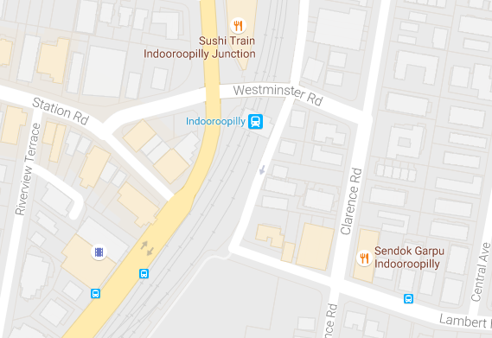
What to expect
Some noise from on-track machines and construction crews, heavy vehicle movements, traffic control in surrounding streets.

Milton station to Toowong station installation of signal foundations
From 2am Saturday 8 October to 4am Monday 10 October and  From 2am Saturday 15 October to 2am Monday 17 October and  From 2am Saturday 22 October to 10pm Sunday 23 October 2016 and  From 2am Saturday 29 October to 2am Monday 31 October 2016.  Night and day works to install signal foundations, including drilling and pouring foundations. |  |  | 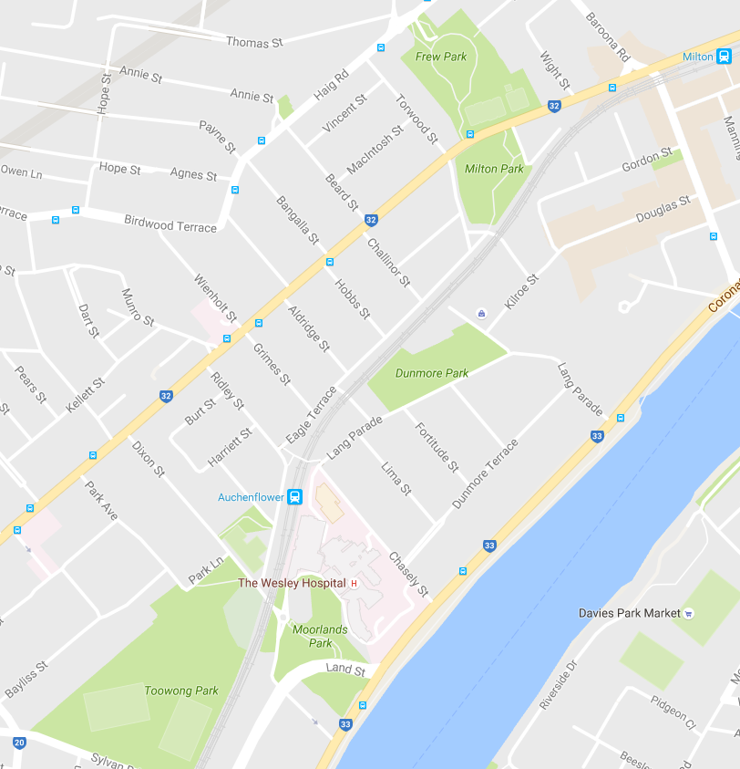
What to expect
Some noise from excavation and drilling, heavy vehicle movements and construction crews in area.
Periodic traffic control near train line access gates, minor traffic delays, reversing alarms, heavy vehicles and equipment movements and parking on nearby streets.
Milton station installation of turnout facility
From 2am Saturday 29 October to 2am Monday 31 October 2016.  Night and day works to install the turnout facility, which is a point in the track where a train can change from one track to another. |  | 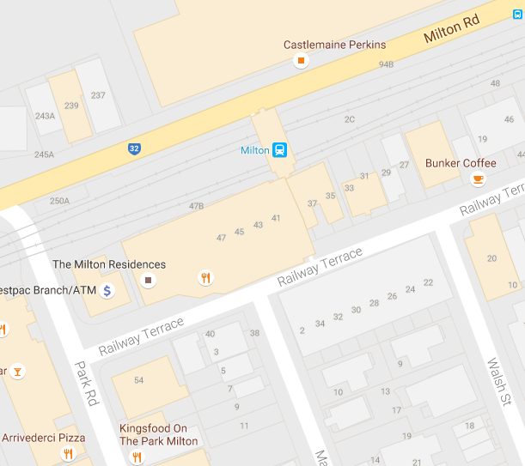
What to expect
Cutting and welding of rail, excavation and drilling, reversing alarms, extra heavy vehicles and equipment movements.
Some noise from heavy vehicle movements and construction crews in area, traffic control will be in place on Milton Road during this time.

Queensland Rail will make every effort to carry out its works with minimal disruption. We encourage you to contact us with your phone or email details so that we can ensure you are notified of any works that need to take place outside of normal construction hours or involve changed traffic arrangements in your area.
This snapshot is broad and subject to change. If you have questions or concerns about specific dates, times or locations, please contact us. We look forward to working with you.
Contact:
Call: 1800 399 222 Email: communityengagement@qr.com.au
For more information about this project visit the Queensland Rail website at www.queenslandrail.com.au/inthecommunity/projects

