1 February to 28 February 2017
Signals Upgrade Project
As a valued neighbour, we are committed to keeping you informed about work Queensland Rail is doing in your area. This notice is a four-week look ahead outlining planned work for our Signals Upgrade Project and approximate locations, so you are fully informed.
The nature of this work is such that there will be little to see, but there will be construction noise and traffic impacts, particularly around those points where we require access to the rail corridor.
We apologise for any inconvenience and thank you for your understanding while we dig trenches, lay cables, move overhead electrical wires and install new signalling equipment on the line between Roma Street and Corinda.
Auchenflower overhead weekend and night works
Night works for overhead line reconfiguration.  From 11pm to 5am each night on:  - Wednesday 8 February  - Thursday 9 February  - Sunday 12 February  - Tuesday 14 February and  - Thursday 16 February.  From 6am to 5pm each day on:  - Saturday 18 February and Sunday 19 February.  From 6pm to 4am on:  - Sunday 19 February.  From 11pm to 5am each night on:  - Monday 20 February  - Tuesday 21 February  - Wednesday 22 February and  - Thursday 23 February.  From 6am to 6pm each day on:  - Saturday 25 February and Sunday 26 February. |  |  | 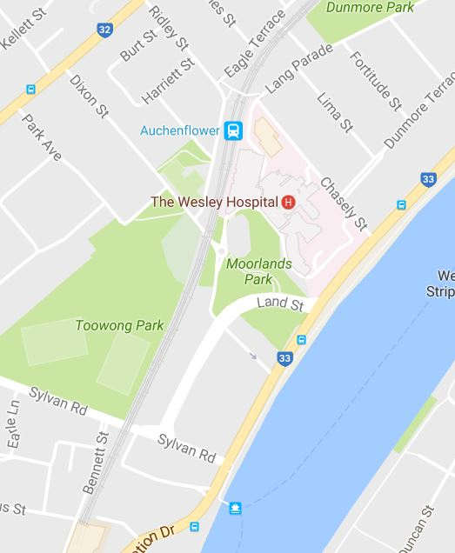
What to expect |  | Some noise from on-track machines and construction crews, heavy vehicle movements and traffic control in surrounding streets.
Roma Street station signal installation weekend works
There will be a single lane closure at Upper Roma Street and Milton Road (due to signal portal installation) as follows:  - From 6am to 6pm Saturday 18 February  - From 6am to 9pm Sunday 19 February. | 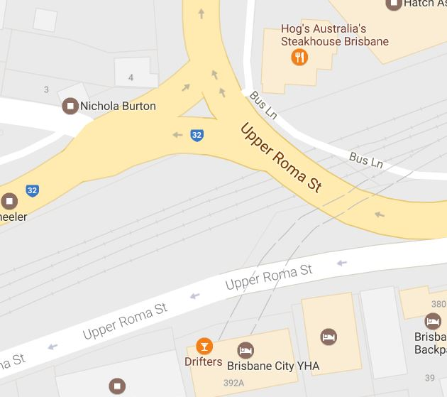
What to expect | Some noise from on-track machines and construction crews, heavy vehicle movements and traffic control in surrounding streets.
Milton to Indooroopilly day works
Ongoing daily conduit installation between Milton and Indooroopilly involving construction crews accessing the corridor and heavy vehicle movements.

Queensland Rail will make every effort to carry out its works with minimal disruption. We encourage you to contact us with your phone or email details so we can ensure you are notified of any works that need to take place outside of normal construction hours, or involve changed traffic arrangements in your area.
This snapshot is broad and subject to change. If you have questions or concerns about specific dates, times or locations, please contact us. We look forward to working with you.
Contact:
Call: 1800 959 989
Email: communityengagement@qr.com.au
For more information about this project visit the Queensland Rail website at www.queenslandrail.com.au/inthecommunity/projects

