Dinmore station accessibility upgrade

Project update –

August 2016
Preliminary footbridge and lift foundation works are well underway at Dinmore station as part of Queensland Rail’s $212 million station upgrade program.

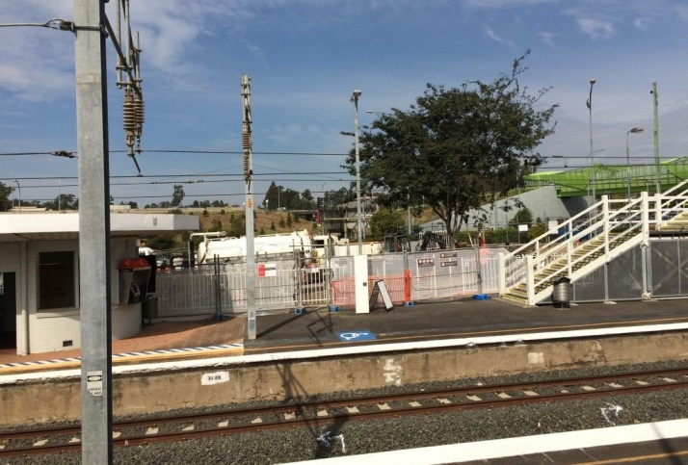

Project progress
The following construction activities were recently completed:
- construction and opening of temporary access ramps between platform 1 and the Brisbane Road carpark
- relocation of underground service pits
- excavation of footings for new stairs
- removal of platform 2 shelter and installation of a temporary shelter behind platform 2
- installation of steel structures for new lift shafts.

Upcoming work
In the coming weeks, customers and the community can expect to see the following activities:
- construction of further temporary access ramps to both platforms
- excavation and concrete pours
- construction of new station entrance from Mason Street carpark.
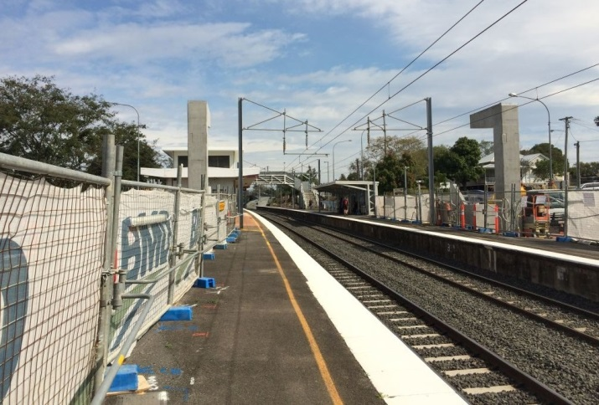

.

Construction impacts
Customers and residents adjacent to Dinmore station may experience:
- noise associated with heavy machinery
- use of reversing beepers
- mobile lighting towers for night works
- changed traffic and parking conditions
- increased vehicle movements around the work zone.
Pedestrians are asked to follow all directional signage during this time.
Residents and other stakeholders will be given advance notification of construction activities likely to cause impacts, including after-hours work (nights and Sundays, if required).

Keeping you informed
For more information on this project, please contact the Stakeholder Engagement team on 1800 722 203 (free call), email stationsupgrade@qr.com.au or visit www.queenslandrail.com.au

